

School of Built Environment, Engineering and Computing

Leeds Beckett University

**Machine Learning Prediction for Droughts using Weather & Soil Data**

By: Karthika Manoj

Jiamei Deng

Submitted to Leeds Beckett University in partial fulfilment of the requirements for the degree of MSc Data Science.

**September 2024**

# Candidate’s Declaration

I, Karthika Manoj, confirm that this dissertation and the work presented in it are my own achievement.

Where I have consulted the published work of others this is always clearly attributed;

Where I have quoted from the work of others the source is always given. With the exception of such quotations this dissertation is entirely my own work;

I have acknowledged all main sources of help;

I have read and understand the penalties associated with Academic Misconduct.



Signed: Karthika Manoj

Date: 06-09-2024

Student ID No: 77364354

# Acknowledgements

I would like to express my sincere gratitude to those who have provided invaluable support and guidance throughout the course of this research project. I am beyond grateful to my supervisor, Jiamei Deng, whose expert advice, constructive feedback, and encouragement have contributed immensely to the successful completion of this study.

I am also deeply thankful to Jacqueline Campbell, my course director, for her support throughout the research process.

I extend my heartfelt thanks to my family and friends for their unwavering support and understanding. Their encouragement has been a source of great motivation and strength.

Additionally, I would also like to acknowledge the cooperative spirit and support of my colleagues, which have significantly enhanced this research.

Lastly, I offer my gratitude to God for providing me with the strength and perseverance necessary to complete this work.

Thank you all for your significant contributions and support.

# Abstract

This research aims to develop and evaluate machine learning models for prediction of droughts utilising meteorological and soil data. Various algorithms and techniques are studied to determine the most effective approach for accurate drought forecasting. The dataset used in this research was pre-processed to manage issues such as missing values, class imbalance, and feature extraction. A wide variety of models, including Random Forest, K-Nearest Neighbours (KNN), AdaBoost, Gradient Boosting, XGBoost and Artificial Neural Networks (ANN), was evaluated. The performance of these models was assessed using metrics such as accuracy, precision, recall, and F1-score. The Random Forest model with Recursive Feature Elimination (RFE) and GridSearchCV illustrated high performance and was selected as the best model.

The study also includes a detailed comparison of model runtimes between local and cloud environments, demonstrating substantial reductions in execution time when utilizing AWS infrastructure. The Random Forest model was deployed on AWS SageMaker and additionally, a web application was developed to facilitate user interaction with the model. This research presents the effectiveness of machine learning techniques for drought prediction and the significant benefits of cloud-based deployment in terms of performance and scalability.

Contents

Candidate’s Declaration ii

Acknowledgements iii

Abstract iv

List of Figures viii

List of Tables 11

Chapter 1 : Introduction 12

1.1 Overview 12

1.2 Rationale 13

1.3 Aim and Objectives 13

1.4 Outline 14

Chapter 2 : Literature Review 15

2.1 Background on Drought Prediction 15

2.1.1 Droughts and their types 15

2.1.2 Traditional Methods of Drought Prediction 16

2.1.3 Limitations of Traditional Drought Prediction Methods 17

2.2 Introduction of Machine Learning for drought prediction 18

2.3 Recent Advances in Machine Learning for Drought Prediction 19

2.4 Emerging Trends and Advances in Drought Prediction 22

2.5 Recent Challenges 23

Chapter 3 : Methodology 25

3.1 Ethical Considerations 25

3.2 Data 26

3.2.1 Data Collection 26

3.2.2 Data Structure 27

3.2.3 Data Preprocessing 33

3.3 Model 40

3.3.1 Model Selection 41

3.3.2 Model Training 42

3.3.3 Validation and Testing 52

3.3.4 Model Evaluation 53

Chapter 4 : Product Design and Implementation 55

4.1 Technology Stack 55

4.1.1 Local Environment 56

4.1.2 Cloud Environment 57

4.2 Runtime Comparison 58

4.3 Model Deployment and Web App 60

4.3.1 Random Forest with Recursive Feature Elimination (RFE) and GridSearchCV 60

4.3.2 Model Deployment on AWS SageMaker 65

Chapter 5 : Research Outcomes 70

5.1 Model Performance Metrics 70

5.2 Runtime Comparison and Analysis 72

5.3 Model Deployment Results 73

Chapter 6 : Project Management 76

Chapter 7 : Conclusion and Future Work 78

References 79

Appendices 83

Ethics 83

Code Repository 86

Presentation Video 86

Meetings 87

# List of Figures

Figure 1 Drought Classification Levels (2020) 29

Figure 2 Meteorological train dataset- I 33

Figure 3 Meteorological train dataset- II 33

Figure 4 Count of null values in target variable- score 34

Figure 5 Dataset after removal of missing target values (NaN), showing zero null values in the score column 34

Figure 6 Features and its datatype 35

Figure 7 Dataset preview after extracting month, year, and day from date attribute 35

Figure 8 Number of values beyond outlier limit for each feature – I 36

Figure 9 Number of values beyond outlier limit for each feature – II 36

Figure 10 Row count post outlier removal 37

Figure 11 Code for merging soil and meteorological data based on fips code 37

Figure 12 Unified train dataset 38

Figure 13 Conversion of target variable to int type 39

Figure 14 Scaling of train, validation and test data 39

Figure 15 Dataset imbalance representation before removing NaN values-with drought scores on x-axis 40

Figure 16 Class imbalance 40

Figure 17 Algorithms utilised for model creation 41

Figure 18 Recursive Feature Elimination 43

Figure 19 Random forest classifier and GridSearchCV 43

Figure 20 SMOTE and PCA 44

Figure 21 AdaBoost 44

Figure 22 SMOTE and PCA 44

Figure 23 SMOTE and PCA 45

Figure 24 XGBoost and GridSearchCV 46

Figure 25 k nearest neighbour classifier with k=5 46

Figure 26 k nearest neighbours with k=5 and SMOTE 47

Figure 27 Decision Tree 47

Figure 28 Decision tree with PCA 48

Figure 29 Decsion tree with down sampling 48

Figure 30 Decision tree with up sampling 49

Figure 31 Decision tree with SMOTE 49

Figure 32 Decision tree with SMOTE and PCA 50

Figure 33 RFE 50

Figure 34 Random forest classifier 51

Figure 35 SMOTE and PCA 51

Figure 36 Adaboost on entire dataset 51

Figure 37 SMOTE and PCA 52

Figure 38 ANN 52

Figure 39 Training time for ANN model locally 59

Figure 40 Training time for ANN on cloud 60

Figure 41 Box plots 61

Figure 42 Desnity plots 61

Figure 43 Density histograms 61

Figure 44 Correlation matrix for meteorological features 62

Figure 45 Scatter plot T2M vs QV2M 63

Figure 46 RFE and selected features 64

Figure 47 GridSearchCV 64

Figure 48 Model performance on test data 65

Figure 49 Packaging and uploading model to S3 bucket 65

Figure 50 rfmodel.tar.gz in S3 bucket containing packaged model 66

Figure 51 Deploying model with endpoint name best-random-forest-endpoint 66

Figure 52 Snippet of app.py 67

Figure 53 Snippet of inference.py 67

Figure 54 Web app user interface 68

Figure 55 Performance metrics from CloudWatch logs 69

Figure 56 Confusion Matrix of Training data 70

Figure 57 Confusion Matrix of Validation data 71

Figure 58 Confusion Matrix of Testing data 71

Figure 59 Model performance for whole dataset training 71

Figure 60 Model performance for subset dataset training 72

Figure 61 Runtime comparison (local vs cloud environment) 72

Figure 62 Uploading test data csv file through web application 73

Figure 63 Logs of datasets being read and pre-processed 74

Figure 64 Logs of data preprocessing 74

Figure 65 Metrics calculated in logs 75

Figure 66 Gantt Chart for Research activities 76

# List of Tables

Table 1 Overview of Dataset Splits 27

Table 2 Temporal Data Split 27

Table 3 Meteorological indicators 28

Table 4 Non-meteorological indicators in meteorological dataset 29

Table 5 Features of Soil dataset 32

Table 6 Performance metrics on test dataset for models trained on whole dataset 53

Table 7 Performance metrics on test dataset for models trained on subset of dataset 54

Table 8 Runtime comparison for top 3 models 58

Table 9 Runtime comparison for models vs instance type 59

Table 10 Performance Metrics of Random Forest model with RFE and GridSearchCV on AWS Sagemaker 70

# Chapter 1 : Introduction

## 1.1 Overview

Owing to the changes in climate changes and urbanization around the world, droughts have become a frequent environmental issue that poses a threat to agriculture, eco-health, water resource management etc. With severity of these droughts worsening over the years, the necessity for on-time, dependable and accurate predictions of these events have become vital. This dissertation explores the application of machine learning techniques for predicting drought conditions using weather and soil data, with the purpose of identifying the most effective predictive models.

The study begins with an extensive analysis of different machine learning models such as Decision trees, KNN, Random Forest, SVM, AdaBoost etc. With the help of performance metrics like accuracy, precision, macro, micro and weighted recall and F1 score, each of these models are then evaluated for their efficiency in predicting droughts efficiently. Through systematic testing and validation of these models using a dataset that includes weather parameters such as temperature, wind speed, humidity, precipitation etc. and soil parameters like moisture levels and nutrient content, this study seeks to determine the optimal model for drought prediction.

Additionally, the research also intends to examine the performance of top performing models on cloud-based platforms such as AWS and produce a comparison of cloud-based and local runtime efficiency. These platforms and tools offer scalability and flexibility in deploying machine learning models allowing for further evaluation of practical applicability of these models in real-world scenarios.

Through this research, the dissertation not only contributes to the growing body of knowledge on drought prediction but also offers valuable insights for stakeholders involved in water resource management, agriculture, and climate adaptation strategies. The ultimate goal is to enhance decision-making processes and promote proactive measures to mitigate the impacts of drought on communities and ecosystems.

## 1.2 Rationale

Many regions that were previously deemed safe from droughts are now prone to critical water shortages due to rapid changes in climate and global warming. This adversely impacts agriculture, damages the ecosystem, increases energy demand and results in water scarcity and soil degradation emphasizing the need for advance and effective prediction of droughts. Efficient forecasting of droughts can aid in management of water resources, planning agricultural activities as well as strategies for disaster response. By leveraging machine learning methods that utilizes weather and soil data, this research strives to contribute to the development of reliable predictive models that can help mitigate the impacts of drought.

The insights gained from this research can help farmers make informed decisions regarding agriculture, optimize water usage and improve disaster recovery. Additionally, the advantages are not exclusive just to farmers as effective drought prediction can support sustainable resource management, support community fortitude and food security. Thus, this research addresses a critical gap in the existing understanding of drought prediction and offers valuable tools for stakeholders across various sectors.

## 1.3 Aim and Objectives

The aim of this research is to develop accurate predictive machine learning models for droughts that can be utilised in enhancing warning systems.

The objectives of this research are as follows-

1. To collect, integrate and process data for weather and soil conditions.
2. To identify machine learning algorithms suitable for accurate drought prediction.
3. To validate and test different machine learning models developed for drought prediction with the help of historic data.
4. To evaluate the performance of selected models in cloud-based platforms and machine learning tools.
5. To deploy the best model as web application.
6. To develop visualisation tools to present predictions and insights.

## 1.4 Outline

This dissertation is organised as follows:

Chapter 2 explores the literature review on droughts and its prediction methods, including traditional and current prediction methods.

Chapter 3 defines the methodology for data collection, preprocessing, and model selection, training, testing and evaluation.

Chapter 4 delivers the research design and implementation details, including the technology stack and deployment strategies.

Chapter 5 describes the outcomes of the research, including model performance metrics, runtime comparisons, and evaluation results.

Chapter 6 discusses the project management aspects of the research.

Finally, Chapter 7 presents the conclusions drawn from the research and outlines potential directions for future work.

# Chapter 2 : Literature Review

As the impact of climate change intensifies, the frequency and severity of droughts have become a global concern, prompting the need for more accurate and reliable prediction methods. Traditional drought prediction methods such as statistical models often lacked the precision needed to efficiently predict and mitigate the risks associated with droughts. As a result, machine learning methods have been widely utilized in the recent years to forecast drought conditions with enhanced accuracy.

The main aim of this chapter review and discuss traditional methods previously used for drought prediction, introduction of machine learning techniques in the study, current models, explore advances, gap in research, examine challenges and highlight emerging trends.

## 2.1 Background on Drought Prediction

Numerous studies have been conducted to understand the characteristics of droughts and assess their impacts. Understanding the causes and nature of droughts is crucial for predicting their occurrence, allowing people to take necessary precautions. Initially, various mathematical models and statistical methods were employed for this purpose

### 2.1.1 Droughts and their types

Droughts are intricate and complex natural phenomena marked by extended periods of insufficient precipitation, resulting in water shortages and affecting agriculture, ecosystems, and human communities adversely. It is important to note that the mere absence of rain or dryness are not indicators of drought. The deficiency in precipitation needs to fall below a set standard or level for it to be considered as a drought in an area (Maybank et al., 1995). However, in contrast to most other natural disasters, droughts can be exceptionally challenging to identify when they are mild, short-lived and localized.

The characteristics of droughts were often analysed with the help of their areal coverage, intensity, duration, frequency, and variability across various spatial and temporal scales. The Standardized Precipitation Index (SPI) was utilized to evaluate drought and wet periods over different time scales, offering insights that are often not captured by conventional drought indices (Edwards, McKee,1997). McKee, Doesken, and Kleist (1993) also note that two of the most important characteristics of droughts are frequency and duration.

According to Sundararajan et al. (2021), droughts can be categorized into three main types:

* meteorological
* hydrological
* agricultural droughts.

Meteorological drought is often identified by a deficiency in precipitation, leading to dryness and reduced infiltration. Agricultural drought occurs when there is insufficient soil moisture to meet the needs of crops, affecting plant growth, biomass, and yield. This type of drought has significant socio-economic and ecological impacts. Hydrological drought is marked by reduced water levels in streams, reservoirs, lakes, and groundwater, affecting the availability of water for various uses.

### 2.1.2 Traditional Methods of Drought Prediction

Before the advent of machine learning algorithms, a variety of other techniques were employed to predict drought occurrences. Meteorologist Wayne Palmer (1968) developed the Palmer Drought Severity Index (PDSI), based on the balance between moisture supply (precipitation) and demand (evapotranspiration), which is considered one of the earliest and most widely used tools for drought prediction. Rao et al. (1973) conducted a spectral analysis of the Palmer Drought Severity Index for 23 subdivisions in India for 60 years. Karl (1986) describes modifications and extensions to the Palmer Index, such as the Palmer Hydrological Drought Index (PHDI), which places greater emphasis on the long-term hydrological impacts of droughts, in contrast to the Palmer Drought Severity Index (PDSI) developed by Palmer, which is more focused on short-term agricultural drought conditions. Johnson and Kohne (1993) found that PHDI to be valuable for investigating droughts over large geographic areas as the utilized it to assess the susceptibility of 516 reservoirs in the US.

Lohani and Loganathan (1997) introduced a decision tree framework that uses drought states as nodes, incorporating potential future scenarios along with their associated probabilities of future weather classes based on the Palmer Drought Severity Index (PDSI). Bonaccorso et al. (2003) utilized a different analytical approach by conducting a principal component analysis of the Standardized Precipitation Index (SPI) to investigate drought conditions in Sicily. Around the same time, Kim and Valdés (2003) developed a non-linear conjunction model that combines dyadic wavelet transforms with neural networks to forecast droughts in the Conchos River Basin in Mexico. Their results showed that this conjunction model significantly enhances the predictive capabilities of neural networks in forecasting regional drought indices. In 2005, Mishra and Desai applied linear stochastic models, including Auto-Regressive Integrated Moving Average (ARIMA) and multiplicative Seasonal ARIMA (SARIMA), to forecast droughts using the Standardized Precipitation Index (SPI) series in the Kansabati River basin in India. In addition to the development of decision tree frameworks and conjunction models for drought forecasting, Cacciamani et al. (2007) applied a different approach by focusing on the Emilia-Romagna region. They utilized the Standardized Precipitation Index (SPI) in combination with a statistical downscaling method that leverages large-scale seasonal forecasts from Atmospheric Global Circulation Models, further refining the regional prediction of droughts. Traditional methods have thus been essential in drought prediction, providing foundational insights that have informed subsequent advancements in this field.

### 2.1.3 Limitations of Traditional Drought Prediction Methods

Despite the significant contributions of traditional methods to drought prediction, these approaches often face several limitations. As drought events grow increasingly complex and are influenced by a multitude of factors, the shortcomings of conventional techniques have become more evident. The sensitivity of the Palmer Drought Severity Index and Z-index to calibration coefficients is one of the challenges these traditional approaches face in accurately forecasting and managing drought conditions in an evolving climate. Karl (1986) discusses that the Palmer Index is influenced by the calibration period used to determine whether the land is classified as wet or dry. He also notes that Palmer's initial drought computation does not account for external factors introduced by human activities, such as irrigation, new reservoirs, and other modifications. Karl (1986) observes that the qualitative descriptions tied to the magnitudes of PDSI, PHDI, and the Z-index are defined in an arbitrary manner. He also highlights that Palmer's model does not account for snow cover. Karl (1986) critiques that no lag is incorporated into runoff calculations within the Palmer Index, despite Thornthwaite and Mather (1955) and Mather (1981) suggesting that incorporating a lag is more effective. He also points out that the model's assumption that runoff doesn't occur until soil capacity is fully saturated is unrealistic.

## 2.2 Introduction of Machine Learning for drought prediction

With the growing complexity and variability of climatic conditions, the limitations of traditional drought prediction methods have become increasingly apparent, underscoring the need for more advanced approaches. Tang et al. (1991) conducted a comparative study on the performance of neural networks versus conventional methods in time series forecasting, concluding that neural networks are robust and offer reliable long-term forecasting capabilities. Tripathi et al. (2006) conducted a statistical downscaling of precipitation using simulations from general circulation models. They introduced a Support Vector Machine (SVM) approach to project future precipitation for meteorological sub-divisions (MSDs) in India. The results indicated that SVMs offer a promising alternative to conventional artificial neural networks for statistical downscaling and are well-suited for conducting climate impact studies. Similarly, Gill et al. (2006) compared the results from SVM modeling with predictions obtained from ANN models, finding that SVM models outperformed ANN models in forecasting soil moisture. Mishra, A.K., Desai, V.R. and Singh, V.P. (2007) combined a linear stochastic model with a nonlinear artificial neural network (ANN) for drought prediction. They used the Standardized Precipitation Index (SPI) to predict droughts in the Kansabati River basin in India, utilizing the stochastic model, ANN, and a hybrid of the two. Their findings indicated that the hybrid model produced the best results. Bacanli, U.G., Firat, M. and Dikbas, F. (2008) developed and tested various Adaptive Neuro-Fuzzy Inference System (ANFIS) forecasting models for the Standardized Precipitation Index (SPI) at time scales of 1–12 months. Additionally, the best-performing models were also trained and tested using Feed Forward Neural Networks (FFNN) and results demonstrated high accuracy and reliability for drought forecasting. However, Belayneh, A. and Adamowski, J. (2012) argued that ANNs are limited in their ability to handle non-stationarities in data, a limitation also observed in multiple linear regression (MLR) and autoregressive integrated moving average (ARIMA) models. They used three models—artificial neural networks (ANNs), support vector regression (SVR), and wavelet networks (WN)—to forecast the Standard Precipitation Index (SPI) in Awash River Basin of Ethiopia and compared the results. The study found that WN models were the most effective in forecasting SPI at both 3-month and 12-month intervals across all three subbasins. WN models demonstrated a greater correlation between observed and predicted SPI compared to simple ANNs and SVR models and consistently showed lower RMSE and MAE values. All data-driven models performed better in forecasting SPI 12 than SPI 3, but forecast accuracy declined as the lead time increased. Among the machine learning techniques, ANNs were found to be more effective in forecasting SPI compared to SVR models. Following their 2012 study, Belayneh and Adamowski (2013) expanded their research by applying artificial neural networks (ANNs), support vector regression (SVR), and coupled wavelet-ANN models to drought prediction. This time, they pre-processed input data using wavelet analysis (WA) to improve the accuracy of forecasts. Their findings indicated that the coupled wavelet neural network (WA-ANN) models provided the most accurate forecasts. Vladimir N. Vapnik introduced the concept of Support Vector Regression (SVR), a relatively new form of machine learning, in his 1995 book The Nature of Statistical Learning Theory (Vapnik, 1995). Later, in the 2013 edition of the same book, Vapnik expanded on this by discussing ensemble methods, including Support Vector Machines (SVM) and AdaBoost, highlighting further advancements in the field (Vapnik, 2013).

## 2.3 Recent Advances in Machine Learning for Drought Prediction

The last decade has seen a spike in innovative approaches and methodologies, all based on the application of machine learning techniques in drought prediction, as the complexities of climate patterns and data volumes continue to grow. Cutting-edge techniques such as deep learning, ensemble models, and hybrid approaches are pushing the boundaries of drought forecasting, representing a significant evolution from earlier machine learning methods. These advancements offer enhanced accuracy, scalability, and adaptability, making them better suited to the ever-changing climate landscape.  
In 2014, Hao et al. (2014) developed the Global Integrated Drought Monitoring and Prediction System (GIDMaPS), which offers comprehensive drought information using multiple drought indicators. This system provides data on meteorological and agricultural droughts by integrating various satellite and model-based precipitation and soil moisture datasets. GIDMaPS features a near real-time monitoring component, alongside a seasonal probabilistic prediction module. The prediction aspect of GIDMaPS is built on the Ensemble Streamflow Prediction (ESP) method, widely employed in numerous hydrological and climate studies. The study by Belayneh et al. (2016a) explored short-term drought forecasting in the Awash River Basin using wavelet transforms and various machine learning methods, published in Sustainable Water Resources Management. This research examined five different data-driven models, including newly proposed methods based on support vector regression (SVR) and wavelet-SVR. The study found that the wavelet-ANN (WA-ANN) method, which incorporated a unique technique for optimizing the number of neurons in the hidden layer, provided the most accurate forecasts, with WA-SVR models also showing strong performance.  
  
Following this, Belayneh et al. (2016b) further investigated the application of coupled machine learning models and ensemble techniques, such as wavelet transforms and boosting, for drought prediction in the Awash River Basin. Published in Atmospheric Research, this study evaluated the performance of wavelet boosting ANN (WBS-ANN) and wavelet boosting SVR (WBS-SVR) models. The results indicated that these coupled models outperformed other approaches in predicting the Standardized Precipitation Index (SPI), demonstrating improved accuracy and reliability. In their 2016 study, Park et al. (2016) employed sixteen remote sensing-based drought factors obtained from satellites to monitor meteorological and agricultural drought conditions during the 2000–2012 growing seasons across various climate regions in the USA. They used the Standardized Precipitation Index (SPI) and crop yield data as references for meteorological and agricultural drought, respectively. The study modelled the relationship between these remote sensing factors and in situ reference data using three machine learning techniques: random forest, boosted regression trees, and Cubist. The results indicated that the random forest approach delivered the most accurate performance for SPI prediction.   
In recent years, deep learning has emerged as a transformative approach in the field of drought prediction. Expanding on the core concepts of machine learning, deep learning techniques utilize advanced neural network architectures to capture and model complex patterns and relationships in extensive datasets. In contrast to traditional methods that typically use simpler models and limited datasets, deep learning approaches—such as Deep Belief Networks (DBNs) and Convolutional Neural Networks (CNNs)— offer better capabilities for handling high-dimensional data and capturing subtle temporal and spatial dependencies. Through intricate feature extraction and hierarchical learning processes, these advanced models have shown potential in improving the accuracy and reliability of drought forecasts . Agana and Homaifar (2017) proposed a Deep Belief Network (DBN) composed of two Restricted Boltzmann Machines for long-term drought prediction in the Gunnison River Basin, part of the Upper Colorado River Basin. The study evaluated the performance of the DBN model against traditional methods such as Multilayer Perceptron (MLP) and Support Vector Regression (SVR) and results demonstrated that the DBN model outperformed the traditional approaches. Liu et al. (2018) evaluated the effectiveness of Extreme Learning Machine (ELM), Online Sequential Extreme Learning Machine (OS-ELM), and Self-Adaptive Evolutionary Extreme Learning Machine (SADE-ELM) as alternative drought-forecasting tools. The study is based on predicting drought indices in Vietnam’s Cai River Basin, particularly the Standardized Precipitation Index (SPI) and the Standardized Precipitation Evapotranspiration Index (SPEI), by utilizing sea surface temperature anomalies (SSTA). The results indicated that SADE-ELM models performed the best, with OS-ELM models showing better performance than ELM models. Researchers continued to explore and refine other machine learning techniques to improve predictive accuracy further, after the advancements in deep learning models like DBNs, which demonstrated enhanced performance in drought prediction. Zhang et al. (2019) applied and compared different models, including a distributed lag nonlinear model (DLNM), an artificial neural network, and the XGBoost model, to forecast the Standardized Precipitation Evapotranspiration Index (SPEI) up to six months in advance. Their study found that the XGBoost model delivered the highest accuracy, especially for predicting severe drought categories, showing the ongoing progress in the field of drought prediction with the use of advanced machine learning methodologies. These developments are an example of the rapid evolution of machine learning applications in drought prediction leading to more accurate, reliable, and timely forecasting tools and continuous innovation and refinement of models. Ultimately, this enhances the chance to mitigate the impacts of drought on both local and global scales.

## 2.4 Emerging Trends and Advances in Drought Prediction

As machine learning continues to evolve, more advanced and potent methods have been brought to the subject of drought prediction A key focus in this area has been the fine-tuning of model parameters, a process known as hyperparameter tuning, which is crucial for optimizing the performance of machine learning models. Furthermore, the ongoing integration of advanced algorithms and novel approaches is reshaping drought prediction, providing increasingly accurate and adaptable forecasting capabilities to address the evolving challenges of climate variability.

Hyperparameter tuning is crucial in machine learning, as it significantly impacts model performance and accuracy. In a pioneering study over Pakistan, Khan et al. (2020) developed drought prediction models using three state-of-the-art machine learning techniques: Support Vector Machine (SVM), Artificial Neural Network (ANN), and k-Nearest Neighbour (KNN). By utilizing hyperparameter tweaking in conjunction with a new feature selection method known as Recursive Feature Elimination (RFE), SVM-based models outperformed the other models in capturing the temporal and geographical aspects of droughts. Alawsi et al. (2022) used climate data spanning a 30-year period to suggest a novel hybrid approach for simulating drought indices (SPI 1, SPI 3, and SPI 6) in Al-Kut City, Iraq. This approach integrated data preprocessing techniques with an Artificial Neural Network (ANN) model, enhanced by the coefficient-based particle swarm optimisation and chaotic gravitational search algorithm (CPSOCGSA) algorithm. The performance of the hybrid model using marine predators algorithm (MPA) and the slime mould algorithm (SMA) algorithms were also evaluated. The findings indicated that the preprocessing techniques effectively denoised the time series data and removed redundant predictors, thereby improving data quality and predictor selection. The study also offers a framework for future investigations into hybrid models that integrate preprocessing and parameter optimization methods for predicting various drought indices across different regions.

Recent progress in machine learning for drought prediction involve not only the development of new algorithms but also the innovative integration of existing techniques to enhance model performance. An important example of this approach is demonstrated in the study by Fung et al. (2020), which explored the combination of fuzzy logic and boosting ensemble techniques with Support Vector Regression (SVR) models. By integrating these methodologies with SVR, the study aimed to improve the accuracy of predicting the Standardized Precipitation Evapotranspiration Index (SPEI) and manage the challenges associated with varying timescales and outliers. This approach highlights the growing trend of leveraging and refining existing methods to achieve more precise and reliable drought forecasts. Similarly, Li et al. (2021) introduced a novel meteorological drought prediction approach that incorporates antecedent sea surface temperature (SST) fluctuation patterns (ASFP) with machine learning techniques, including support vector regression (SVR), random forest (RF), and extreme learning machine (ELM). The study developed three models—ASFP-SVR, ASFP-ELM, and ASFP-RF—to address ensemble, probabilistic, and deterministic drought predictions. The ASFP-ELM model demonstrated superior performance in predicting drought events, outperforming both ASFP-SVR and ASFP-RF models. This shows the potential of combining SST patterns with advanced machine learning techniques to enhance drought prediction capabilities and support the development of effective early warning systems. In 2023, another approach was introduced by Karbasi et al. by integrating empirical wavelet transform (EWT) and discrete wavelet transform (DWT) with machine learning models such as multilayer perceptrons (MLP), extended Kalman filter (EKF), and group method of data handling (GMDH) neural networks. Their study demonstrated that combining these techniques significantly improved forecasting performance compared to standalone models, with the EWT-MLP-EKF combination proving most effective.

As Sundararajan et al. (2021) point out, the choice between direct and recursive models significantly impacts the accuracy of drought forecasting depending on the time scale of the Standardized Precipitation Index (SPI). Direct models have shown superior performance at longer SPI time scales, while recursive models excel at shorter time scales. Additionally, the integration of wavelet transforms with Adaptive Neuro-Fuzzy Inference Systems (ANFIS) has been particularly successful in enhancing drought forecasting accuracy. These insights underscore the importance of tailoring model selection and preprocessing techniques to the specific characteristics of the drought index and time scale under consideration.

## 2.5 Recent Challenges

A significant challenge in drought prediction involves the integration of advanced technologies with machine learning models to enhance forecasting accuracy. For instance, while Achite et al. (2023) demonstrated the potential of machine learning models like ANNs and SVMs for predicting hydrological drought, their application requires substantial data and computational resources. Moreover, Nandgude et al. (2023) highlighted the drawbacks of machine learning and deep learning models, including the need for large datasets and significant computational power, which pose challenges in terms of time and resources. They suggest that future research should focus on reducing computational costs through hardware optimization, data preprocessing, and hyperparameter tuning. Additionally, leveraging cloud, edge, and fog computing could address these challenges by providing scalable resources for more efficient drought prediction (Gyaneshwar et al., 2023).

# Chapter 3 : Methodology

The methodology section outlines the systematic approach adopted in this research to develop, implement, and evaluate advanced machine learning models for drought prediction. Considering the existing complexities regarding climatic and soil conditions, this research employed a combination of state-of-the-art data preprocessing techniques, model selection, training, and evaluation processes for the effective forecasting of droughts. The methods utilized in this study were thoughtfully chosen and rigorously implemented to ensure that the models achieve a high level of accuracy while maintaining the robustness required for practical, real-world use thereby aiming to contribute to the field of predictive analytics for drought management.

## 3.1 Ethical Considerations

This study adheres to ethical guidelines as set by Leeds Beckett University and does not involve any activities that would require additional ethical scrutiny. The research is solely based on the analysis of publicly available data from the NASA Langley Research Center (LaRC) POWER Project. There is no involvement of human participants, sensitive personal data, or any actions that could compromise confidentiality, anonymity, or individual well-being.

The study clearly does not:

* Involve the collection or analysis of personal or sensitive information not in the public domain.
* Require consent or permission to conduct or publish the research.
* Pose any risk of compromising confidentiality or anonymity.
* Include any invasive or intrusive procedures or involve participants who are particularly vulnerable.
* Involve any form of deception or pose risks beyond those experienced in everyday life.

The research is classified as Risk Category 1, meaning it has been provisionally approved by the research supervisor with no substantial amendments necessary. This ensures that the research is carried out with minimal ethical risks, while still offering valuable insights into drought prediction and strives to make a significant contribution to the field in a responsible and ethically sound manner.

The details of the ethical considerations for this study, including the completed ethics form, are provided in the Appendix.

## 3.2 Data

The effectiveness and accuracy of machine learning models for drought prediction depends heavily on the quality and relevance of the data used. This research uses data sourced from reputable and publicly available datasets. This section further details the data collection and preprocessing methods, briefing the processes involved in collection and preparation the data for effective use in the modeling phase.

### 3.2.1 Data Collection

This study employs extensive meteorological data to predict drought conditions using machine learning techniques. The primary dataset utilized in this research was sourced from Kaggle, a well-known platform for data science and machine learning datasets. Specifically, the dataset used is available at Kaggle's US Drought Meteorological Data. The dataset, compiled by CDMinix, includes detailed meteorological records relevant to drought prediction, crucial for both training and validating the predictive models. It is derived from the NASA Langley Research Center (LaRC) POWER Project and encompasses various weather and soil parameters. This is a classification dataset over six levels of drought where data in each row represents the drought level at a specific point in time in a specific US county, along with the 18 meteorological indicators (as shown in Table 3) recorded in the last 90 days. This quantitative data underpins the analysis, facilitating accurate drought predictions through both statistical and machine learning techniques.

Additionally, the study incorporates quantitative data from the Harmonized World Soil Database, which was designed by Nachtergaele et al. (2023). This dataset provides critical soil-related metrics for the drought prediction models. The combination of these data sources ensures a solid basis for developing accurate and dependable drought prediction models

### 3.2.2 Data Structure

This main meteorological data sets were obtained from Kaggle. In addition, this data is already pre-split in the form of training, validation and test sets.

|  |  |  |
| --- | --- | --- |
| ****Dataset**** | ****Number of Rows**** | ****Number of Features**** |
| Meteorological Training Set | 19,300,680 ≈ 19 million | 21 |
| Meteorological Validation Set | 2,268,840 ≈ 2 million | 21 |
| Meteorological Testing Set | 2,271,948 ≈ 2 million | 21 |
| Soil Set | 3109 | 32 |

Table 1 Overview of Dataset Splits

To avoid any data leakage, the data has been split in a way that the training set consists of data from years 2000-2009, validation set from years 2010-2011 and test dataset from years 2012-2020.

|  |  |
| --- | --- |
| ****Dataset**** | ****Year Range**** |
| Training Set | 2000-2009 |
| Validation Set | 2010-2011 |
| Testing Set | 2012-2020 |

Table 2 Temporal Data Split

The meteorological data comprises of the following 18 meteorological indicators, which collectively provide a comprehensive view of environmental conditions:

* Daily maximum and minimum temperatures
* Average precipitation
* Relative humidity levels
* Solar radiation
* Wind speed
* Soil moisture content
* Evapotranspiration rates
* Other atmospheric conditions that influence drought dynamics

These indicators (as shown in Table 3) are crucial inputs to the model that helps it to predict drought severity, based on the recent weather conditions.

|  |  |  |
| --- | --- | --- |
| S.No | Indicator | Description |
| 1 | WS10M_MIN | Minimum Wind Speed at 10 Meters (m/s) |
| 2 | QV2M | Specific Humidity at 2 Meters (g/kg) |
| 3 | T2M_RANGE | Temperature Range at 2 Meters (C) |
| 4 | WS10M | Wind Speed at 10 Meters (m/s) |
| 5 | T2M | Temperature at 2 Meters (C) |
| 6 | WS50M_MIN | Minimum Wind Speed at 50 Meters (m/s) |
| 7 | T2M_MAX | Maximum Temperature at 2 Meters (C) |
| 8 | WS50M | Wind Speed at 50 Meters (m/s) |
| 9 | TS | Earth Skin Temperature (C) |
| 10 | WS50M_RANGE | Wind Speed Range at 50 Meters (m/s) |
| 11 | WS50M_MAX | Maximum Wind Speed at 50 Meters (m/s |
| 12 | WS10M_MAX | Maximum Wind Speed at 10 Meters (m/s) |
| 13 | WS10M_RANGE | Wind Speed Range at 10 Meters (m/s) |
| 14 | PS | Surface Pressure (kPa) |
| 15 | T2MDEW | Dew/Frost Point at 2 Meters (C) |
| 16 | T2M_MIN | Minimum Temperature at 2 Meters (C) |
| 17 | T2MWET | Wet Bulb Temperature at 2 Meters (C) |
| 18 | PRECTOT | Precipitation (mm day-1) |

Table 3 Meteorological indicators

Apart from these meteorological indicators, the dataset also contains, a code corresponding to location, date and the target variable score (as shown in Table 4). The data used in this study is a classification dataset that categorizes drought conditions into six distinct levels, ranging from no drought (None) to five increasing levels of drought severity (as shown in Figure 1).

The classification labels within the dataset are defined as follows:

* None: No drought conditions are present.
* D0 - Abnormally Dry: Conditions are approaching drought, with short-term dryness slowing planting or growth.
* D1 - Moderate Drought: Some damage to crops and pastures; streams, reservoirs, or wells low; some water shortages developing.
* D2 - Severe Drought: Crop or pasture losses likely; water shortages common; water restrictions imposed.
* D3 - Extreme Drought: Major crop/pasture losses; widespread water shortages or restrictions.
* D4 - Exceptional Drought: Exceptional and widespread crop/pasture losses; shortages of water in reservoirs, streams, and wells creating water emergencies.

|  |  |
| --- | --- |
| Feature/ Column | Description |
| fips | US county FIPS code |
| date | Observation date |
| score | Measure of drought ranging from 0 (no drought) to 5 |

Table 4 Non-meteorological indicators in meteorological dataset

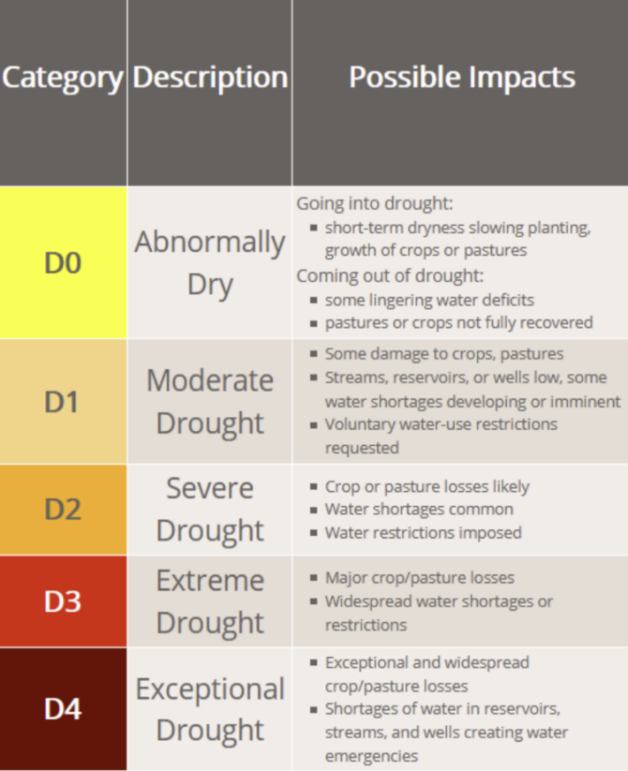

Figure 1 Drought Classification Levels (2020)

The soil dataset includes detailed soil and land characteristics across various U.S. counties, identified by their FIPS codes (Federal Information Processing Standards). It consists of spatial features like latitude, longitude and elevation, as well as an array of soil quality indicators and land use classifications (as shown in Table 5).

The key features are –

* FIPS: A unique identifier for each U.S. county, allowing for location-specific analysis.
* Latitude (lat) and Longitude (lon): Geographic coordinates indicating the location of the data point.
* Elevation: The median elevation of the area (in meters), which influences local climate and soil properties.

**Slope Characteristics**

* Slope1 to Slope8: Represent various slope categories ranging from nearly flat (0%–0.5%) to steep (over 45%), which affect water retention and soil stability.

**Aspect Data**

Aspect data indicates the direction the slope faces, affecting sunlight exposure and microclimate conditions:

* AspectN: North-facing slopes (0°–45° or 315°–360°).
* AspectE: East-facing slopes (45°–135°).
* AspectS: South-facing slopes (135°–225°).
* AspectW: West-facing slopes (225°–315°).
* AspectUnknown: Undefined aspect, often where slopes are very gentle or flat.

**Land Use Classifications**

Understanding land cover is vital for assessing water absorption and land use impact on drought conditions:

* WAT_LAND: Areas covered by water bodies.
* NVG_LAND: Barren or sparsely vegetated land.
* URB_LAND: Urban or built-up land, which influences runoff and soil sealing.
* GRS_LAND: Grassland, scrub, and woodland areas that impact water retention.
* FOR_LAND: Forest land, critical for maintaining soil moisture and reducing erosion.
* CULTRF_LAND: Irrigated cultivated land, indicating agricultural areas dependent on artificial watering systems.
* CULT_LAND: Total cultivated land, including both irrigated and non-irrigated agricultural zones.

**Soil Quality Indicators (SQ1-SQ7)**

These indicators evaluate the soil's capacity to support plant growth and maintain water retention:

* SQ1 - Nutrient Availability: Essential for crop growth and overall soil fertility.
* SQ2 - Nutrient Retention Capacity: Soil's ability to retain essential nutrients, impacting drought resilience.
* SQ3 - Rooting Conditions: Factors like soil texture and depth affecting root penetration and stability.
* SQ4 - Oxygen Availability to Roots: Important for root respiration, especially in saturated or compacted soils.
* SQ5 - Excess Salts: High salt levels can hinder plant growth and reduce drought resilience.
* SQ6 - Toxicity: Presence of toxic elements that can impede plant growth.
* SQ7 - Workability: Constraints on soil management, influencing agricultural practices.

|  |  |  |
| --- | --- | --- |
| S. No | Features | Description |
| 1 | fips | US county FIPS code |
| 2 | lat | Latitude |
| 3 | lon | Longitude |
| 4 | elevation | Median elevation (meters) |
| 5 | slope1 | 0 % ≤ slope ≤ 0.5 % |
| 6 | slope2 | 0.5 % ≤ slope ≤ 2 % |
| 7 | slope3 | 2 % ≤ slope ≤ 5 % |
| 8 | slope4 | 5 % ≤ slope ≤ 10 % |
| 9 | slope5 | 10 % ≤ slope ≤ 15 % |
| 10 | slope6 | 15 % ≤ slope ≤ 30 % |
| 11 | slope7 | 30 % ≤ slope ≤ 45 % |
| 12 | slope8 | Slope > 45 % |
| 13 | aspectN | North: 0˚< aspect ≤45˚ or 315˚< aspect ≤360˚ |
| 14 | aspectE | East: 45˚ < aspect ≤ 135˚ |
| 15 | aspectS | South: 135˚ < aspect ≤ 225˚ |
| 16 | aspectW | West: 225˚ < aspect ≤ 315˚ |
| 17 | aspectUnknown | Undefined: Slope aspect undefined; this value is used for grids where slope gradient is undefined or slope gradient is less than 2%. |
| 18 | WAT_LAND | mapped water bodies |
| 19 | NVG_LAND | barren/very sparsely vegetated land |
| 20 | URB_LAND | built-up land (residential and infrastructure) |
| 21 | GRS_LAND | grass/scrub/woodland |
| 22 | FOR_LAND | forest land, calibrated to FRA2000 land statistics |
| 23 | CULTRF_LAND |  |
| 24 | CULTIR_LAND | irrigated cultivated land, according to GMIA 4.0 |
| 25 | CULT_LAND | total cultivated land |
| 26 | SQ1 | Nutrient availability |
| 27 | SQ2 | Nutrient retention capacity |
| 28 | SQ3 | Rooting conditions |
| 29 | SQ4 | Oxygen availability to roots |
| 30 | SQ5 | Excess salts. |
| 31 | SQ6 | Toxicity |
| 32 | SQ7 | Workability (constraining field management) |

Table 5 Features of Soil dataset

### 3.2.3 Data Preprocessing

A crucial part of machine learning is data preprocessing to improve the quality and effectiveness of model’s performance. This includes handling missing values, scaling the data and features or merging datasets. It prevents any biases or errors in prediction and enhances the robustness of model in making accurate predictions on high-dimensional data.

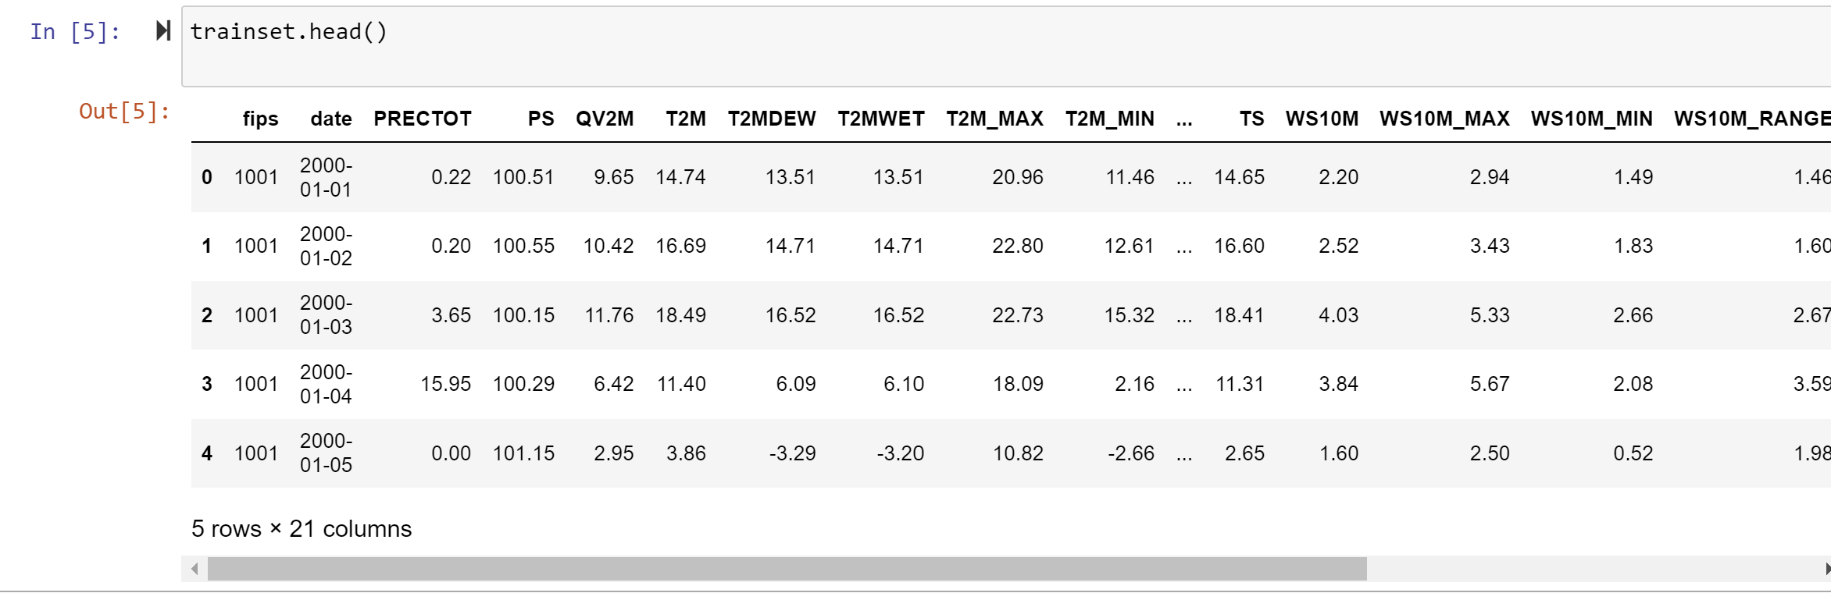

Figure 2 Meteorological train dataset- I

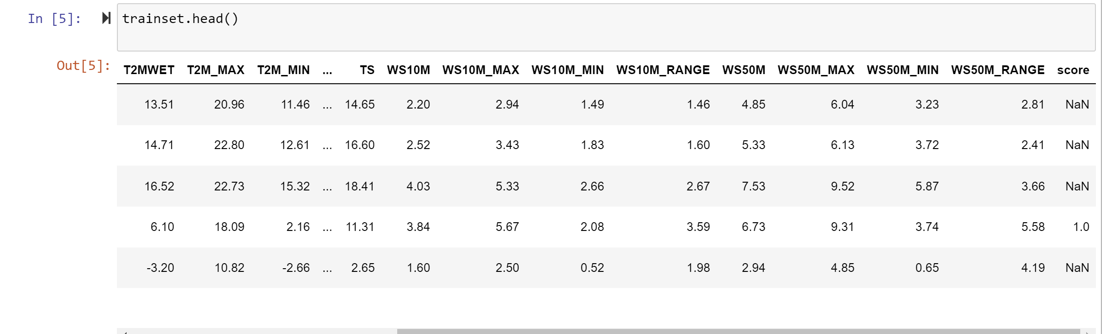

Figure 3 Meteorological train dataset- II

The following are the preprocessing steps performed on the data-

* Handling missing values- Even though data for meteorological indicators are available every day, as the drought score is only available once in every 7 days, the data with score value as NaN needs to be removed ( Figure 2 , Figure 3 ). About 16543884 records were present with NaN as value for target variable, score (as shown in Figure 4). One of the initial steps in data preprocessing is addressing missing values, which can significantly affect the performance and reliability of machine learning models. In this study, while meteorological data was recorded daily, the drought score was only available once every seven days. This discrepancy resulted in several records having missing (NaN) values for the target variable, which needed to be carefully handled to maintain data integrity.

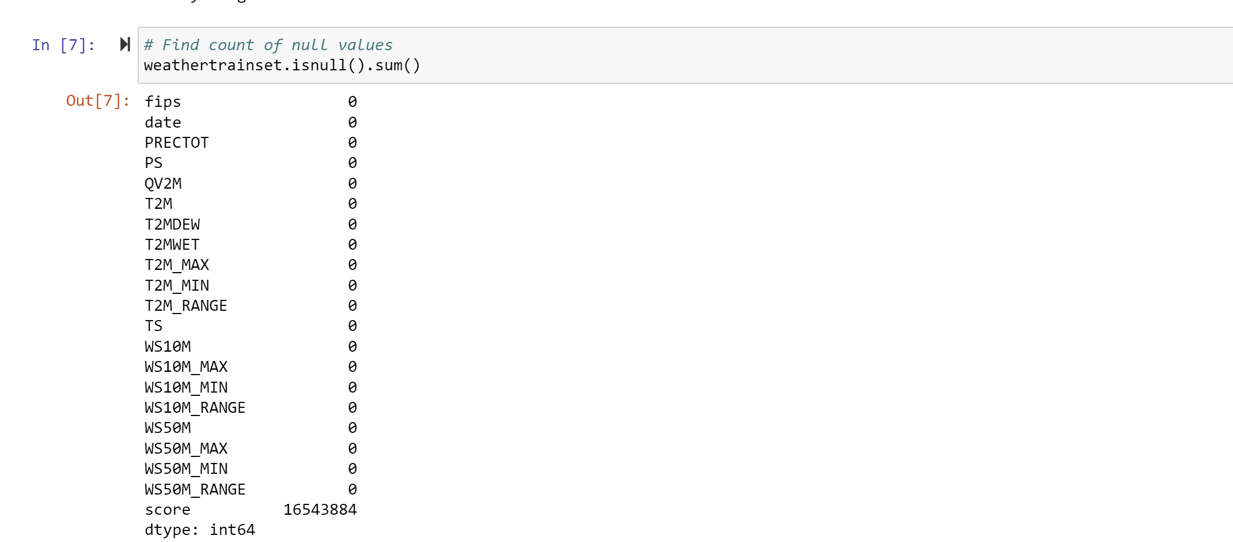

Figure 4 Count of null values in target variable- score

Specifically, about 16,543,884 records contained NaN values for the target variable drought score (as illustrated in Figure 2 , Figure 3 and Figure 4).). These missing values, if left unaddressed, could introduce biases or inaccuracies in the model's predictions. To resolve this, rows with missing target values were systematically removed using the dropna() function, ensuring that only complete and relevant data were used in the analysis (Figure 5). This step was essential to streamline the dataset and prepare it for effective model training and evaluation.

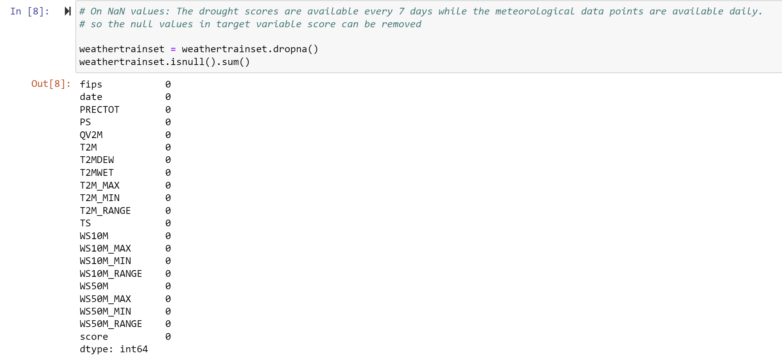

Figure 5 Dataset after removal of missing target values (NaN), showing zero null values in the score column

* Extracting temporal features from the date attribute- The 'date' attribute in the dataset was originally stored as an object (string) type, which was not directly usable for extracting time-related information ( Figure 6 ). To address this, the 'date' attribute was first converted into a datetime format using the pd.DatetimeIndex function. This conversion enabled the creation of three new features: month, year, and day, which provide valuable insights into temporal patterns that could influence drought conditions (Figure 7 ).

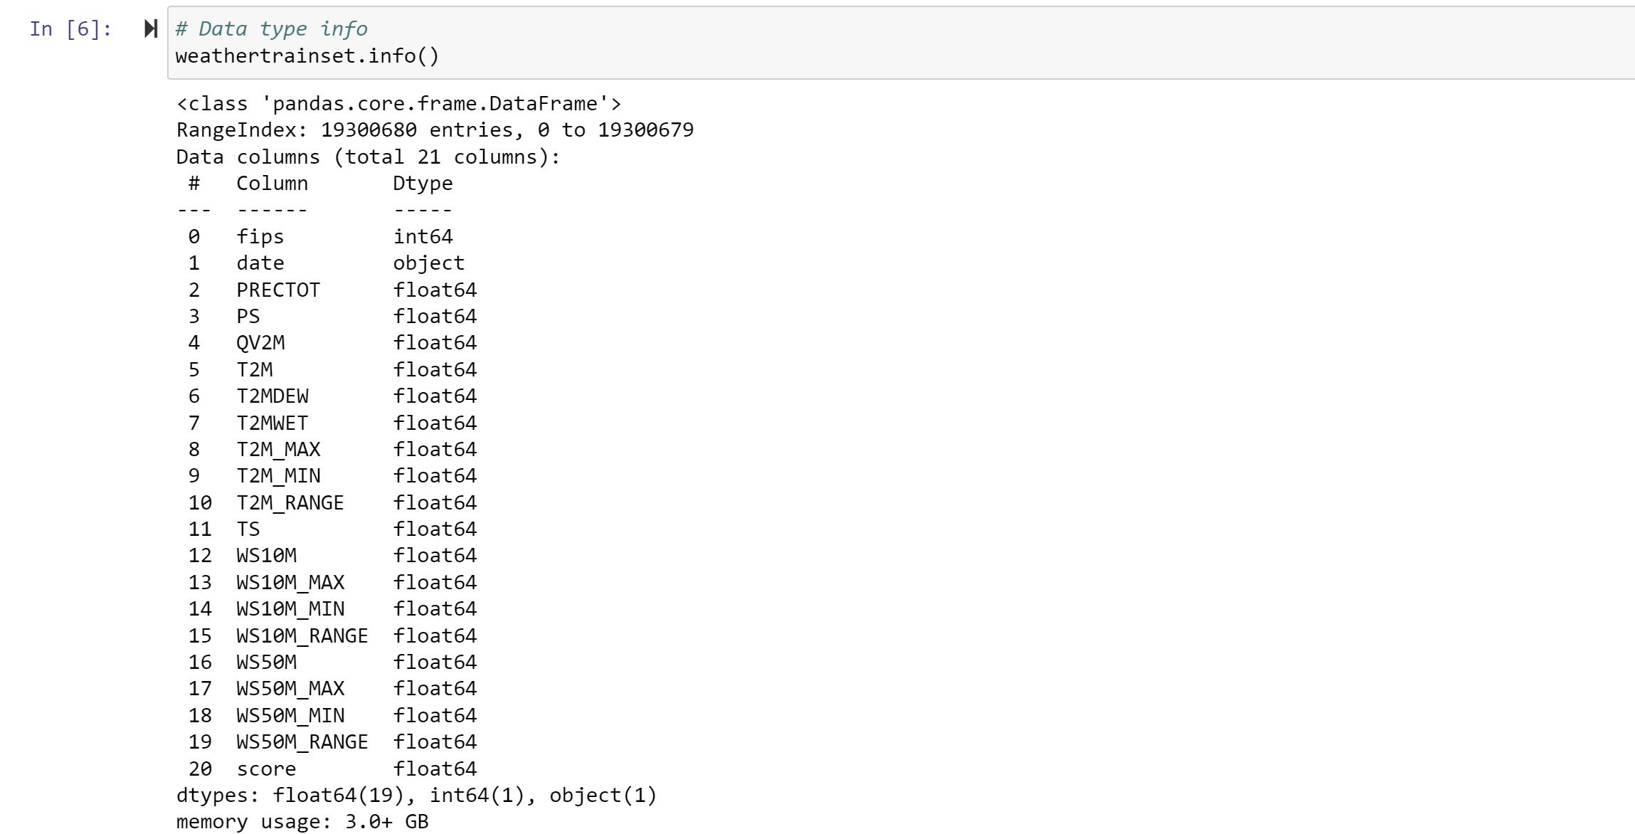

Figure 6 Features and its datatype

Importance of Temporal Features:

1. Month Extraction: Identifies seasonal variations, which are critical in understanding weather patterns and their impact on drought conditions.
2. Year Extraction: Helps capture long-term changes and trends, providing a macro-level temporal context.
3. Day Extraction: Allows for a finer granularity of temporal data, enabling the model to capture variations within specific months.

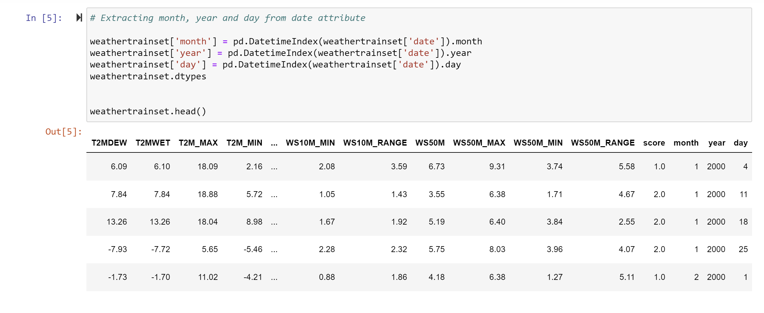

Figure 7 Dataset preview after extracting month, year, and day from date attribute

* Outlier removal- Removing extreme value data points ensure that they do not knew data analysis or training of the model. This is achieved by following the 3-sigma rule where outliers from each feature in the dataset are removed by keeping only those rows where feature values lie within three standard deviations of the mean.

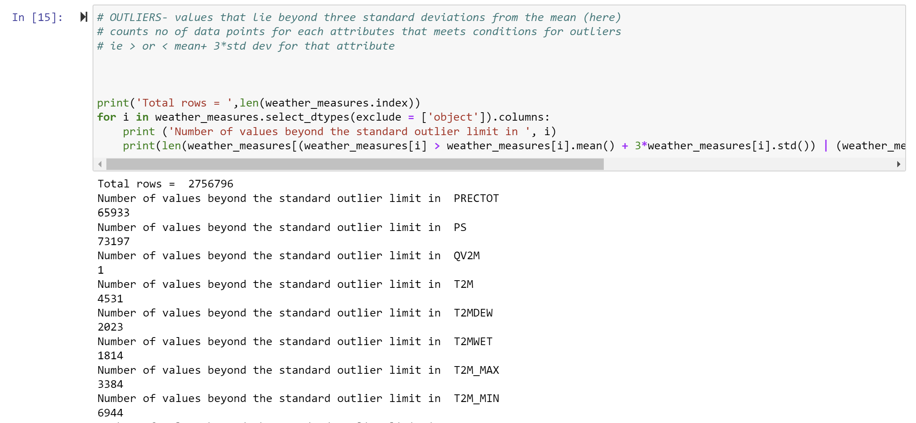

Figure 8 Number of values beyond outlier limit for each feature – I

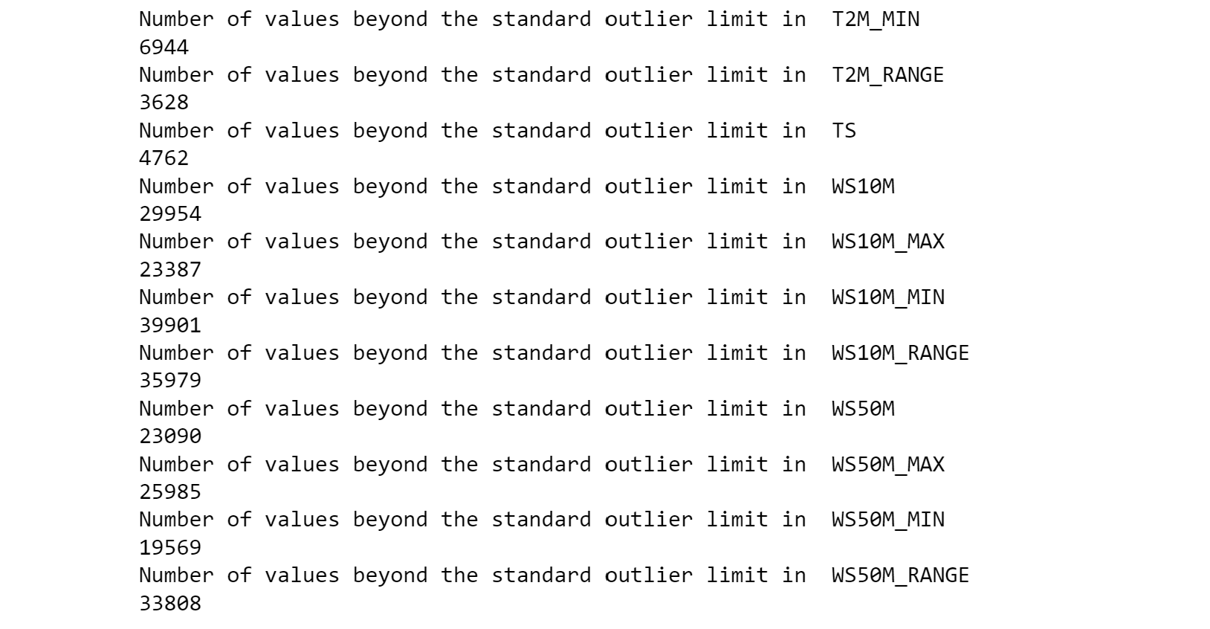

Figure 9 Number of values beyond outlier limit for each feature – II

This ensures that data points significantly deviating from the norm, which could unduly influence model training, are excluded.

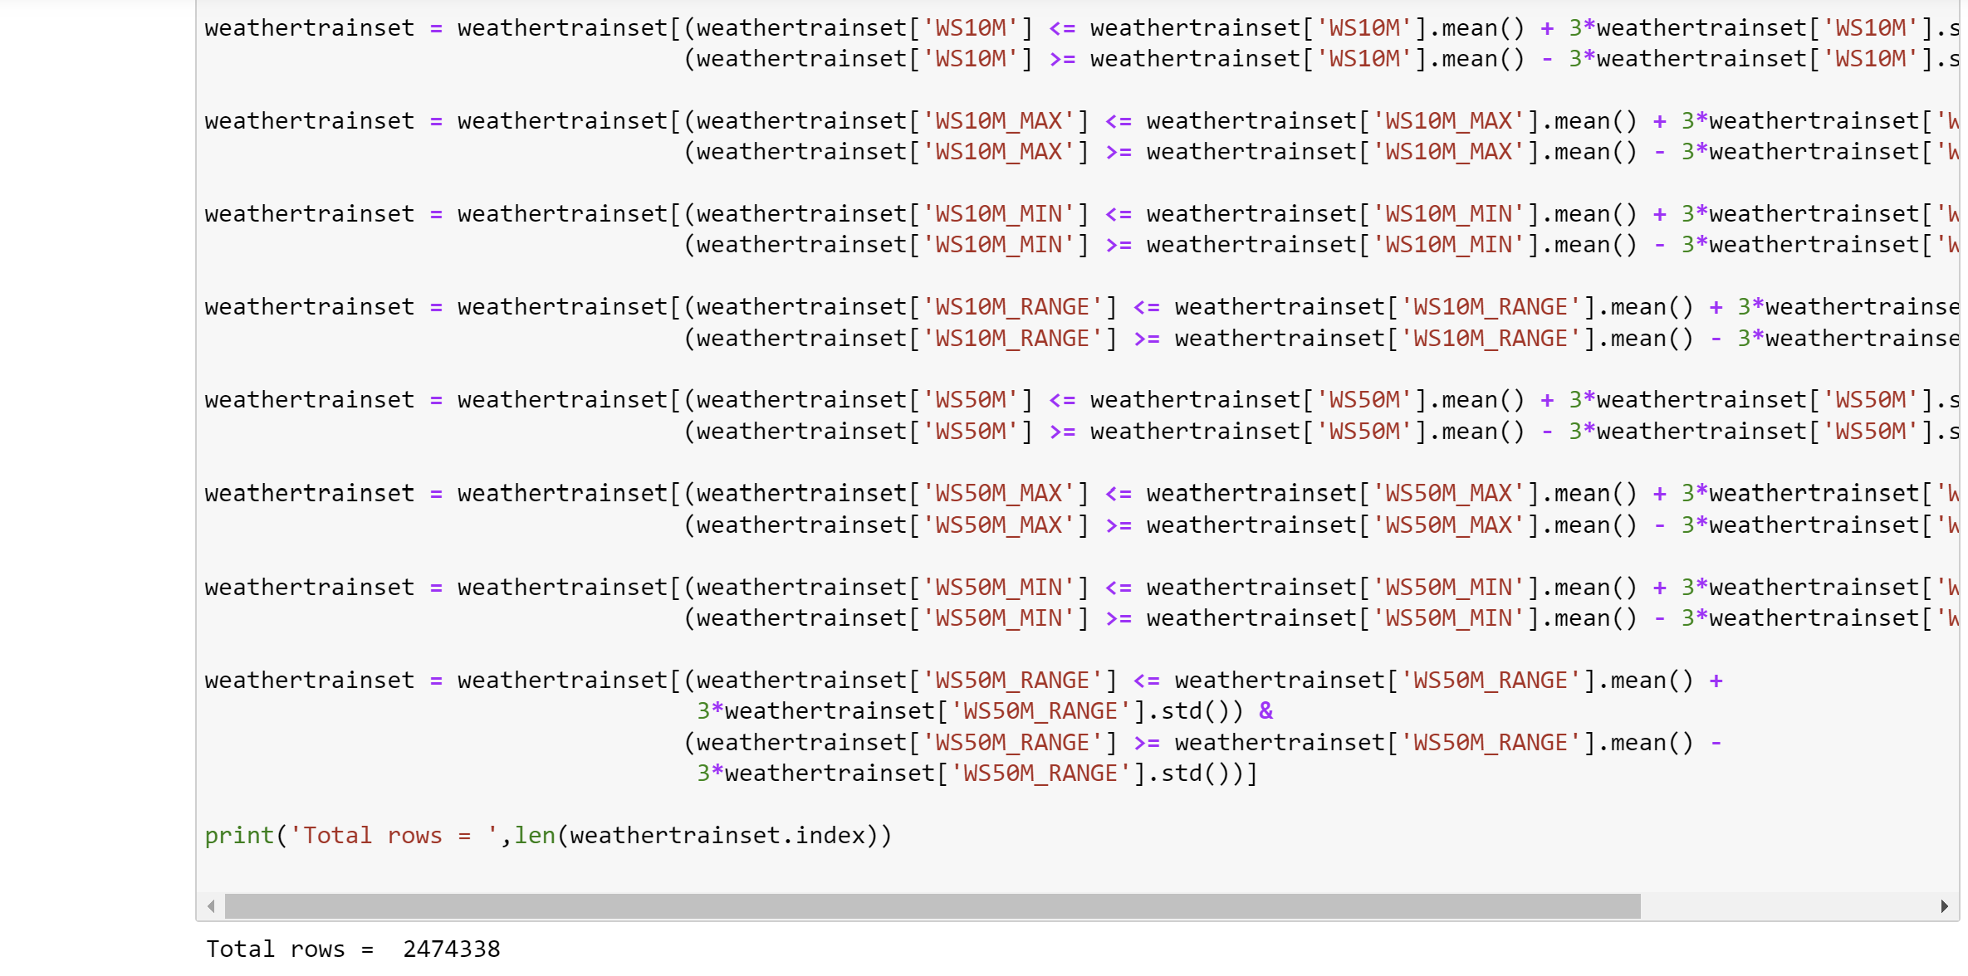

Figure 10 Row count post outlier removal

* Merging meteorological and soil datasets- The meteorological and soil datasets were merged to form a unified dataset for training, validation, and testing for enhancing the predictive capability of the drought models. The soil dataset, which provides important information about various soil characteristics such as slope, elevation, and land type, was merged with the respective meteorological data for each subset—train, test, and validation. This merging was done based on the common attribute, the county FIPS code ( Figure 11). Thus, each record in the combined dataset reflects both the weather conditions and soil properties of a specific location and time. By integrating these complementary data sources, the resulting dataset provides a more comprehensive input for the machine learning models, capturing both atmospheric and terrestrial factors influencing drought conditions ( Figure 12).



Figure 11 Code for merging soil and meteorological data based on fips code

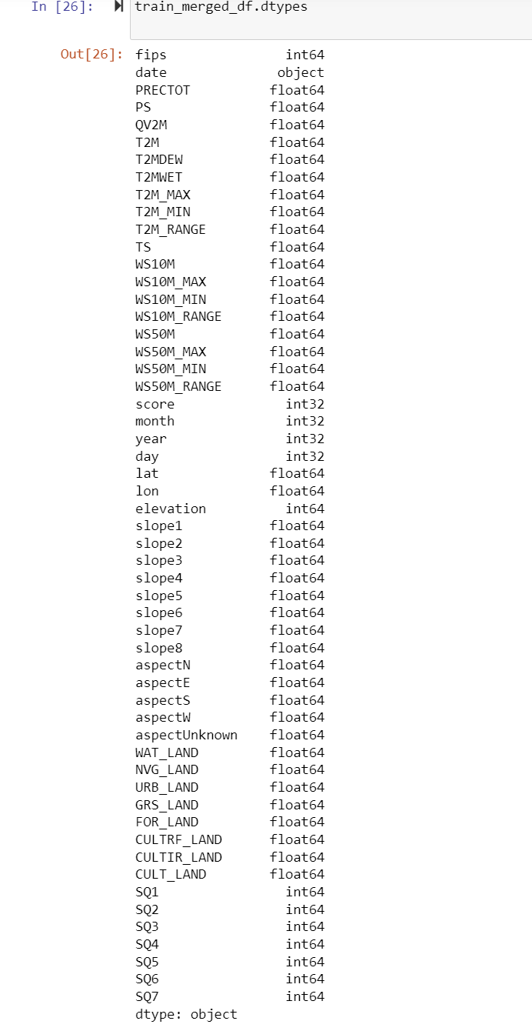

Figure 12 Unified train dataset

* Converting target variable score to integer type- Since this research involves a classification problem with numerical target classes, it was essential to convert the score variable from a float to an integer type. This conversion facilitates effective training and evaluation of the machine learning model by ensuring that the target variable is correctly interpreted as discrete numerical classes rather than continuous values. By explicitly converting the score values to integers, the data, thereby is standardized facilitating the modeling process and ensuring that the variable is properly recognized as a categorical target during the classification tasks.

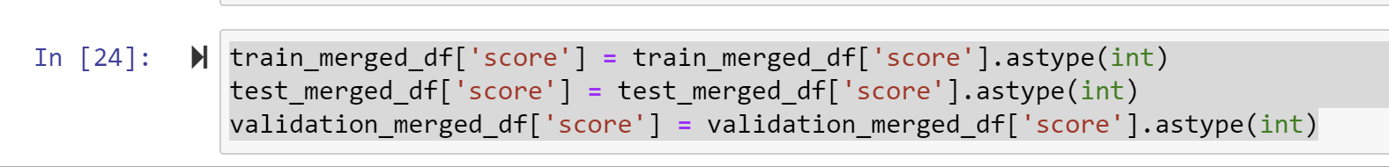

Figure 13 Conversion of target variable to int type

* Scaling- It is essential to scale the data when the data involved in a machine learning process is of varying magnitude and units. Therefore, to ensure that the machine learning models can effectively learn from the data, scaling was performed on the training, validation and testing datasets. The StandardScaler was used to standardize the features by removing the mean and scaling to unit variance. The scaler was first fitted to the training data (X_train) to compute the necessary parameters (mean and standard deviation), and then applied to transform the training, test, and validation datasets (X_train, X_test, and X_validation, respectively). This process ensures that all data sets are scaled consistently, which helps improve the performance and stability of the machine learning models during training and evaluation.

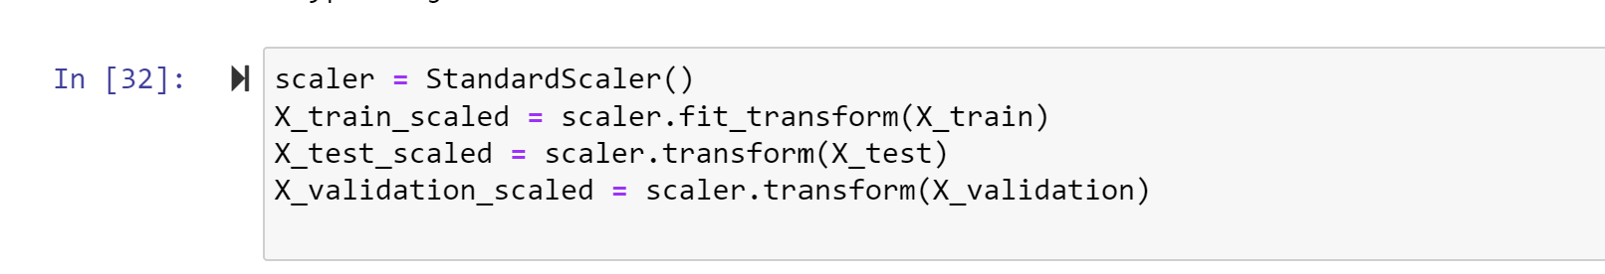

Figure 14 Scaling of train, validation and test data

* Dealing with dataset imbalance- The dataset exhibited a significant class imbalance, with a disproportionately high number of instances corresponding to the target variable class 0. To address this issue and prevent the imbalance from negatively impacting model performance, various techniques were employed. Specifically, algorithms like SMOTE, along with up sampling and down sampling methods, were applied in conjunction with selected models. These strategies aimed to balance the class distribution, thereby enhancing the model's ability to make accurate predictions across all classes.

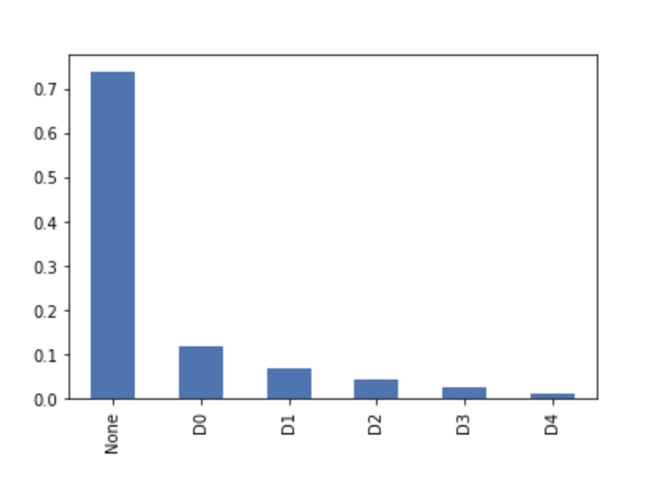

Figure 15 Dataset imbalance representation before removing NaN values-with drought scores on x-axis

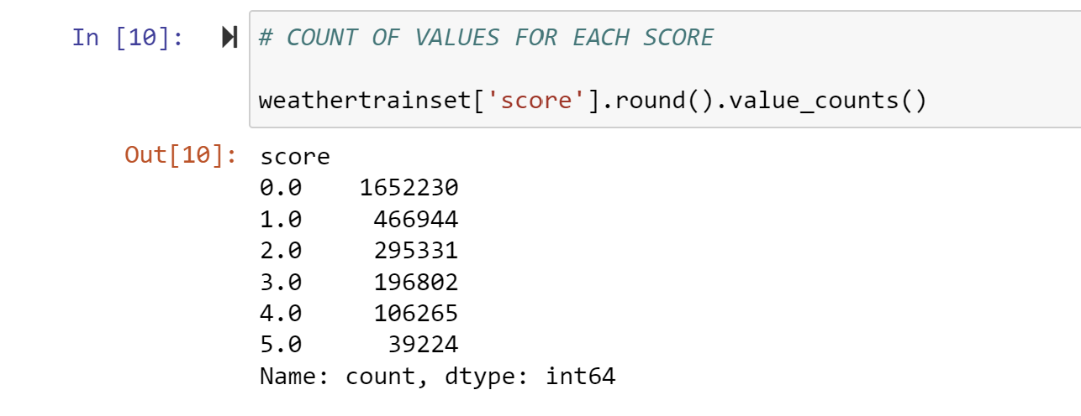

Figure 16 Class imbalance

## 3.3 Model

The success of machine learning models in drought prediction relies not only on high-quality data but also on the proper selection, training, and evaluation of the models. This section outlines the process of model development, from selecting suitable algorithms to rigorous training and evaluation procedures. It details the methods and strategies used to build robust models capable of effectively predicting drought conditions.

### 3.3.1 Model Selection

In this research, a diverse range of machine learning models and techniques were explored to determine the most effective approach for drought prediction. The selection process involved experimenting with multiple algorithms, feature engineering techniques, and data sampling methods to identify the best-performing models. The choice of algorithms was decided not only by their theoretical strengths but also by insights gained from the literature review, which highlighted their successful applications in similar predictive tasks.

|  |  |  |
| --- | --- | --- |
| S. No | Algorithm | Description |
| 1 | Random Forest with RFE | Recursive Feature Elimination for feature selection |
| 2 | K-Nearest Neighbours (KNN) with SMOTE | SMOTE for handling class imbalance |
| 3 | AdaBoost with PCA and SMOTE | Principal Component Analysis and SMOTE for dimensionality reduction and class balancing |
| 4 | Gradient Boosting with PCA and SMOTE | PCA and SMOTE combined for model training |
| 5 | XGBoost with PCA and SMOTE and GridSearchCV | Enhanced XGBoost with PCA, SMOTE, and hyperparameter tuning |
| 6 | Decision Tree | Basic Decision Tree model |
| 7 | Decision Tree with PCA | Decision Tree with Principal Component Analysis |
| 8 | Decision Tree with Downsampling | Decision Tree with down sampled data for class balancing |
| 9 | Decision Tree with Upsampling | Decision Tree with up sampled data for class balancing |
| 10 | Decision Tree with SMOTE | Decision Tree with SMOTE for class balancing |
| 11 | Decision Tree with SMOTE and PCA | Decision Tree with both SMOTE and PCA |
| 12 | K-Nearest Neighbours (KNN) (k=5) | K-Nearest Neighbours (KNN) (k=5) |
| 13 | ANN with SMOTE and PCA | Artificial Neural Network with SMOTE and PCA |
| 14 | Random Forest with RFE and GridSearchCV | A Random Forest model optimized using Recursive Feature Elimination (RFE) and hyperparameters tuned with GridSearchCV. |

Figure 17 Algorithms utilised for model creation

To effectively evaluate the models' performance, various combinations of algorithms and preprocessing methods were trained on both a subset of the data and the complete dataset. This approach ensured a thorough exploration of each model’s potential while dealing with the computational constraints for the training process.

### 3.3.2 Model Training

Model training involved fitting the selected algorithms to the prepared datasets to optimize their predictive performance. Due to computational constraints and varying complexities of the models, some algorithms were trained on a smaller subset of the data, while others were trained on the complete dataset. The training process included the application of techniques such as feature selection, dimensionality reduction, and class balancing methods to enhance model accuracy and address class imbalance issues. Each model was rigorously trained using appropriate hyperparameter tuning methods to achieve the best performance in predicting drought conditions.

Models Trained on a Subset of Data:

Some models, particularly those that were computationally intensive, were trained on a smaller subset of the data due to resource limitations. Specifically, a subset of 19,000 records (approximately 0.1% of the total 19 million dataset) was used for training these models. This approach allowed for efficient experimentation and optimization without overwhelming computational resources.

1. **Random Forest with Recursive Feature Elimination (RFE) and GridSearchCV:** Selected for its ability to identify important features and optimize hyperparameters, although it was computationally intensive.

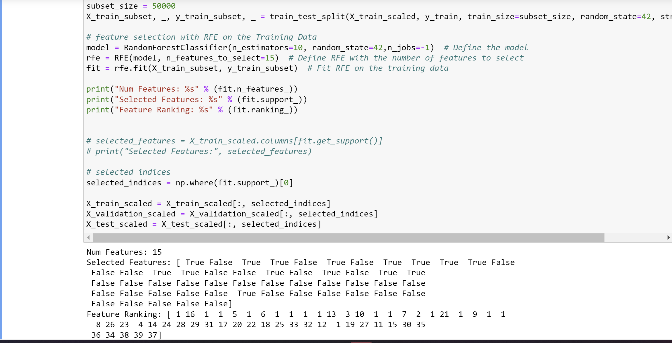

Figure 18 Recursive Feature Elimination

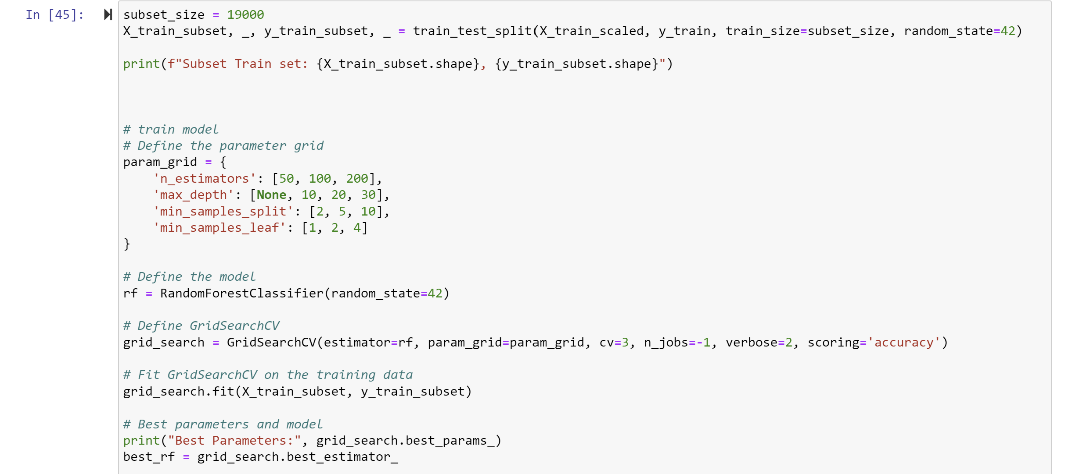

Figure 19 Random forest classifier and GridSearchCV

1. **AdaBoost with PCA and SMOTE:** Combined boosting with dimensionality reduction and class balancing techniques, requiring significant processing power.

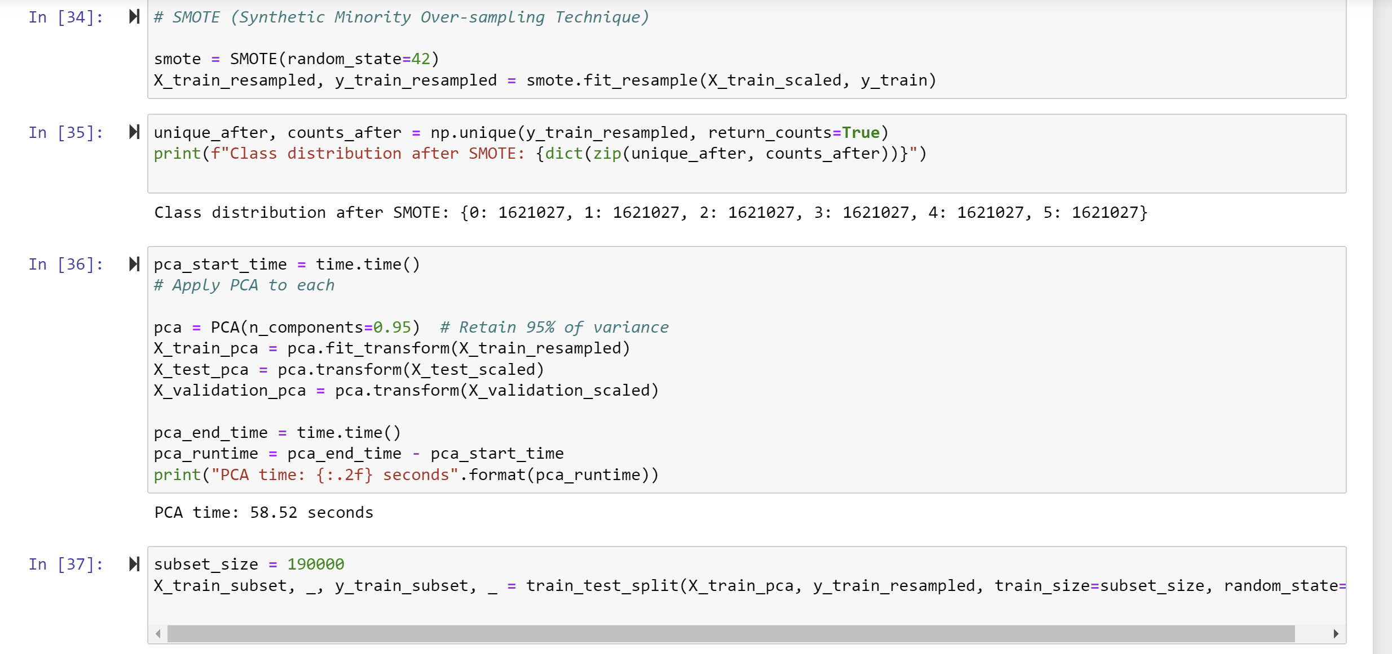

Figure 20 SMOTE and PCA

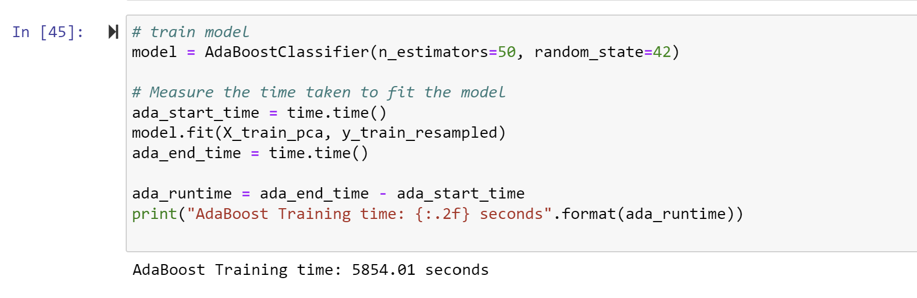

Figure 21 AdaBoost

1. **Gradient Boosting with PCA and SMOTE:** Employed for its robustness, though testing was limited to a subset due to the high computational cost.

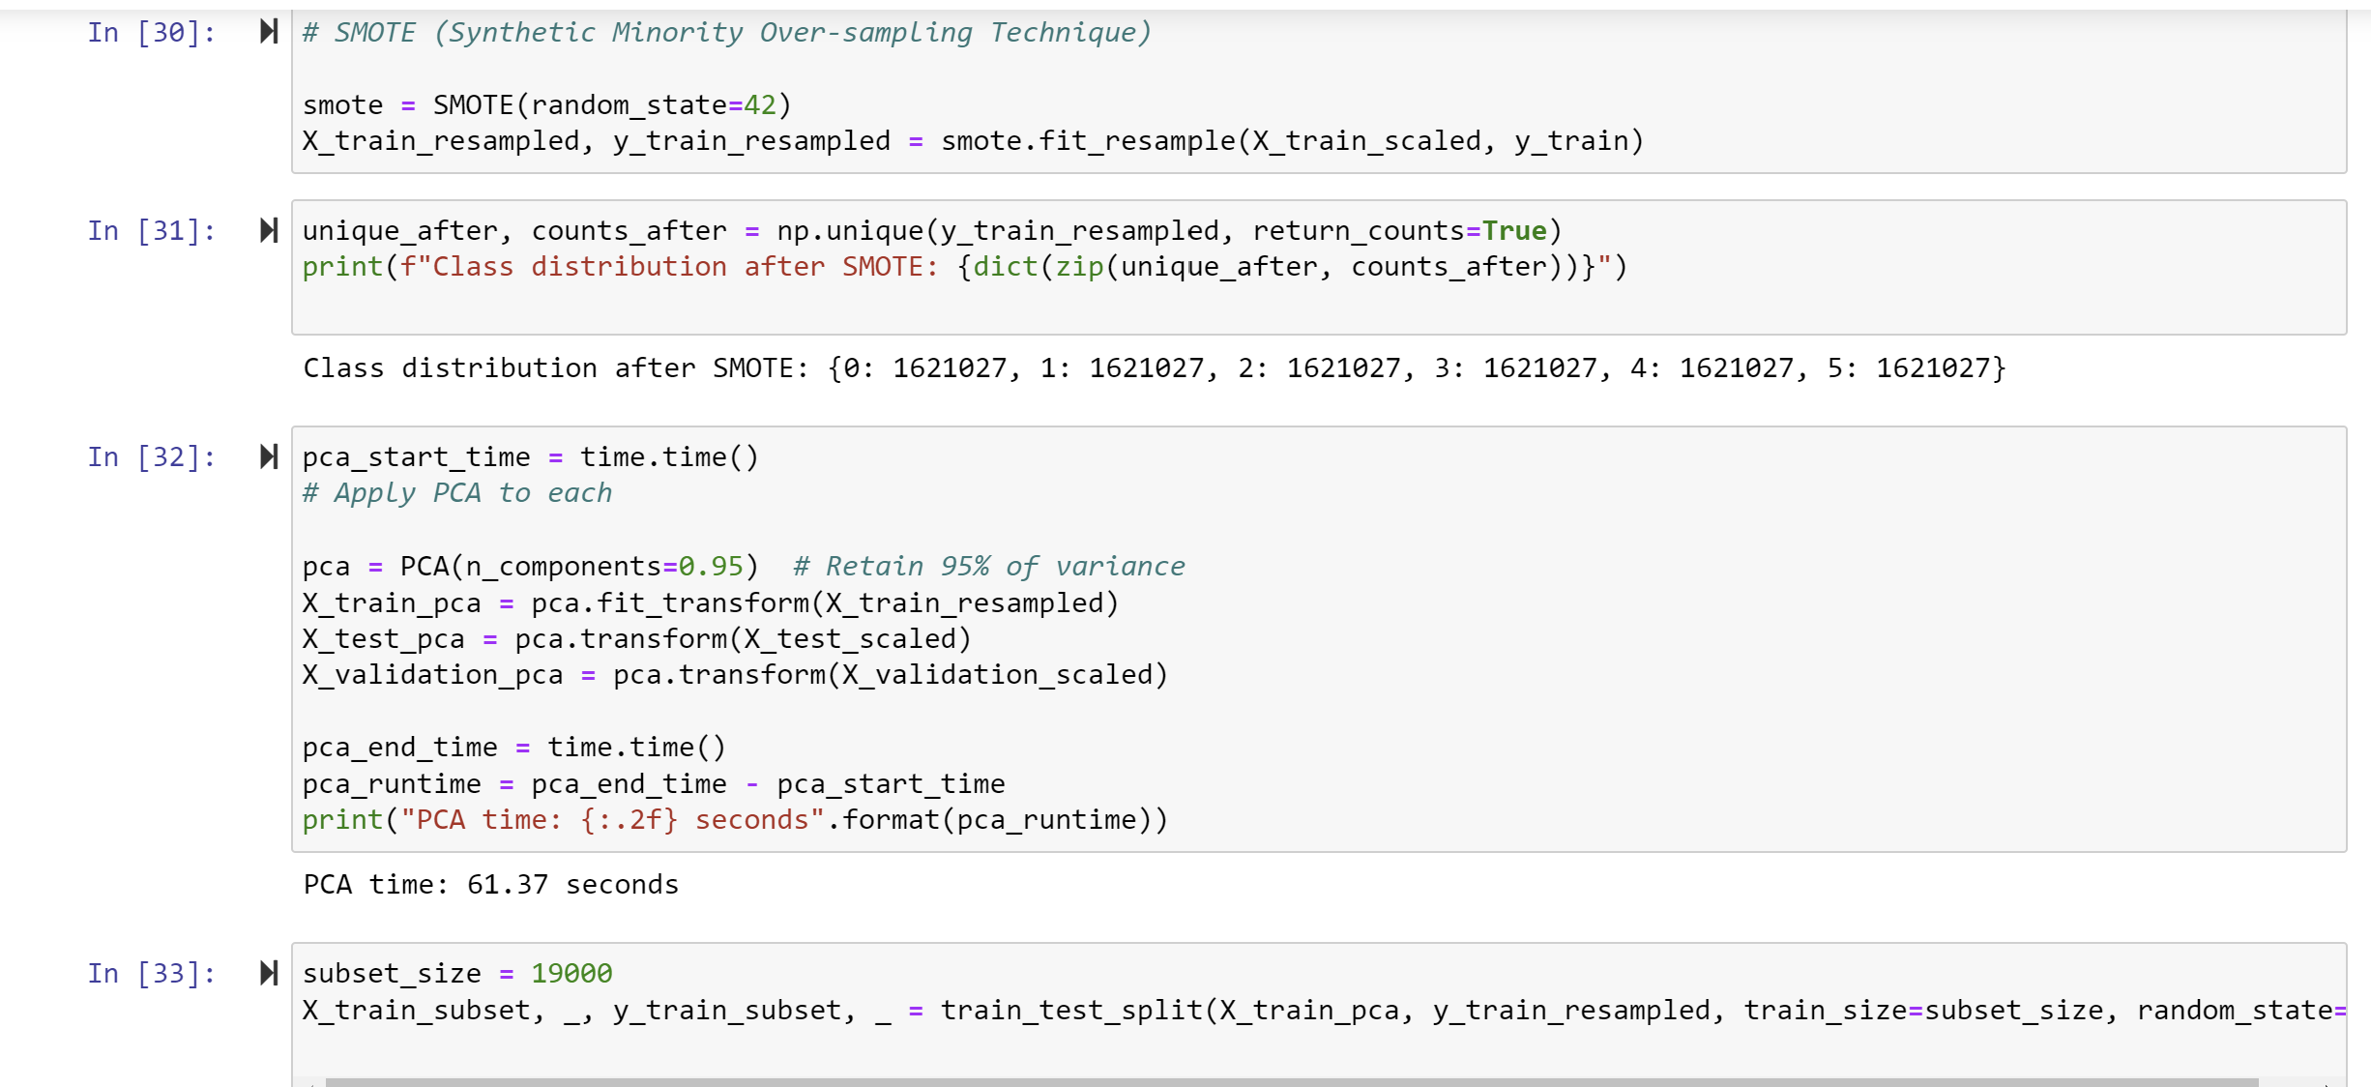

Figure 22 SMOTE and PCA

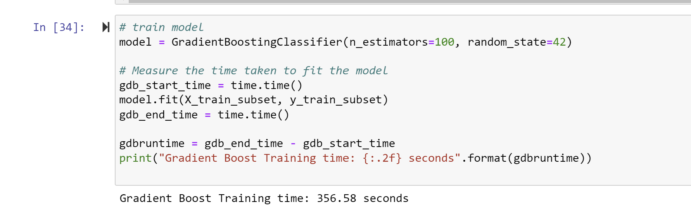

1. **XGBoost with PCA, SMOTE, and GridSearchCV:** Included for its powerful ensemble capabilities, but restricted to a subset to manage execution times.

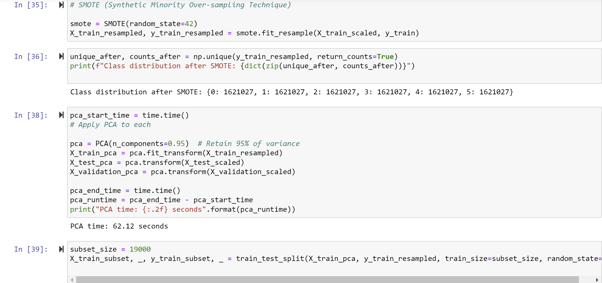

Figure 23 SMOTE and PCA

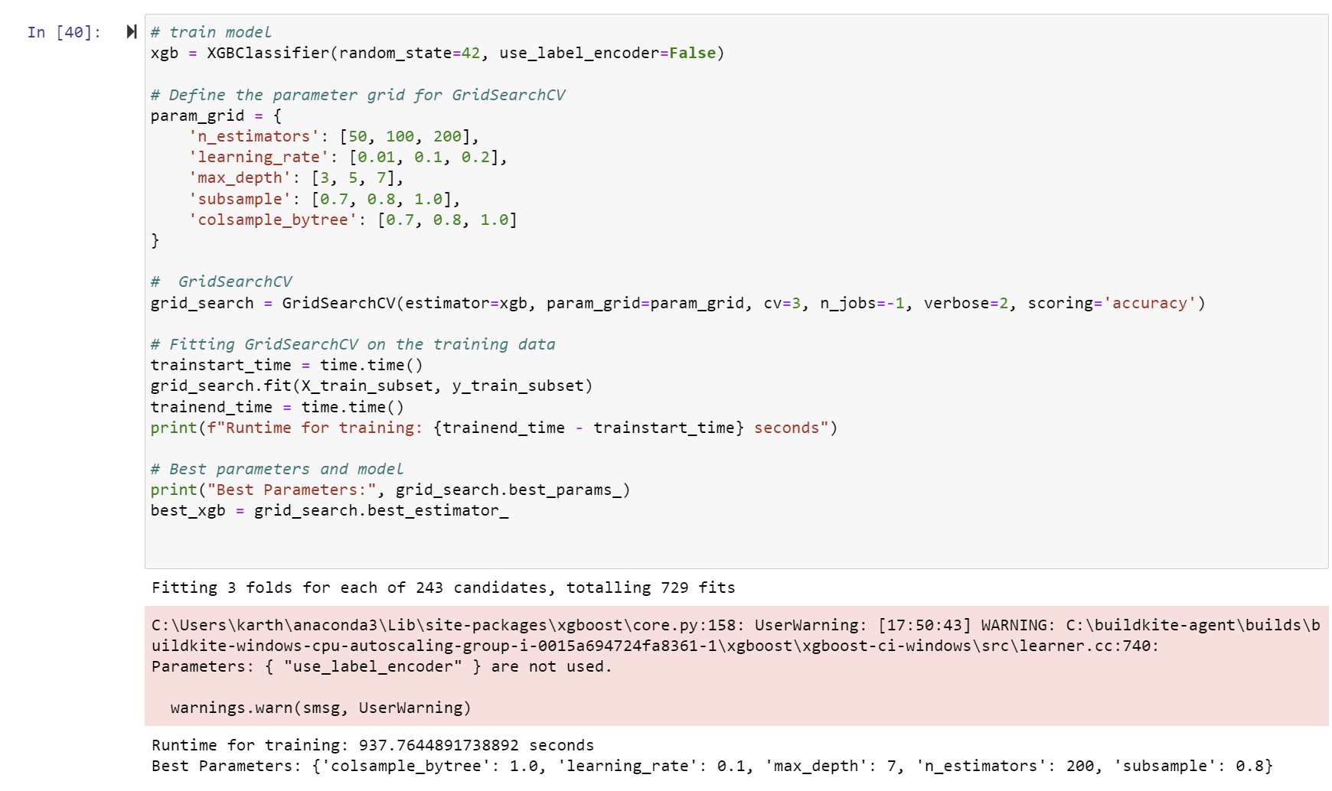

Figure 24 XGBoost and GridSearchCV

1. **KNN (k=5):** A simpler model that was tested for its efficiency and effectiveness in handling smaller data segments.

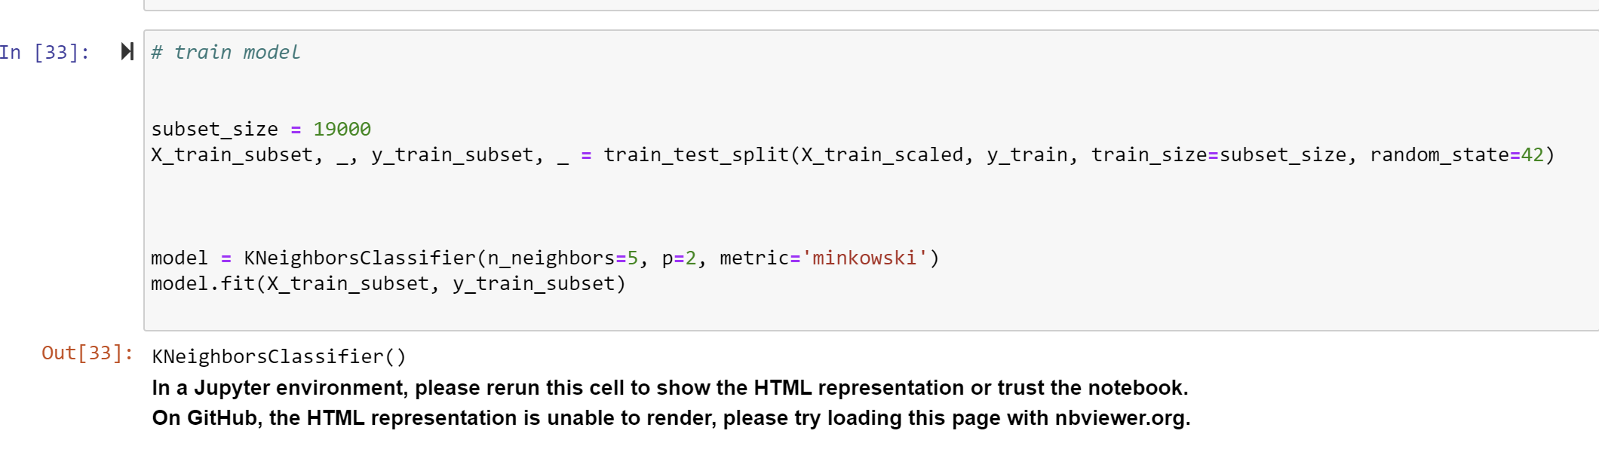

Figure 25 k nearest neighbour classifier with k=5

1. **K-Nearest Neighbors (KNN) with SMOTE:** Implemented to handle class imbalance, with SMOTE enhancing the prediction of minority classes.

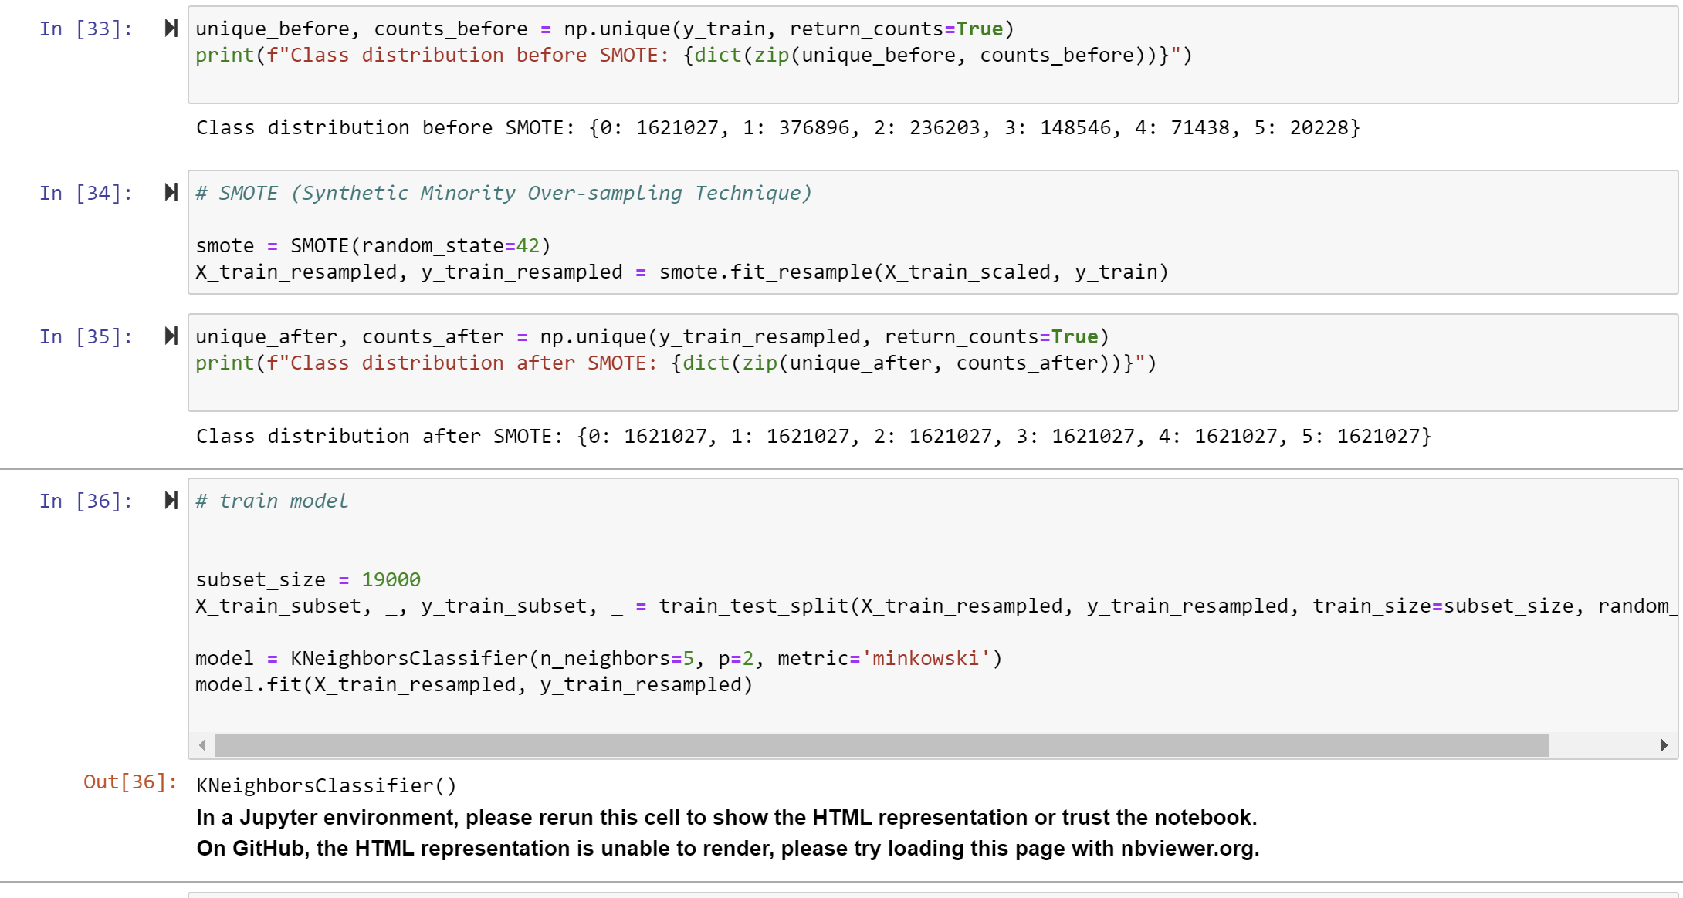

Figure 26 k nearest neighbours with k=5 and SMOTE

**Models Trained on the Whole Dataset:**

1. **Decision Tree:** A baseline model used for its interpretability and relatively low computational requirements.

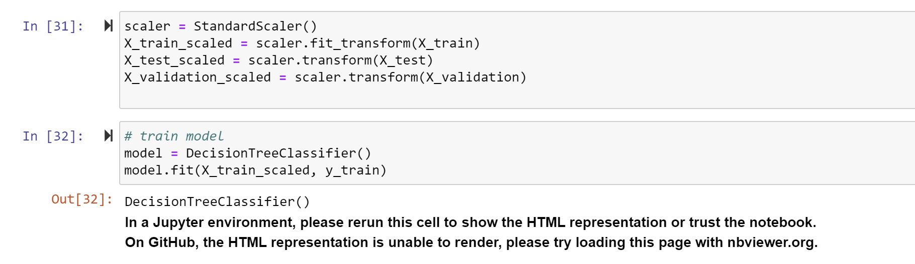

Figure 27 Decision Tree

1. **Decision Tree with PCA:** Assessed the impact of dimensionality reduction on the decision tree's performance.

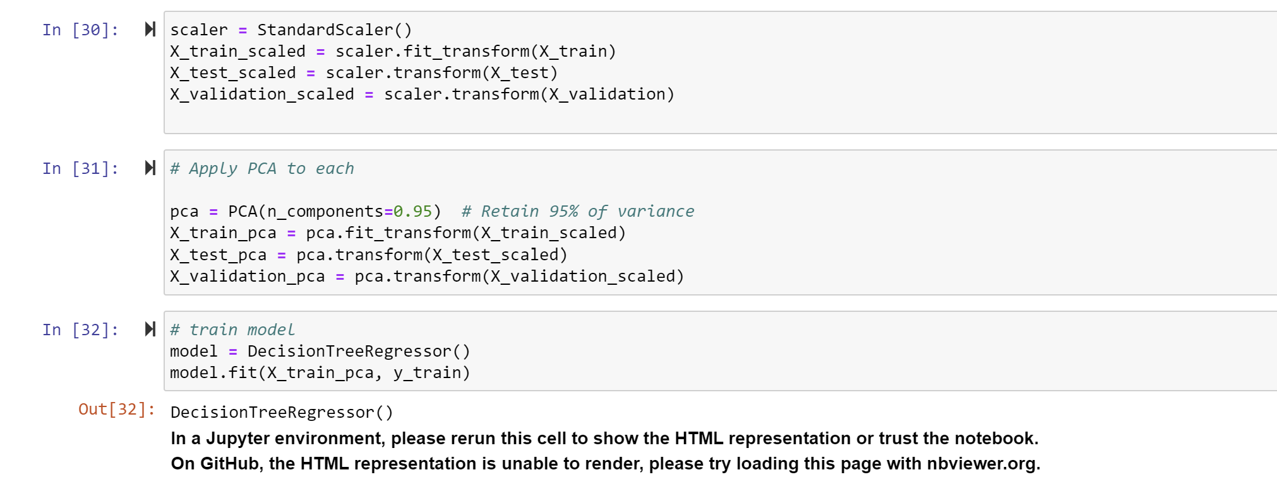

Figure 28 Decision tree with PCA

1. **Decision Tree with Downsampling:** Tested to correct class imbalance by reducing the majority class size.

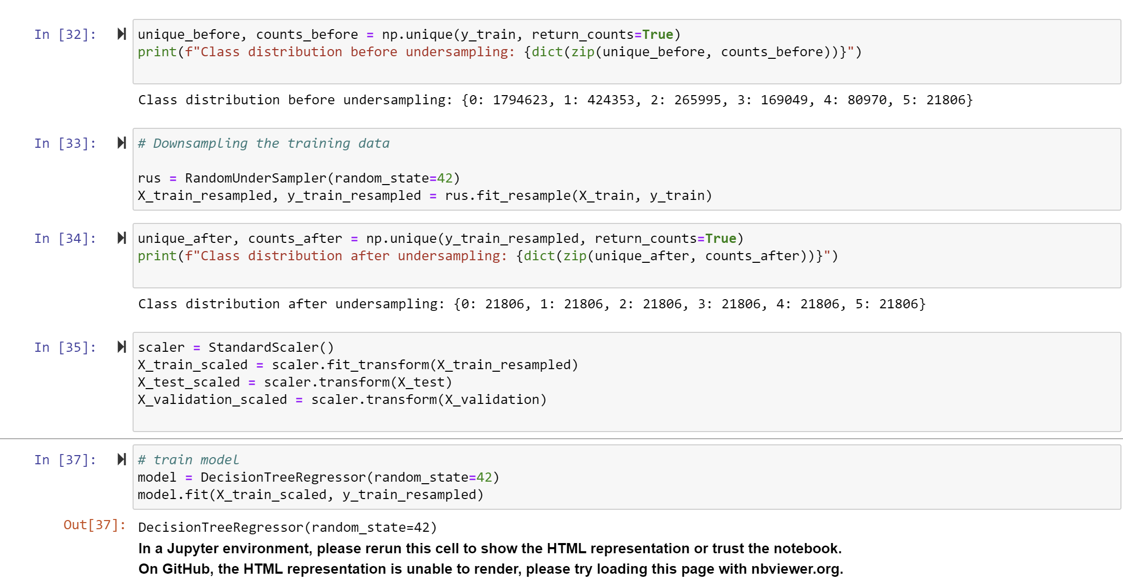

Figure 29 Decsion tree with down sampling

1. **Decision Tree with Upsampling:** Used to balance the dataset by increasing the minority class size.

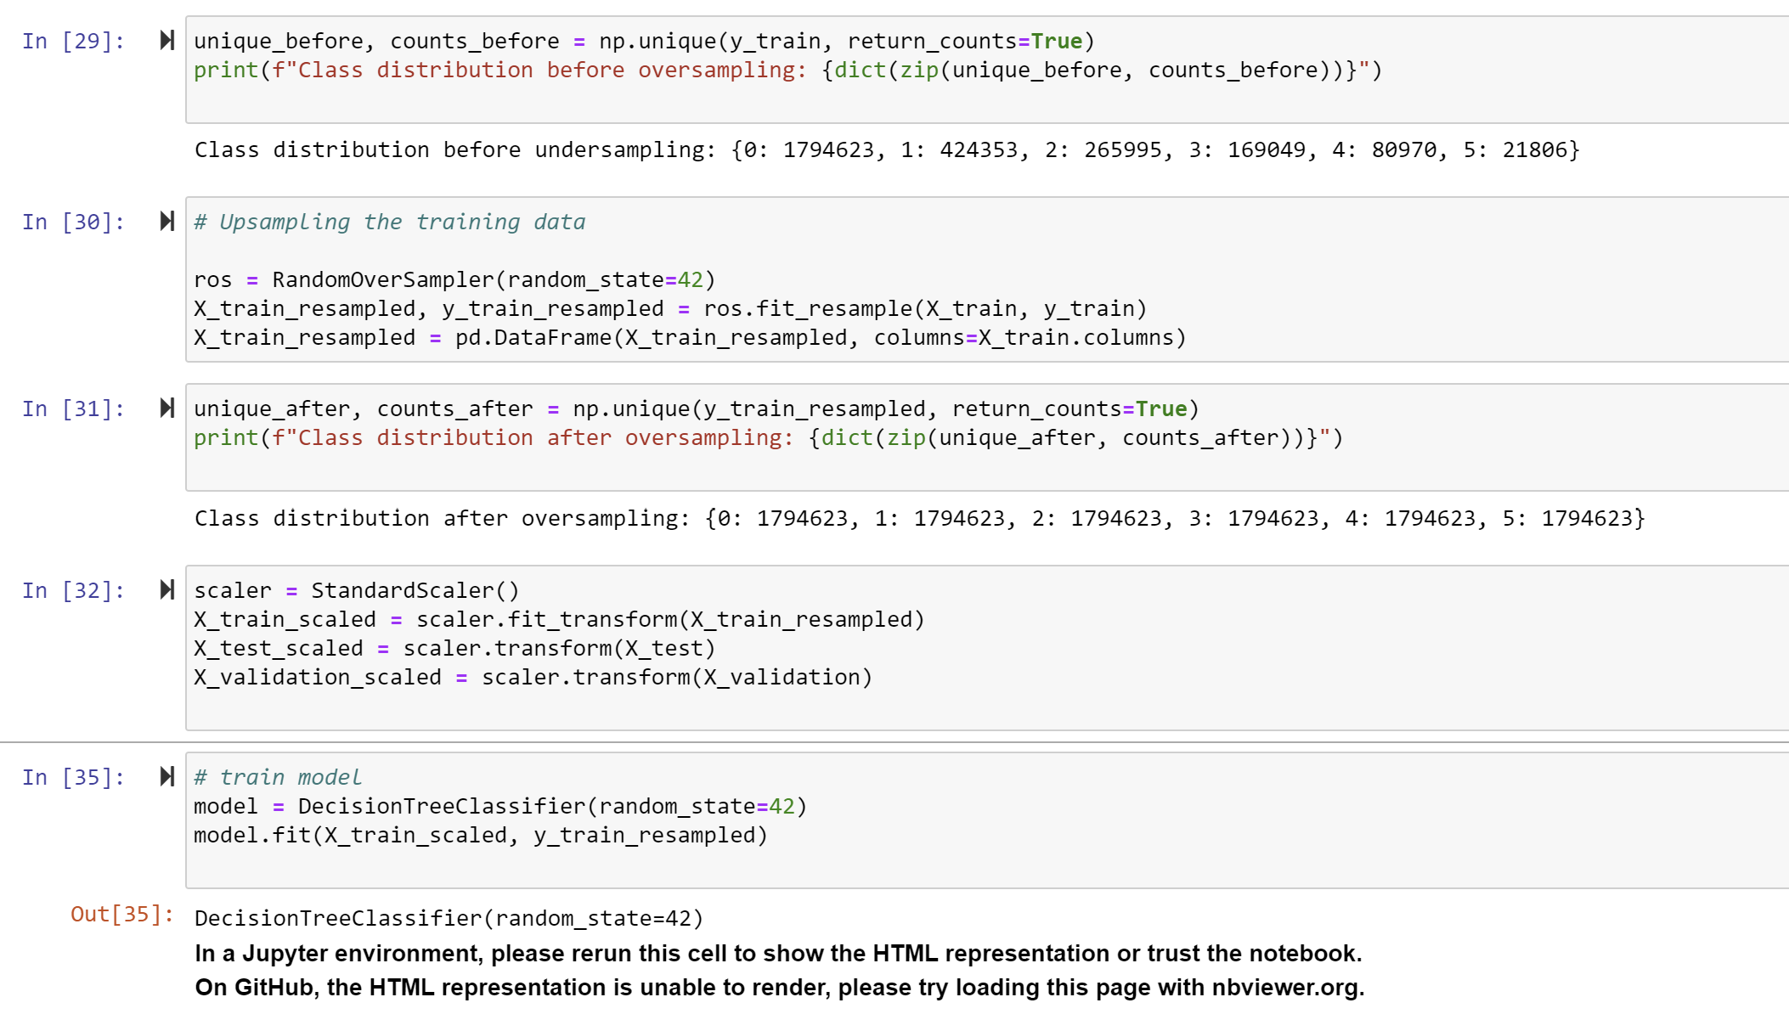

Figure 30 Decision tree with up sampling

1. **Decision Tree with SMOTE:** Employed SMOTE to improve the prediction of minority classes on the full dataset.

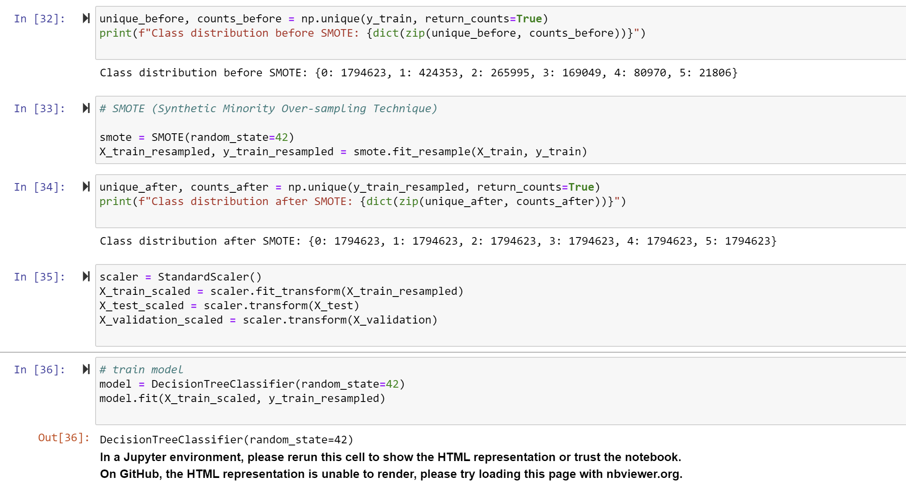

Figure 31 Decision tree with SMOTE

1. **Decision Tree with SMOTE and PCA:** Combined SMOTE and PCA to evaluate their combined effect on model accuracy.

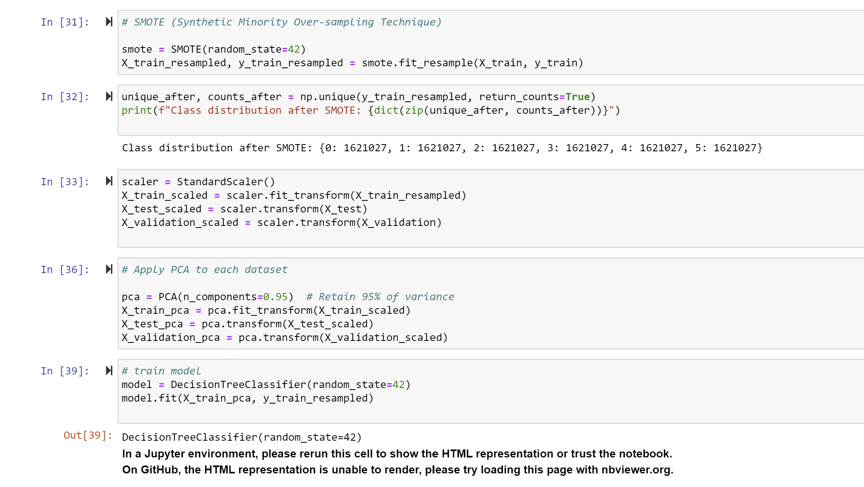

Figure 32 Decision tree with SMOTE and PCA

1. **Random Forest with RFE:** Evaluated on the full dataset to determine feature importance and refine predictions.

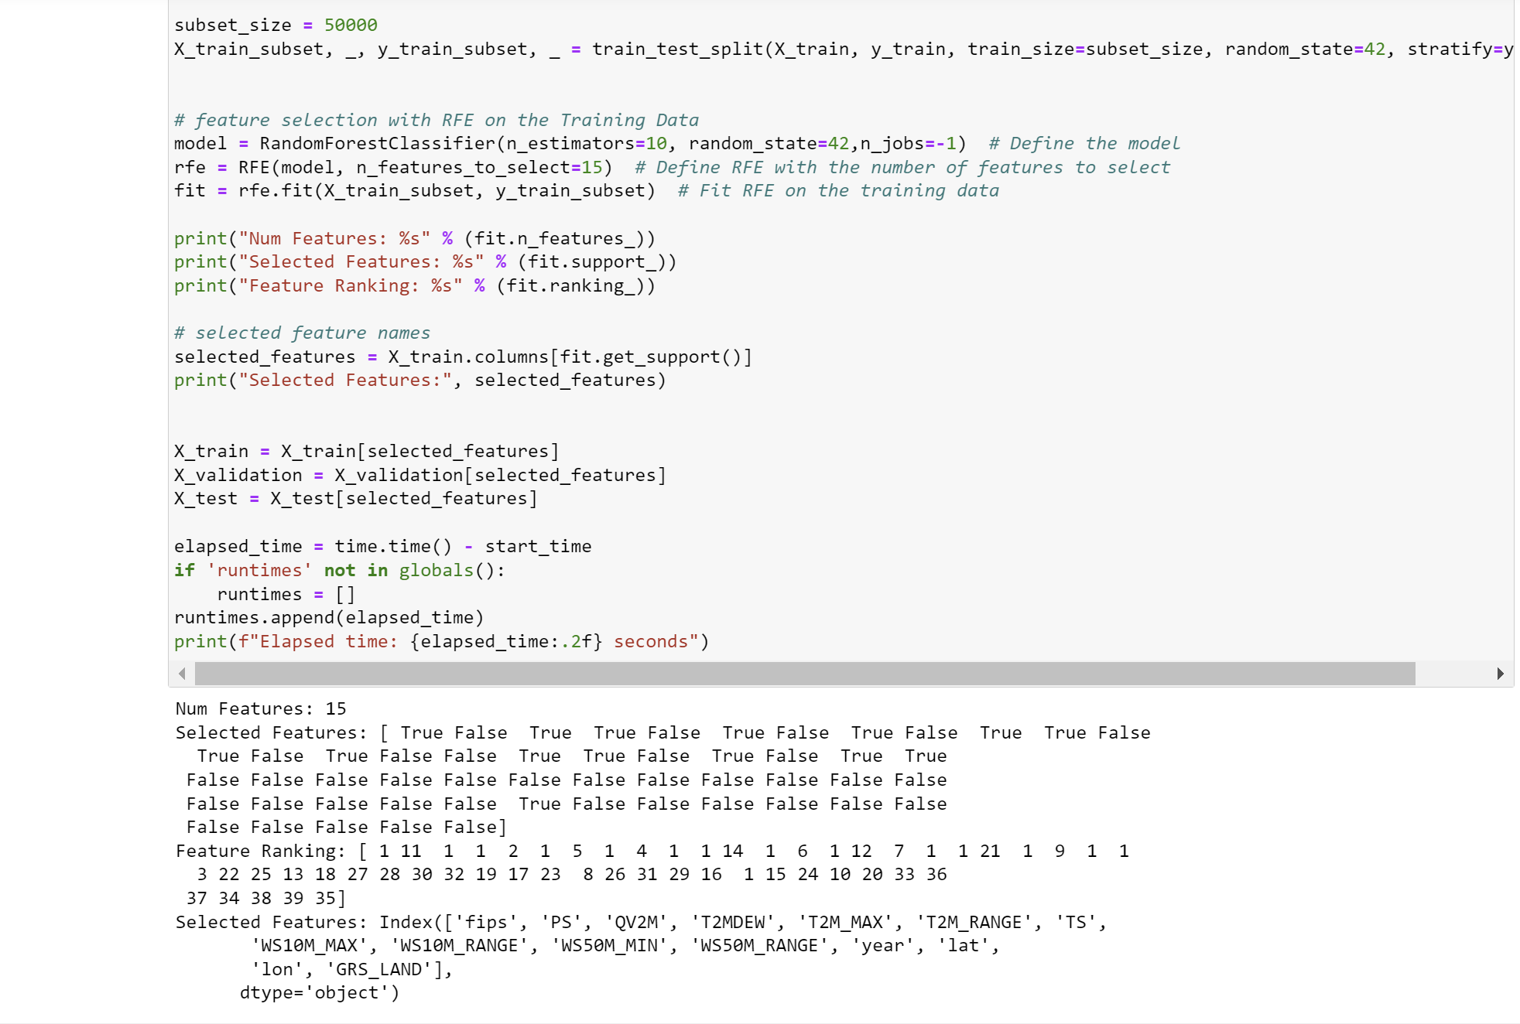

Figure 33 RFE

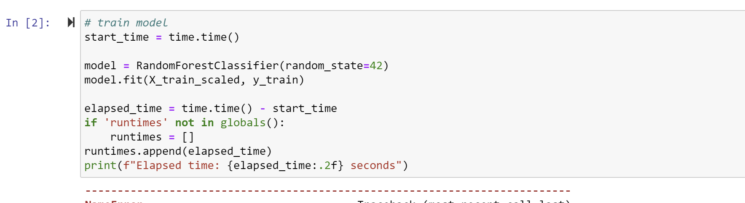

Figure 34 Random forest classifier

1. **AdaBoost with PCA and SMOTE:** Tested on the entire dataset to explore the benefits of boosting in conjunction with PCA and SMOTE.



Figure 35 SMOTE and PCA



Figure 36 Adaboost on entire dataset

1. **Artificial Neural Network (ANN) with SMOTE and PCA:** Utilized to capture complex patterns, incorporating SMOTE and PCA to optimize neural network performance.

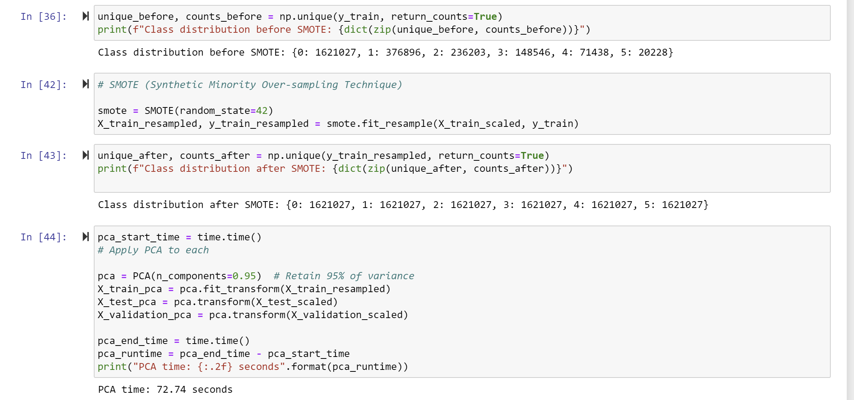

Figure 37 SMOTE and PCA

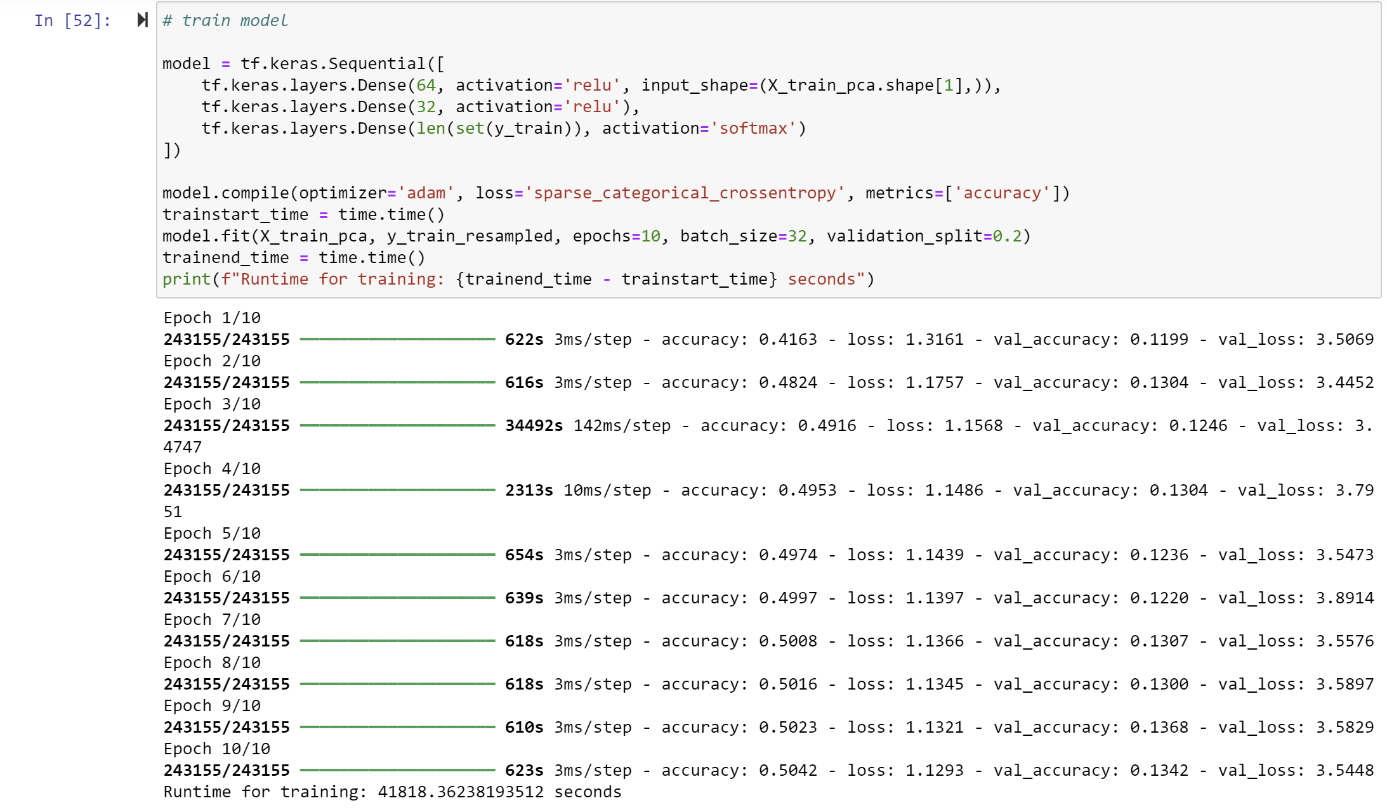

Figure 38 ANN

In total, 14 different algorithms were employed to train the data, leveraging various preprocessing techniques and hyperparameter tuning strategies. This comprehensive approach ensured that the models were adequately optimized to handle the complexities of drought prediction, providing a robust evaluation of their effectiveness in real-world applications.

### 3.3.3 Validation and Testing

With the help of validation sets, hyperparameters were further fine-tuned. Once the model parameters were finalized, the model was evaluated on the test set, which was not used during training or validation. This final test provided an unbiased assessment of the model's performance on unseen data, ensuring that the results accurately reflect its ability to generalize.

### 3.3.4 Model Evaluation

To assess the performance of the trained machine learning models, various evaluation metrics were employed, including accuracy, precision, recall, F1 score, and confusion matrix analysis. These metrics provide a comprehensive evaluation of the models, capturing not only the overall correctness of predictions (accuracy) but also the balance between correctly identified drought levels (precision), the ability to detect true drought occurrences (recall), and the harmonic mean of precision and recall (F1 score). The confusion matrix further breaks down the performance by showing the distribution of correct and incorrect predictions across each drought class, offering insights into the models' strengths and areas needing improvement.

Performance metrics on test data of models trained on whole data set:

|  |  |  |  |  |  |
| --- | --- | --- | --- | --- | --- |
| S. No | Model | Accuracy | Precision | Recall | F1-score |
| 1 | Random Forest with RFE | 0.78 | 0.71 | 0.78 | 0.74 |
| 2 | AdaBoost with PCA and SMOTE | 0.4642 | 0.7464 | 0.4642 | 0.5180 |
| 3 | Decision Tree | 0.60 | 0.72 | 0.60 | 0.65 |
| 4 | Decision Tree with PCA | 0.57 | 0.70 | 0.57 | 0.63 |
| 5 | Decision Tree with Downsampling | 0.51 | 0.71 | 0.51 | 0.59 |
| 6 | Decision Tree with Upsampling | 0.66 | 0.71 | 0.66 | 0.68 |
| 7 | Decision Tree with SMOTE | 0.64 | 0.70 | 0.64 | 0.67 |
| 8 | Decision Tree with SMOTE and PCA | 0.55 | 0.70 | 0.55 | 0.61 |
| 9 | |  | | --- | |  |   ANN with SMOTE and PCA | 0.7951 | 0.6945 | 0.7951 | 0.7328 |

Table 6 Performance metrics on test dataset for models trained on whole dataset

Performance metrics on test data of models trained on subset of data set (0.1%):

|  |  |  |  |  |  |
| --- | --- | --- | --- | --- | --- |
| S. No | Model | Accuracy | Precision | Recall | F1-score |
| 1 | Random Forest with RFE and GridSearchCV | 0.81 | 0.70 | 0.81 | 0.74 |
| 2 | KNN with SMOTE | 0.37 | 0.74 | 0.37 | 0.48 |
| 3 | Adaboost with PCA and SMOTE | 0.5068 | 0.7396 | 0.5068 | 0.5188 |
| 4 | Gradientboost with PCA and SMOTE | 0.5302 | 0.7480 | 0.5302 | 0.5504 |
| 5 | XGBoost with PCA and SMOTE and GridSearchCV | 0.6219 | 0.7378 | 0.6219 | 0.5669 |
| 6 | KNN(k=5) | 0.7682 | 0.6997 | 0.7682 | 0.7293 |

Table 7 Performance metrics on test dataset for models trained on subset of dataset

# Chapter 4 : Product Design and Implementation

Following the model evaluation phase, where the top-performing models were identified based on accuracy metrics, the focus shifted to assessing the efficiency of these models. The next crucial step was to compare the runtime performance of the top three models both on a local environment and on a cloud platform. This comparison aimed to determine the scalability and efficiency of each model in different computing environments.

As per the performance metrics the Random Forest model, optimized with Recursive Feature Elimination (RFE) and GridSearchCV, was the top performing model with an accuracy of 81%. Therefore, the model was chosen to be deployed on a cloud platform as a web application owing to the model's superior accuracy and efficient use of computational resources.

The following sections detail the technology stack used for this project, as well as the specific processes involved in the deployment and web application development.

## 4.1 Technology Stack

The successful implementation of this project involved various set of technologies and tools, both locally and in the cloud. The technology stack was meticulously selected to cover the requirements of data processing, model training, and deployment efficiently. Locally, Jupyter Notebook and Anaconda were employed for their powerful capabilities in data analysis and environment management. Python served as the core programming language for developing and evaluating machine learning models. For cloud-based tasks, Amazon Web Services (AWS) was utilized to leverage scalable computing resources. Key AWS services included Amazon SageMaker for model training and deployment, Ngrok for secure local server access, and Flask for creating the web application interface. This combination of technologies enabled a seamless transition from model development to deployment and user interaction. The following sections provide detailed insights into each component of the technology stack and its role in the project.

### 4.1.1 Local Environment

1. **Hardware Specifications:**

* System model: HP Spectre 3x60 2-in-1 laptop
* Processor: 13th Gen Intel(R) Core(TM) i7-1355U 1.70 GHz
* Memory (RAM): 32.0 GB (31.7 GB usable)
* Storage: 952 GB available
* Operating System: Windows 11 Home Single Language
* System type : 64-bit operating system, x64-based processor

1. **Software Environment:**

* Development Environment:
  + Jupyter Notebook: Used for interactive code development and data visualization.
  + Anaconda: Employed as the Python distribution and environment management tool.
* Programming Language:
  + Python: Python 3.11.5 used for data analysis and model development.
* Libraries and Frameworks:
  + Pandas, NumPy: For data manipulation and numerical operations.
  + Scikit-learn: For implementing machine learning algorithms.
  + Matplotlib, Seaborn: For data visualization.
  + UMAP: Utilized for dimensionality reduction and visualization of high-dimensional data.
  + Imbalanced-learn (imblearn): Employed for handling class imbalance using techniques like SMOTE, up sampling, and down sampling.

### 4.1.2 Cloud Environment

1. **Cloud Platform:**

* Amazon Web Services (AWS): Utilized for scalable, cloud-based model training, testing, and deployment.

1. **Instance Configuration:**

* Amazon SageMaker Instance:
  + Instance Types used:

1. ml.m5.xlarge (4 vCPUs, 16 GiB memory)
2. ml.m5.2xlarge (8 vCPUs, 32 GiB memory)
3. ml.t3.medium (2 vCPUs, 4 GiB memory)
4. ml.r5.2xlarge (8 vCPUs, 64 GiB memory)
5. ml.r5.xlarge (4 vCPUs, 32 GiB memory)
   * Storage: 10 GB attached EBS volume.
   * Purpose: Used for efficient training of large datasets and running computationally intensive tasks to monitor and compare runtime.

* Deployment Instance:
  + Instance Type: ml.r5.xlarge - used for hosting the web application
  + Configuration: (4 vCPUs, 32 GiB memory)
  + Cost - $0.32 per hour for Hosting

1. **Software Environment:**

* Development Environment:
  + Jupyter Notebook on SageMaker: Leveraged for code execution, training models, and analysis directly on AWS.
* Programming Language:
  + Python: Version 3.8, consistent with the local environment for smooth code migration.
* Libraries and Frameworks:

In addition to the frameworks used locally, the following were also utilised:

* + Boto3: AWS SDK for Python used for automating interactions with AWS services (e.g., managing S3 buckets, deploying models).
  + Ngrok: Used for secure tunnelling during testing of the locally developed web app.
  + Flask: Employed to build and deploy the web application interface, facilitating data upload and interaction with the deployed model.

1. **Deployment Tools and Services:**

* Amazon S3: Used for storing datasets, trained models, and experiment logs.
* AWS CloudWatch: To monitor logs and events.

## 4.2 Runtime Comparison

Given the large dataset size of approximately 19 million records, it was crucial to assess the efficiency of each model in terms of runtime. The purpose of this comparison is to determine how each model performs in terms of execution time when running on a local system versus a cloud-based environment using AWS SageMaker. This comparison provides insights into how each model scales with increased computational resources and helps identify practices for resource-efficiency for model deployment in a production setting.

|  |  |  |
| --- | --- | --- |
| Model | Runtime in local env | Runtime in Cloud env |
| Random Forest with RFE and GridSearchCV | 3320.11 seconds ≈ 55 minutes | 1495.12 seconds ≈ 25 minutes |
| ANN with SMOTE and PCA | 41818.36 seconds ≈ 11 hours | 4027.21 seconds ≈ 67 minutes |
| Random Forest with RFE | 2520.58 seconds ≈ 42 minutes | 1383.76 seconds ≈ 23 minutes |

Table 8 Runtime comparison for top 3 models

|  |  |  |
| --- | --- | --- |
| Model | Instance used | Runtime in Cloud env |
| Random Forest with RFE and GridSearchCV | ml.x5.2xlarge | 1495.12 seconds ≈ 25 minutes |
| ANN with SMOTE and PCA | ml.r5.2xlarge | 4027.21 seconds ≈ 67 minutes |
| Random Forest with RFE | ml.x5.2xlarge | 1383.76 seconds ≈ 23 minutes |

Table 9 Runtime comparison for models vs instance type

In general, most models demonstrated significantly improved runtimes on the cloud compared to local execution, with many completing in half or less than half of their local runtimes ( Table 8). However, the most notable improvement was observed with the Artificial Neural Network (ANN) model. On the local system, the training step alone, with 10 epochs, took nearly 11 hours when using SMOTE and PCA preprocessing techniques ( Figure 39). This runtime was dramatically reduced to just 67 minutes on the cloud, thanks to the enhanced computational power of the ml.r5.2xlarge instance used on AWS SageMaker. This highlights the substantial benefits of leveraging cloud resources, particularly for computationally intensive tasks like neural network training.

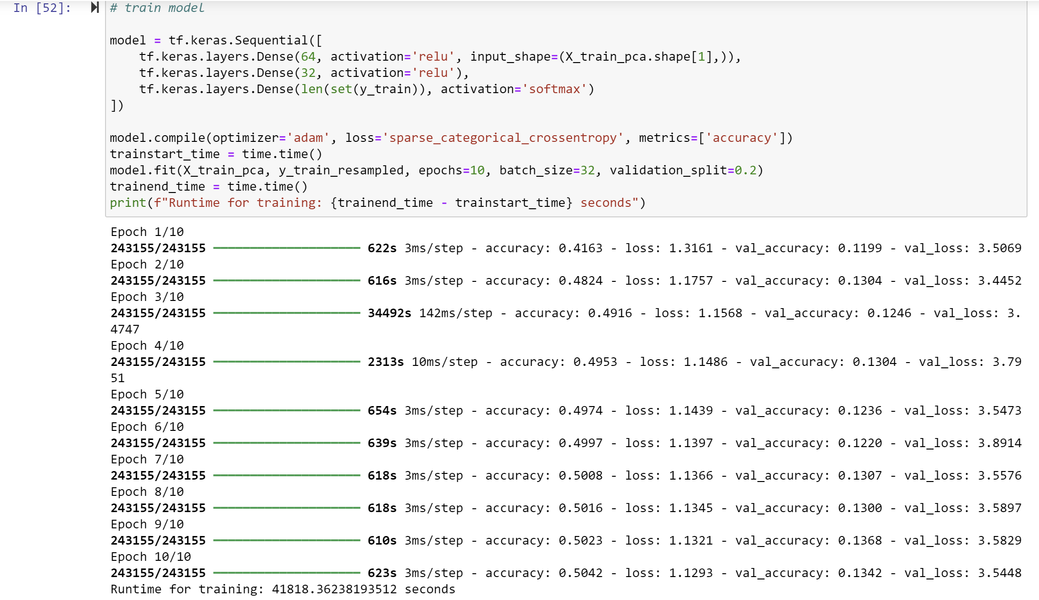

Figure 39 Training time for ANN model locally

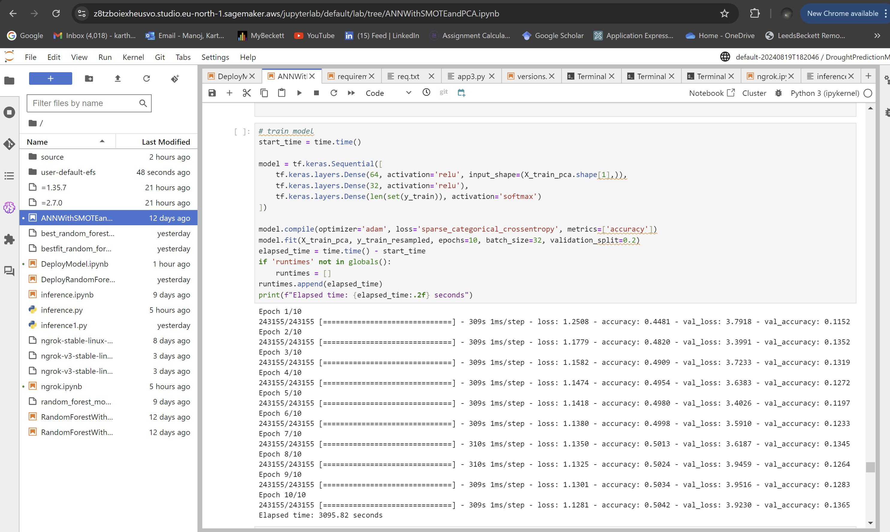

Figure 40 Training time for ANN on cloud

## 4.3 Model Deployment and Web App

The primary focus after selecting Random Forest with Recursive Feature Elimination (RFE) and GridSearchCV as the best-performing model was to deploy the model to make it accessible for real-world applications. This section outlines the deployment process on AWS SageMaker and discusses the initial development of a web interface, highlighting the current progress and areas designated for future work.

### 4.3.1 Random Forest with Recursive Feature Elimination (RFE) and GridSearchCV

After extensive experimentation with various models, the Random Forest algorithm emerged as the most effective for the drought prediction task. To optimize this model, two critical techniques were employed: Recursive Feature Elimination (RFE) and GridSearchCV.

As initial analysis, density histograms, density plots and boxplots were made use of to study the relationship between features. Correlation analysis was also carried out to eliminate any redundant features that might have high variation. However, since some features were found to have significant variance amidst a good degree of correlation, all features were initially retained. Features were further analysed and reduced or eliminated with algorithms like Recursive Feature Elimination.

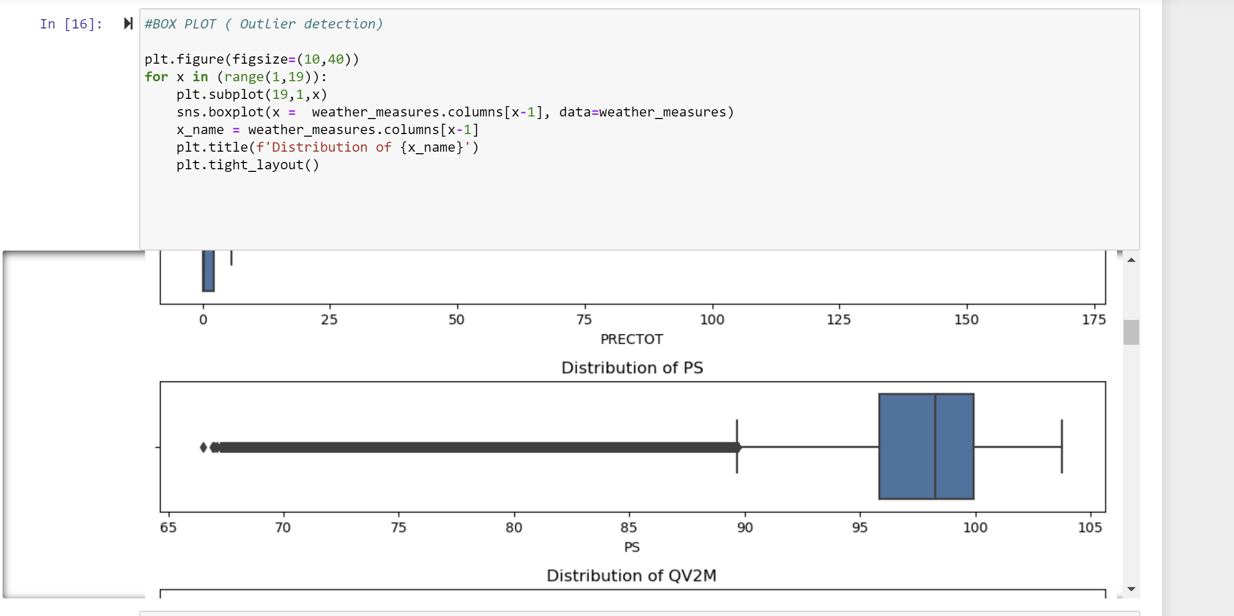

Figure 41 Box plots

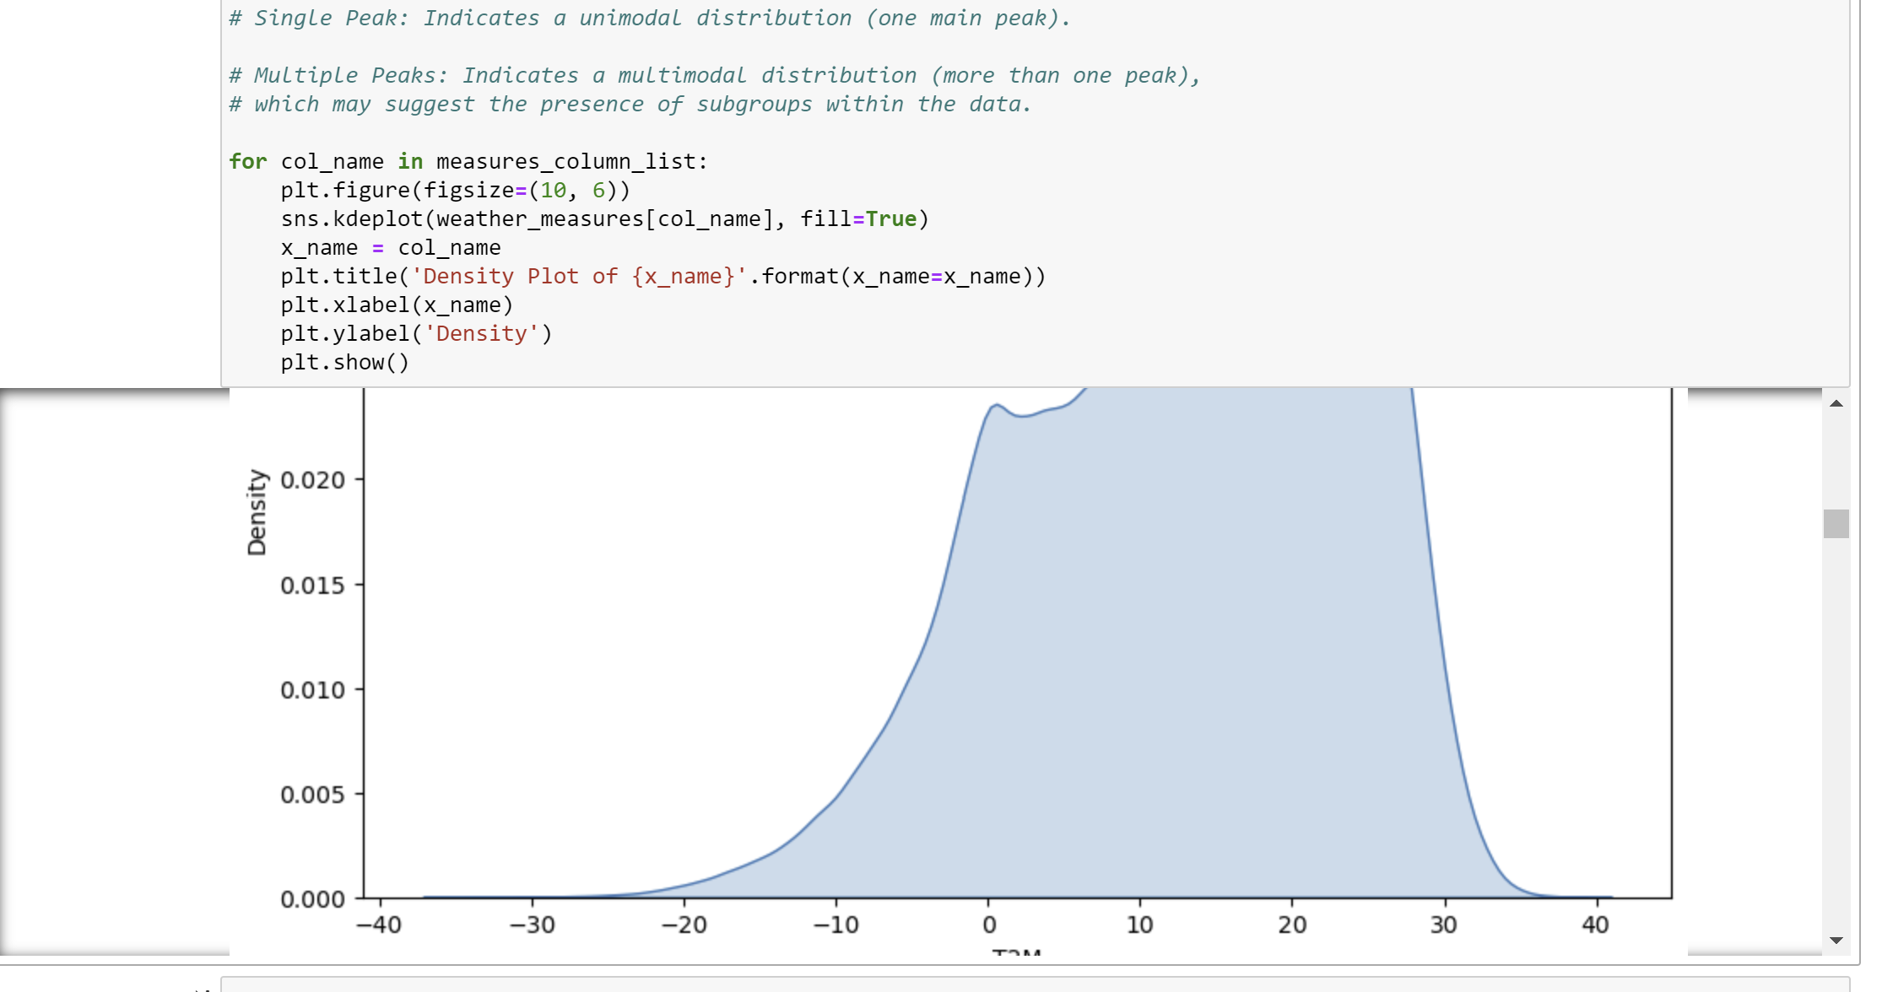

Figure 42 Desnity plots

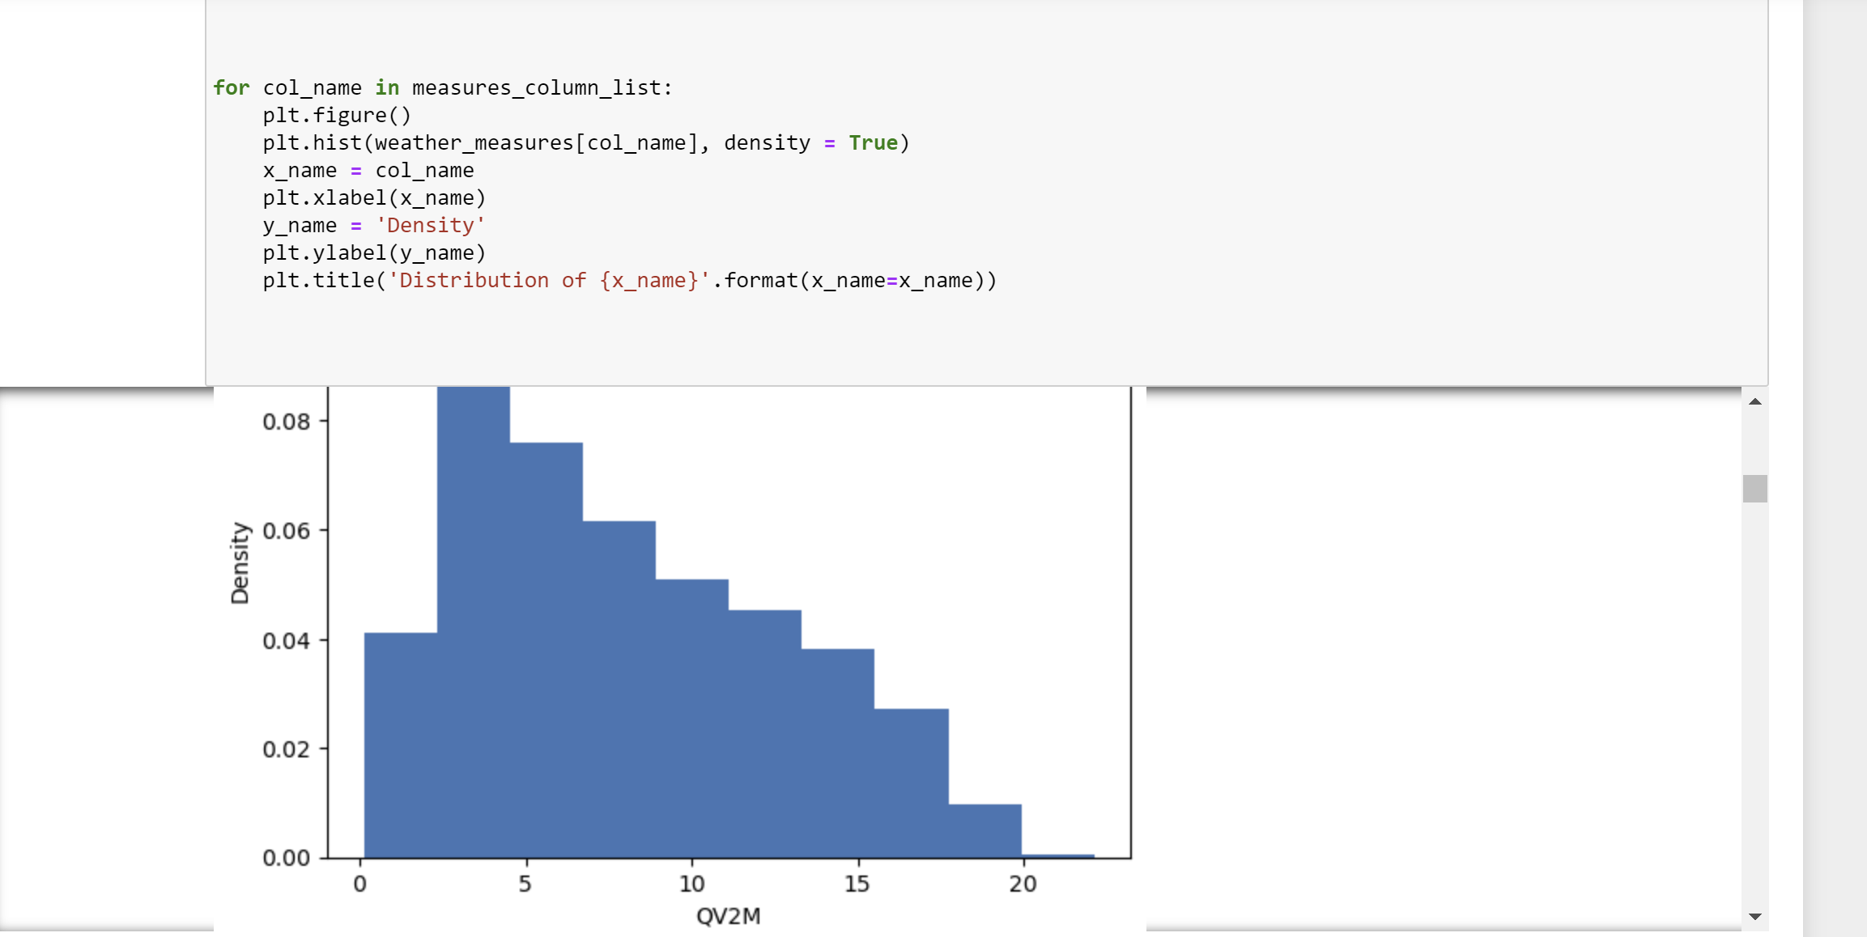

Figure 43 Density histograms

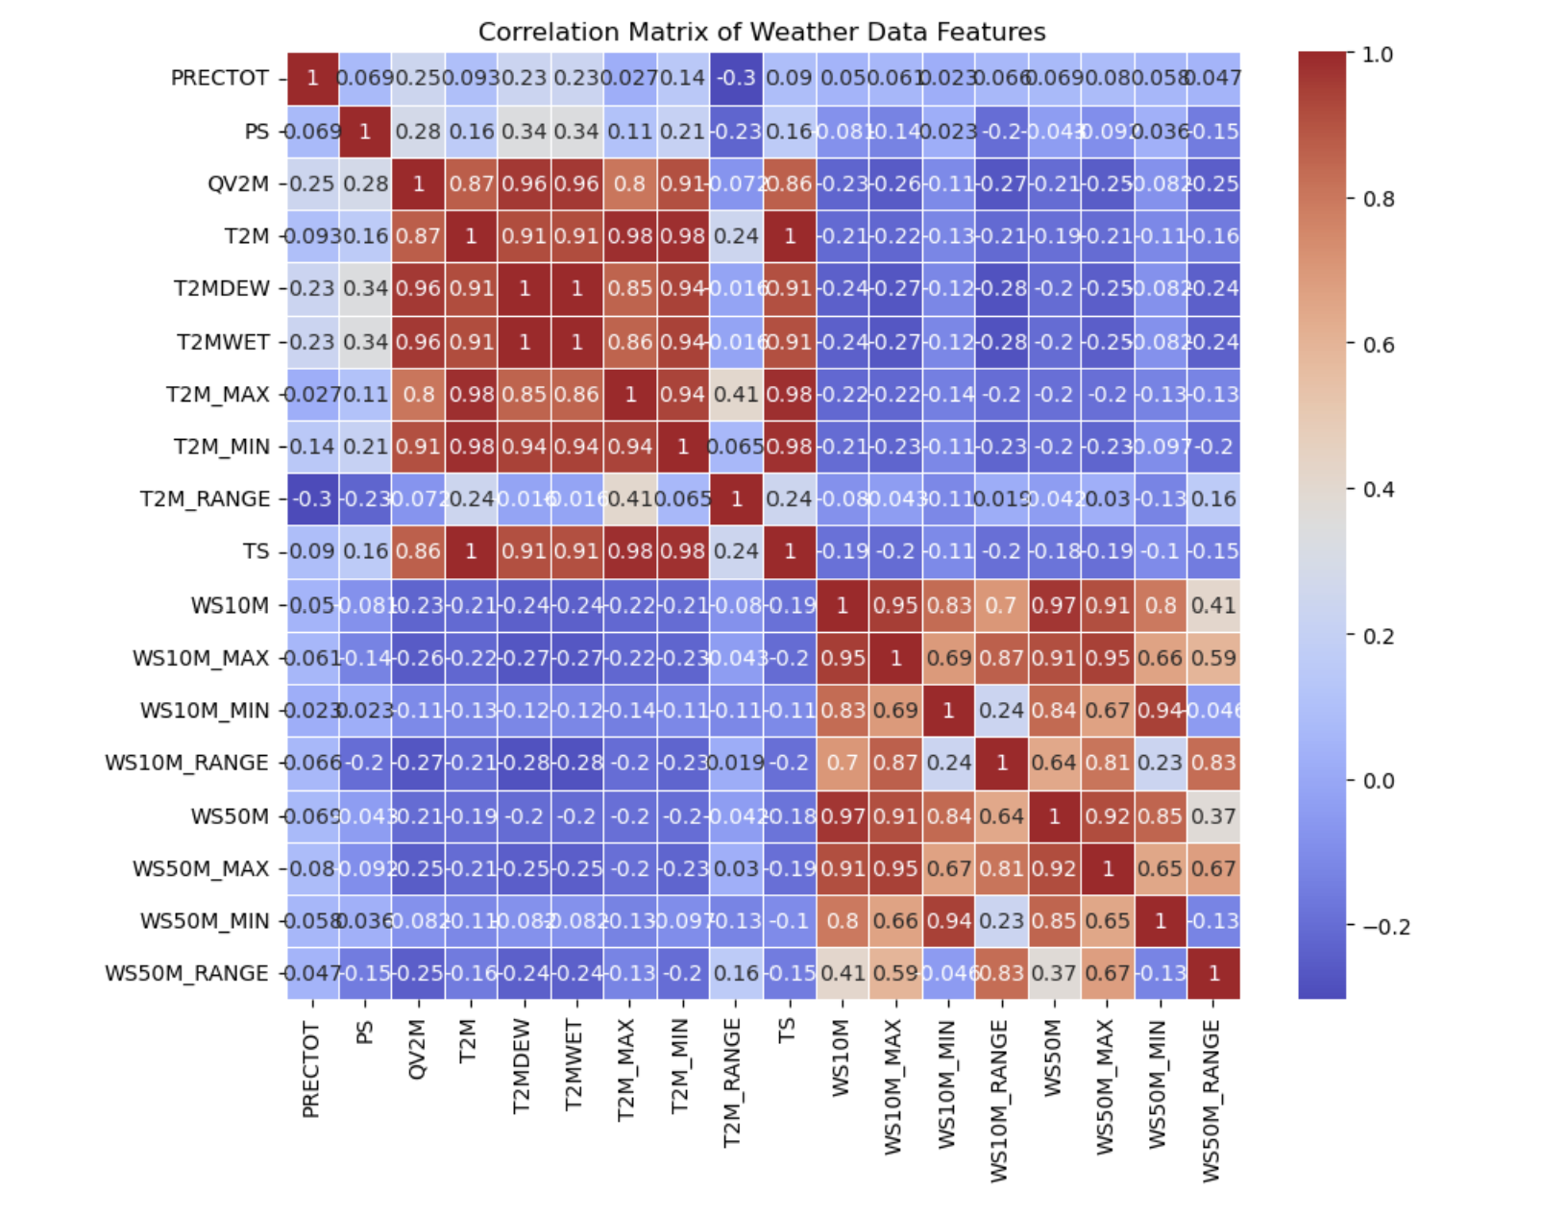

Figure 44 Correlation matrix for meteorological features

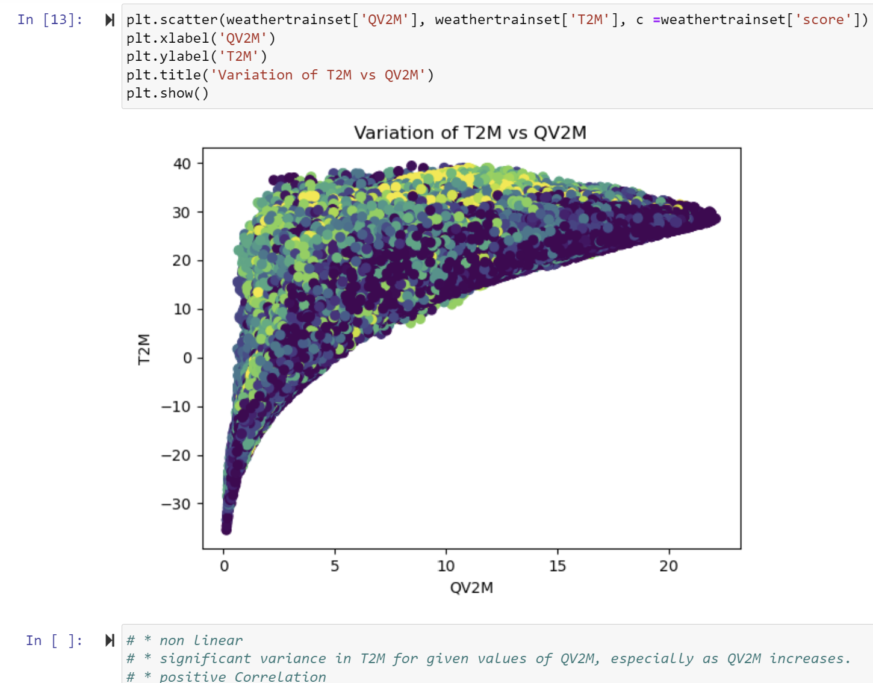

Figure 45 Scatter plot T2M vs QV2M

To enhance the Random Forest model's performance, Recursive Feature Elimination (RFE) was used for feature selection. RFE helps in identifying the most important features by iteratively removing the least important ones. This process was applied on a smaller subset of the training data to expedite computation and fine-tune feature selection. A subset of 50,000 samples was randomly selected from the scaled training data. This subset size was chosen to balance computational efficiency with the need for a representative feature set. A Random Forest Classifier with 10 estimators was initialized and RFE was set to select the top 15 features.

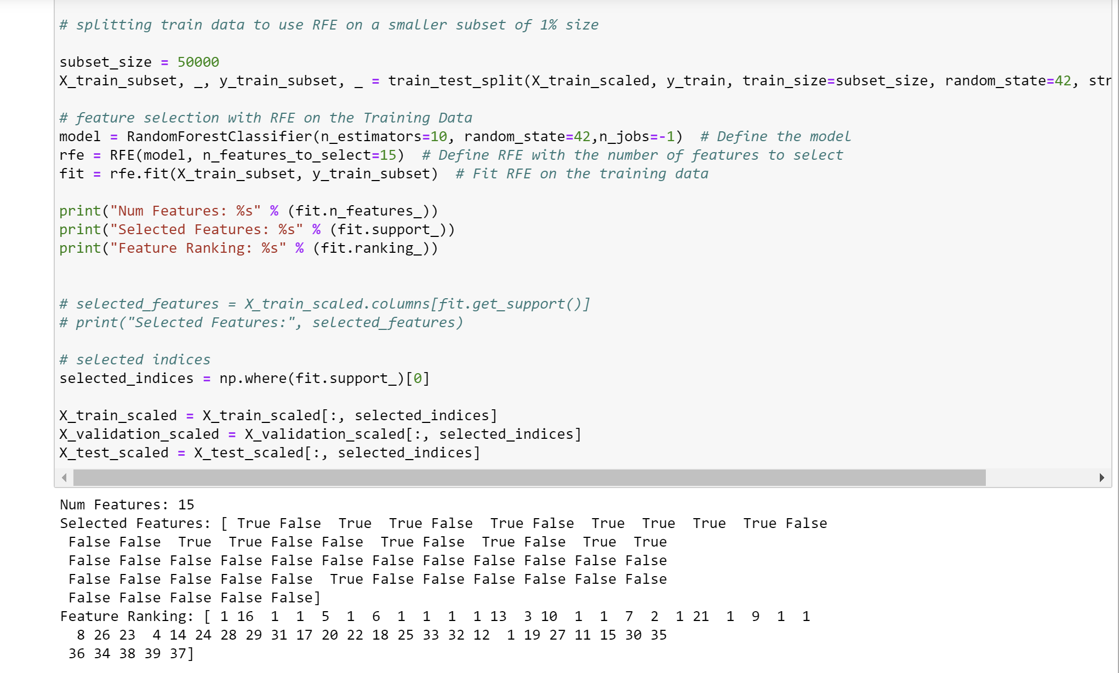

Figure 46 RFE and selected features

The model determined the number of important features as well as ranks each feature based on importance. GridSearchCV was used to optimize the hyperparameters of the Random Forest model. This method exhaustively searches over specified parameter values and selects the combination that yields the best performance. A Random Forest Classifier was used defined with a 3-fold cross-validation, and accuracy as the scoring metric. The model showed an accuracy of 0.81 for test data with about 2 million records.

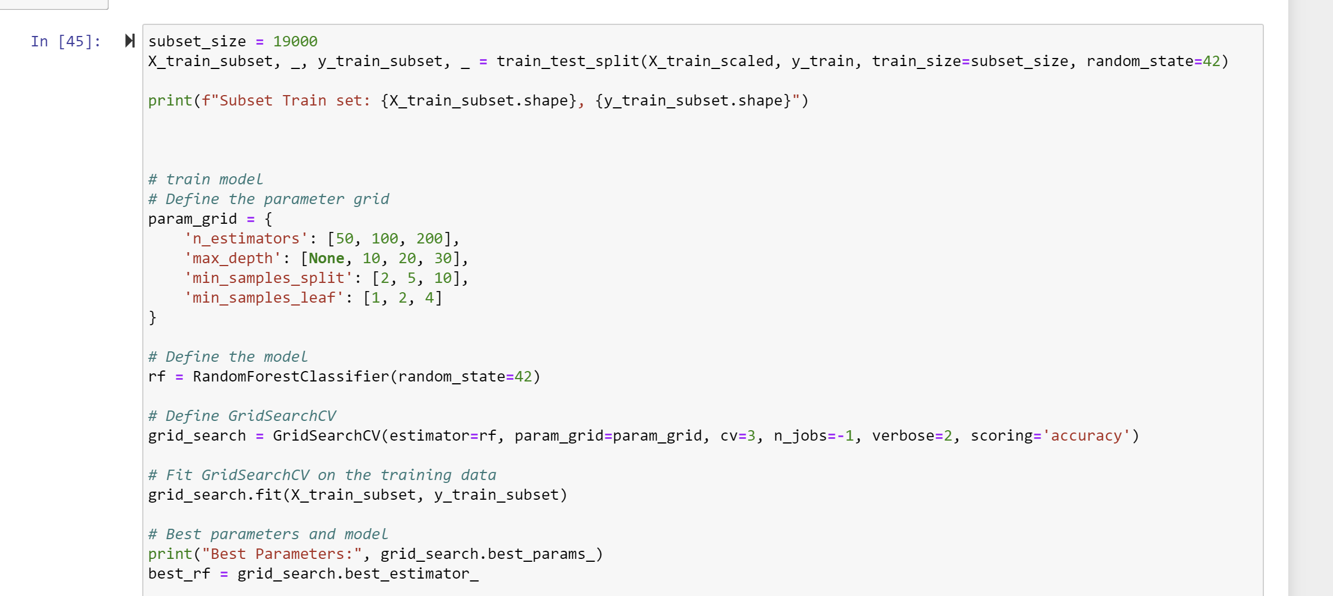

Figure 47 GridSearchCV

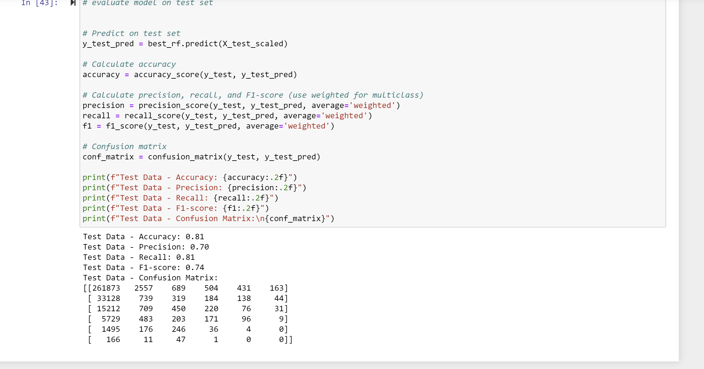

Figure 48 Model performance on test data

### 4.3.2 Model Deployment on AWS SageMaker

The deployment of the optimized Random Forest model was carried out on AWS SageMaker to leverage cloud-based resources for scalable and efficient inference. The trained Random Forest model was packaged as a .pkl file along with inference.py containing essential logic to run the model on the test file given as input. It was stored in S3 buckets and then deployed on an ml.r5.xlarge instance using AWS SageMaker. This instance type was selected for its optimal balance of computational power and cost, ensuring efficient inference capabilities.

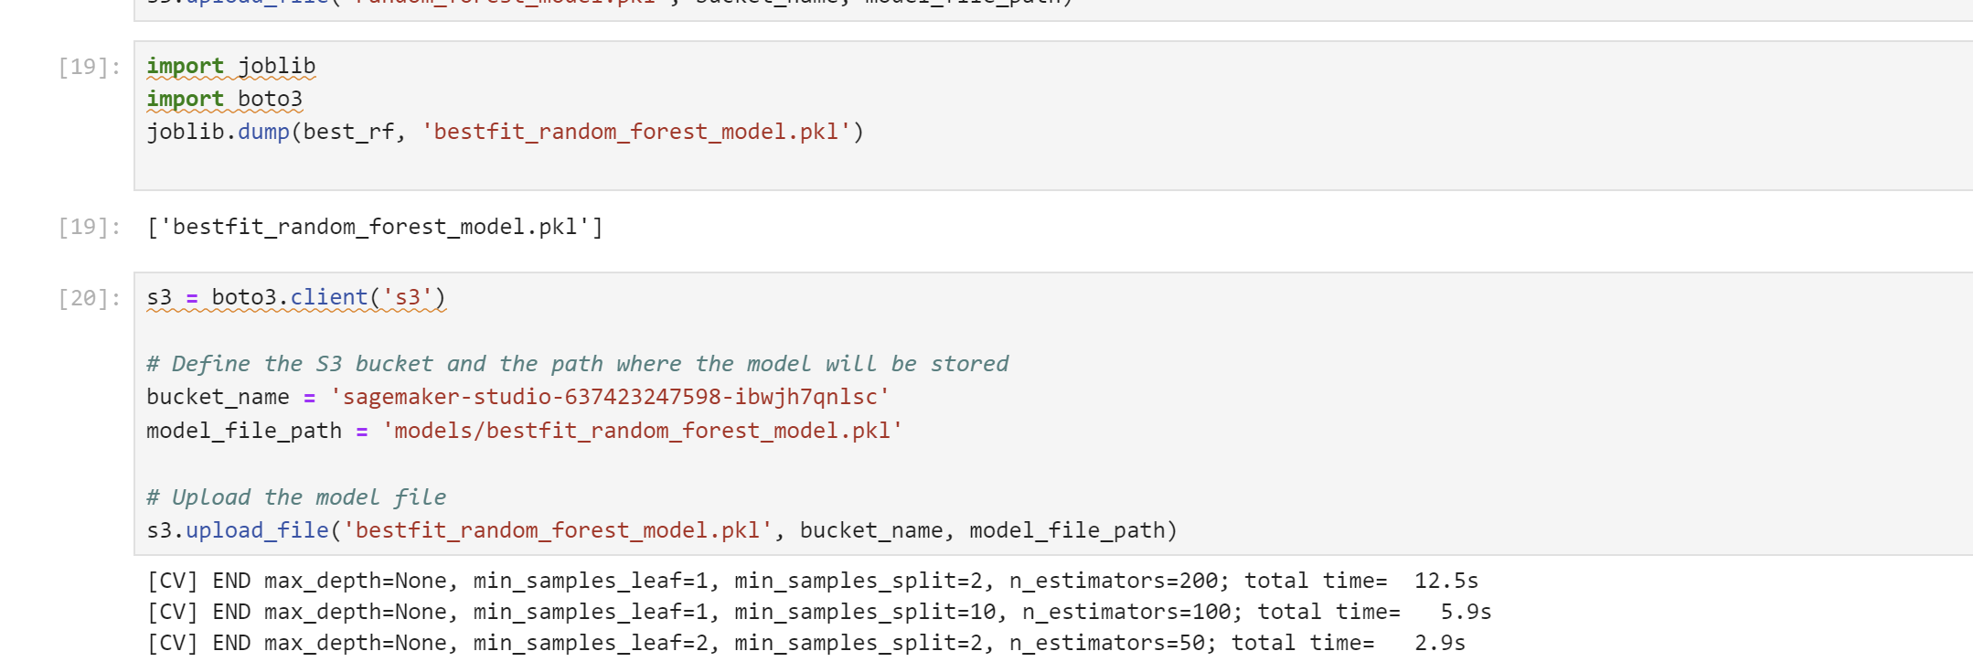

Figure 49 Packaging and uploading model to S3 bucket

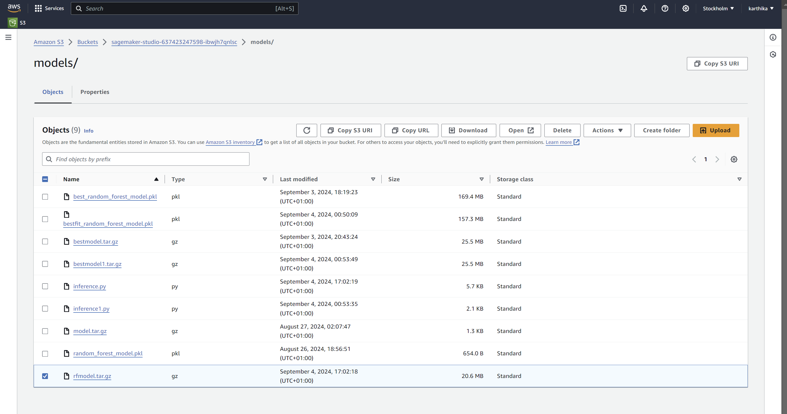

Figure 50 rfmodel.tar.gz in S3 bucket containing packaged model

A real-time endpoint named best-random-forest-endpoint was created to allow the model to process incoming data and generate predictions. This setup enables seamless interaction with the deployed model through API calls, making it suitable for various applications that require rapid and reliable drought predictions.

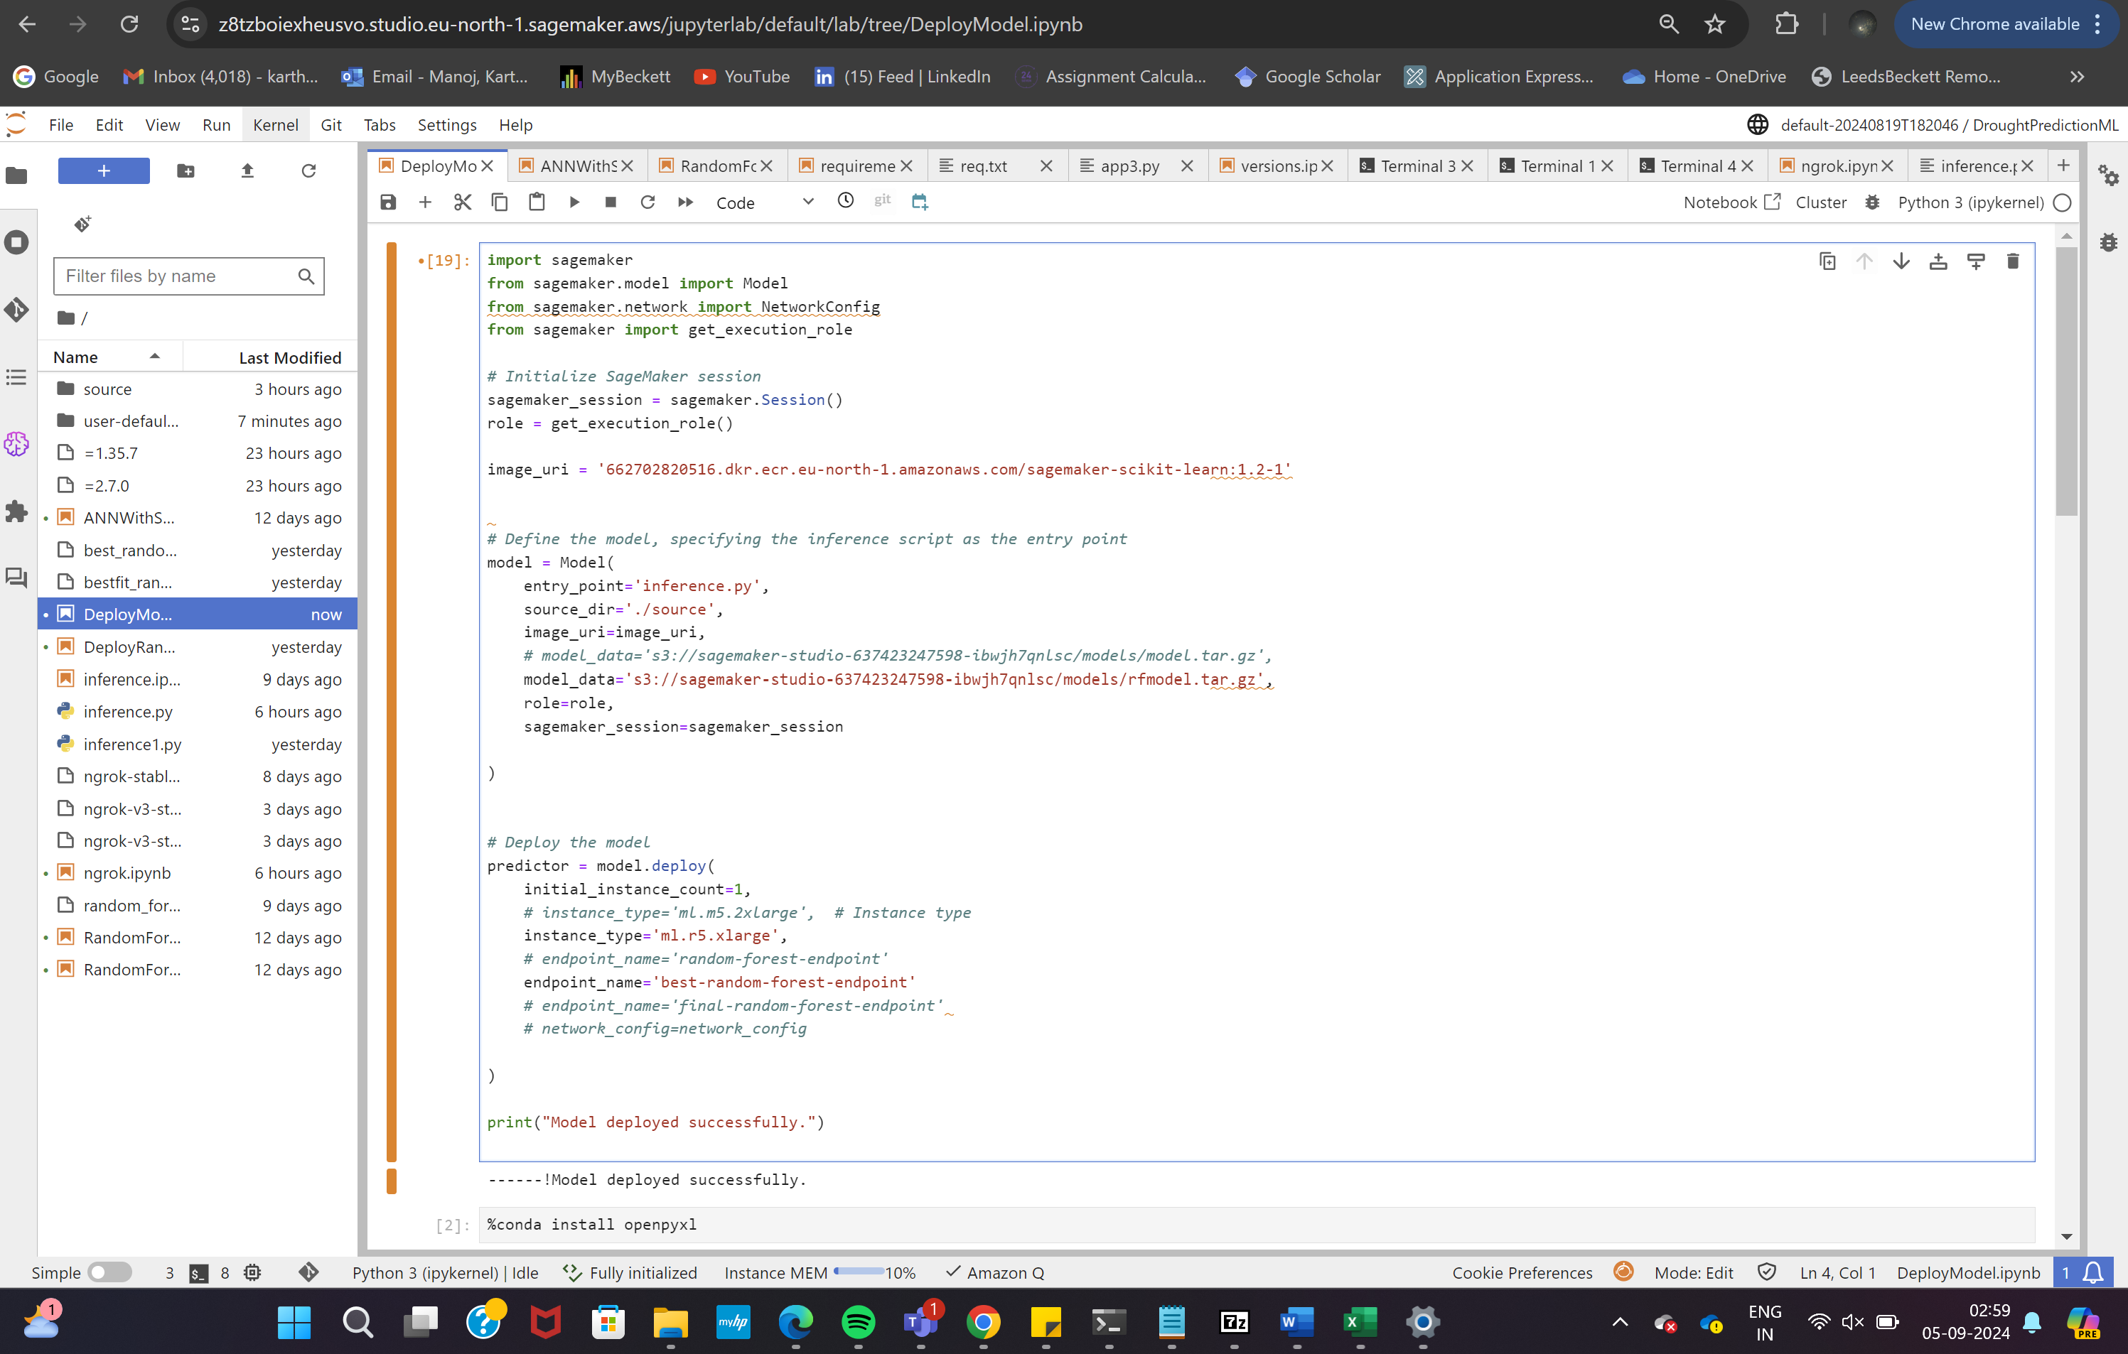

Figure 51 Deploying model with endpoint name best-random-forest-endpoint

This app.py script is the core of the web application. It handles the user interface and interactions, allowing users to upload test data files. The app integrates with the SageMaker endpoint to send data and retrieve predictions. It is designed to process user inputs, manage file uploads, and interact with the deployed model to generate predictions whereas the inferencescript is used for model inference within the SageMaker environment. It contains the code necessary to load the model and perform predictions on incoming data. inference.py is invoked by SageMaker when a prediction request is made to the endpoint. It ensures that the data is properly formatted and passed to the model for generating predictions.

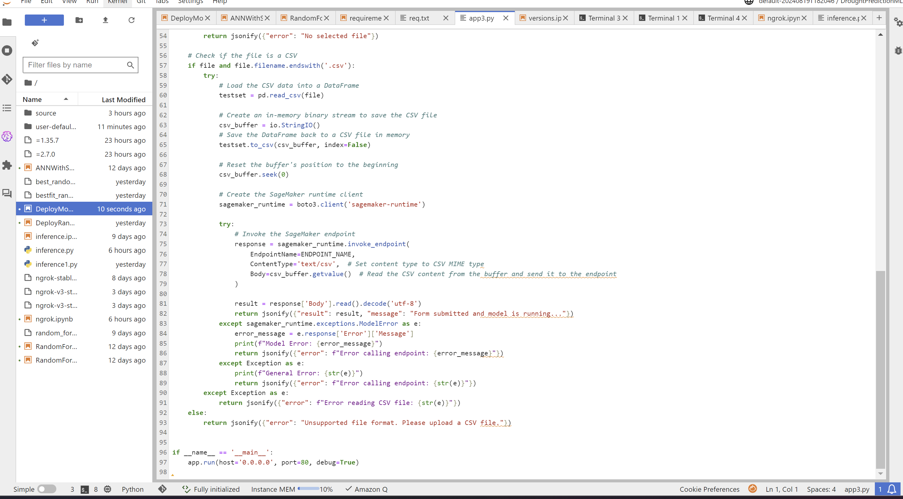

Figure 52 Snippet of app.py

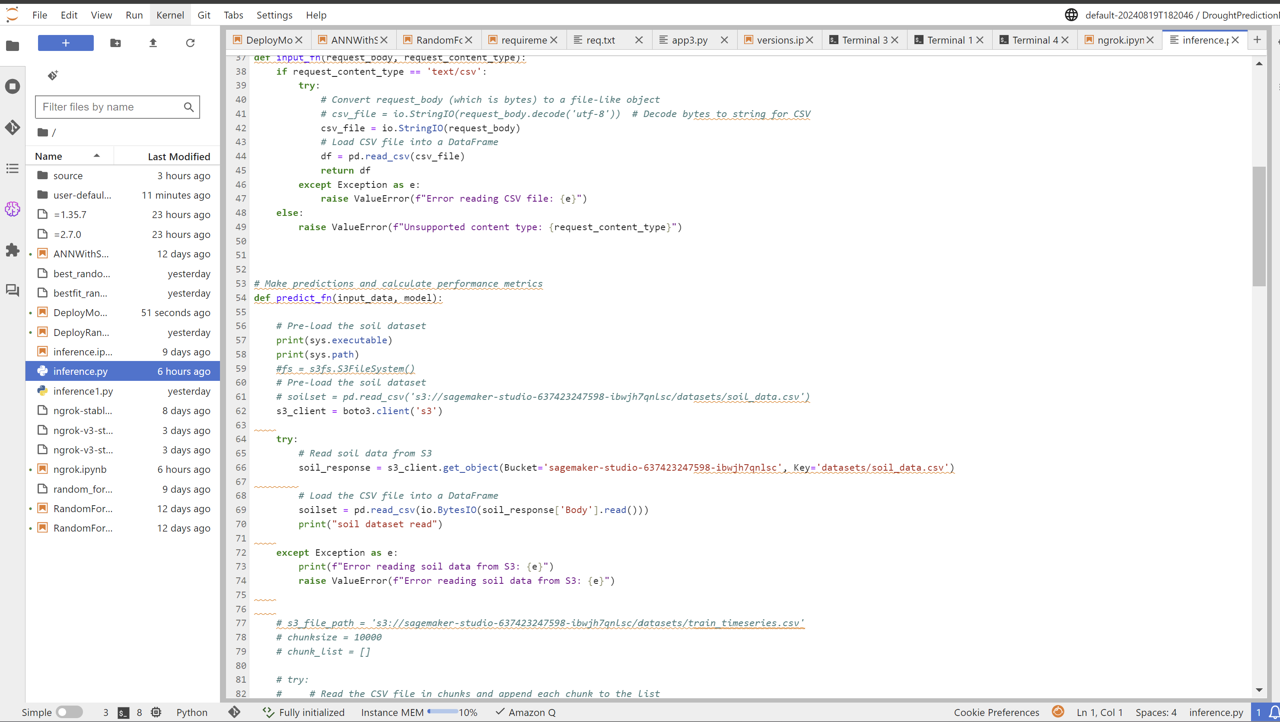

Figure 53 Snippet of inference.py

The web application was developed to provide an interactive platform for users to upload test data and receive predictions. Currently, the application supports file uploads and processes these through the deployed model. The application allows users to upload an Excel file containing test data, which is then pre-processed and sent to the deployed model for predictions. This feature provides a straightforward way for users to interact with the model and test its functionality. However, results are displayed in the log output rather than directly on the HTML page. The results of the predictions can be accessed through the SageMaker logs, which display the output once the data is processed by the model. This approach ensures the model is fully functional and ready for integration into a user-facing application. Future enhancements will focus on displaying results within the web interface to improve user experience.



Figure 54 Web app user interface

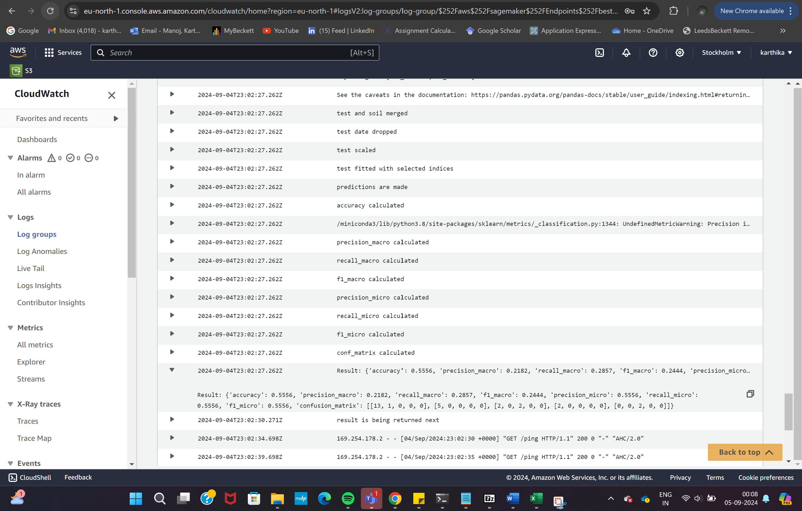

Figure 55 Performance metrics from CloudWatch logs

# Chapter 5 : Research Outcomes

This chapter describes the outcomes of the research by presenting the performance metrics of the optimized models, comparing runtime efficiency on local and cloud platforms, and showcasing the web application's functionality.

## 5.1 Model Performance Metrics

The Random Forest model, enhanced with Recursive Feature Elimination (RFE) and GridSearchCV, was identified as the top-performing model with an accuracy of 0.81( 0.80 on AWS). Its performance was assessed across the training, validation, and test datasets using various metrics as summarised in Table 10 .

|  |  |  |  |
| --- | --- | --- | --- |
| Metrics | Training | Validation | Testing |
| Accuracy | 0.6731 | 0.7398 | 0.8066 |
| Precision | 0.5890 | 0.6089 | 0.7043 |
| Weighted Recall | 0.6731 | 0.7398 | 0.8066 |
| Macro-Recall | 0.2319 | 0.1716 | 0.1766 |
| Micro-Recall | 0.6731 | 0.7398 | 0.8066 |
| F1-score | 0.5761 | 0.6473 | 0.7392 |

Table 10 Performance Metrics of Random Forest model with RFE and GridSearchCV on AWS Sagemaker

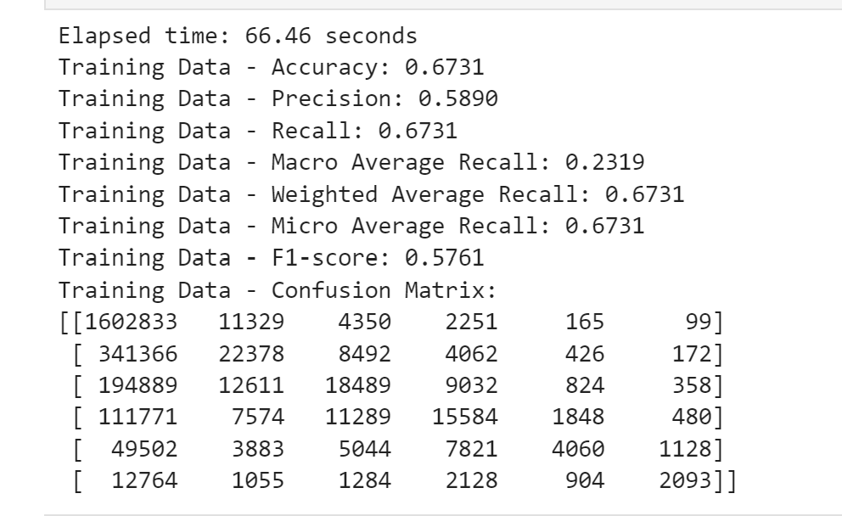

Figure 56 Confusion Matrix of Training data

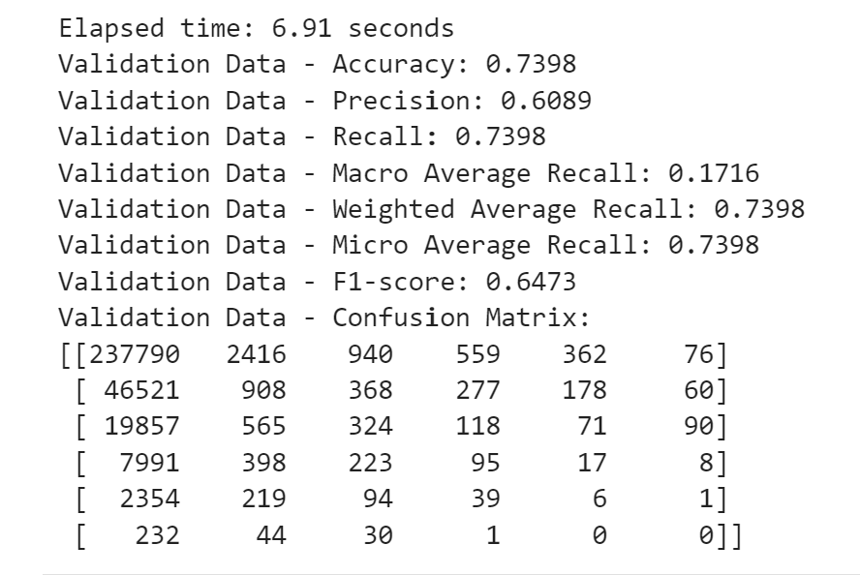

Figure 57 Confusion Matrix of Validation data

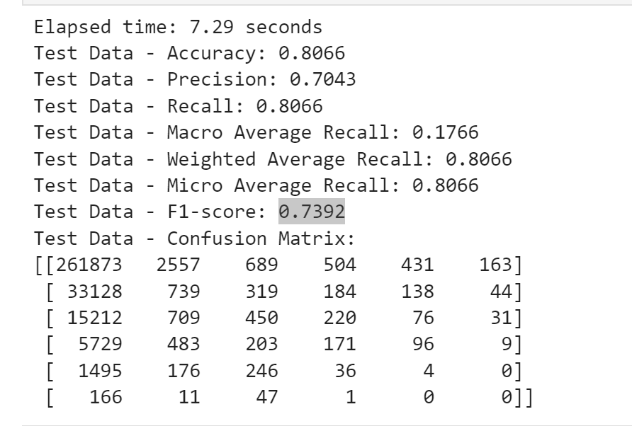

Figure 58 Confusion Matrix of Testing data

The graphs below further show the performance of models trained on whole datasets ( Figure 59) and partial datasets ( Figure 60).

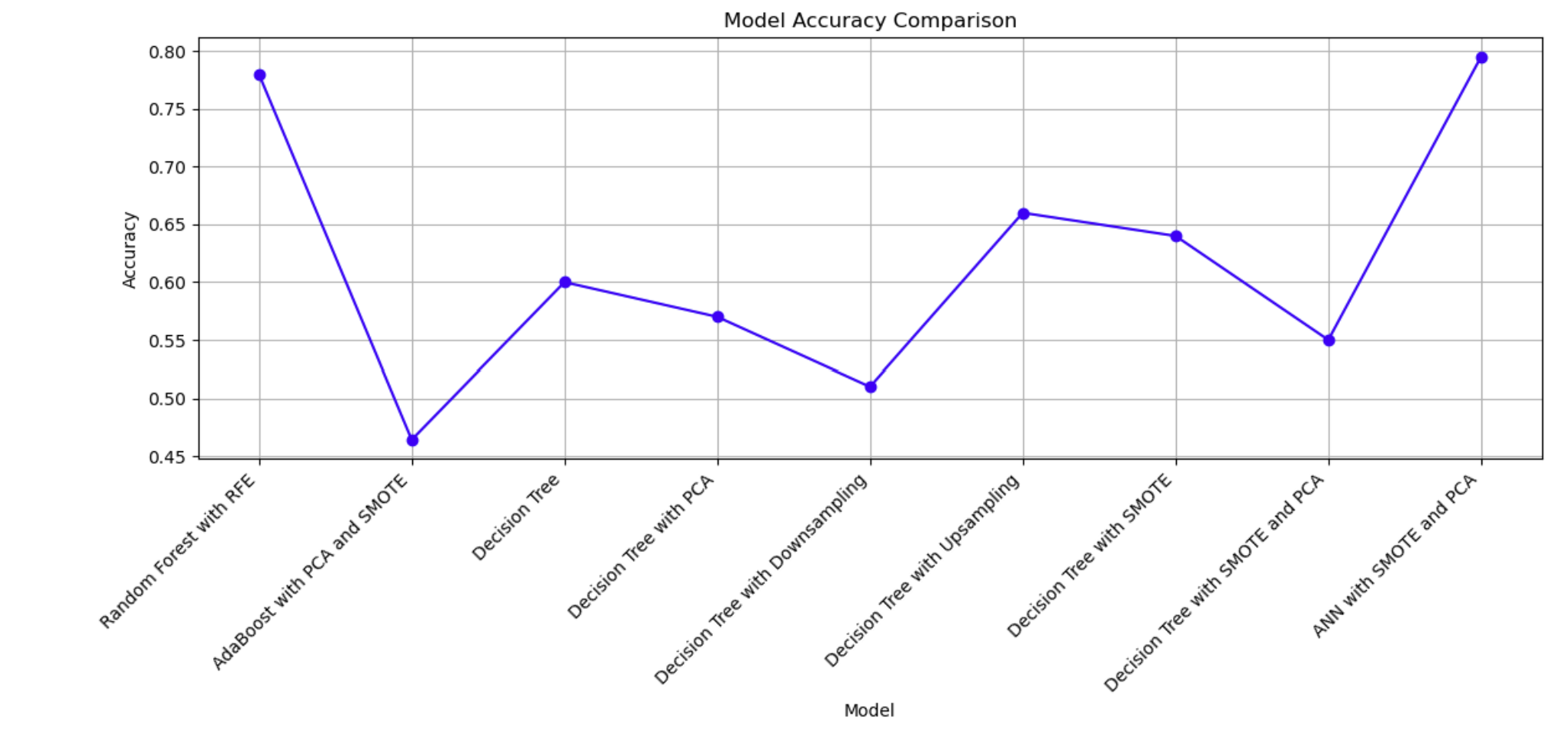

Figure 59 Model performance for whole dataset training

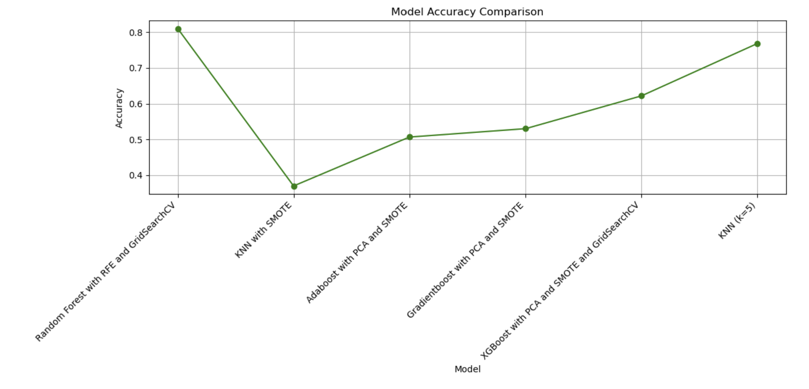

Figure 60 Model performance for subset dataset training

## 5.2 Runtime Comparison and Analysis

To evaluate the efficiency of the models, their runtimes were compared in both local and AWS environments. The graph below illustrates the runtime for the top three models on each platform, highlighting the significant improvements achieved with cloud deployment:

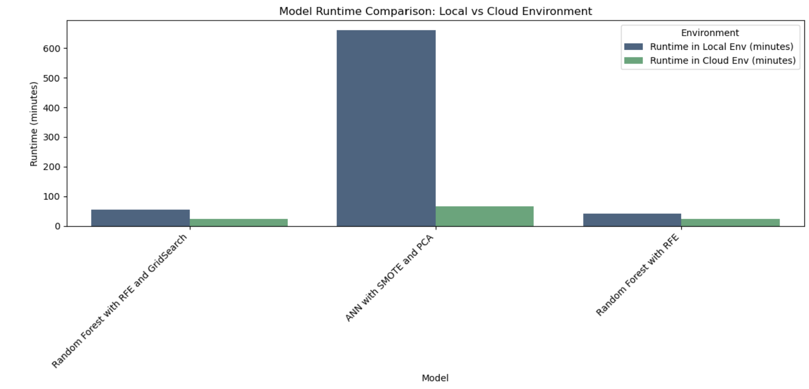

Figure 61 Runtime comparison (local vs cloud environment)

## 5.3 Model Deployment Results

The model was deployed through SageMaker with a instance and a web application was developed to facilitate real-time predictions and handle user inputs. Although the app currently supports uploading test data files, displaying results directly on the HTML page is a future enhancement. Presently, results are visible through logs. Below are screenshots of the application interface and the results:

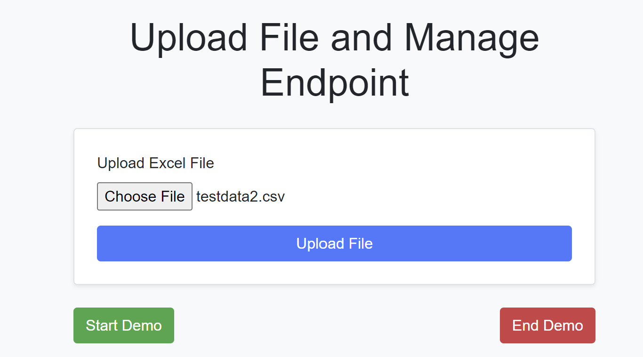

Figure 62 Uploading test data csv file through web application

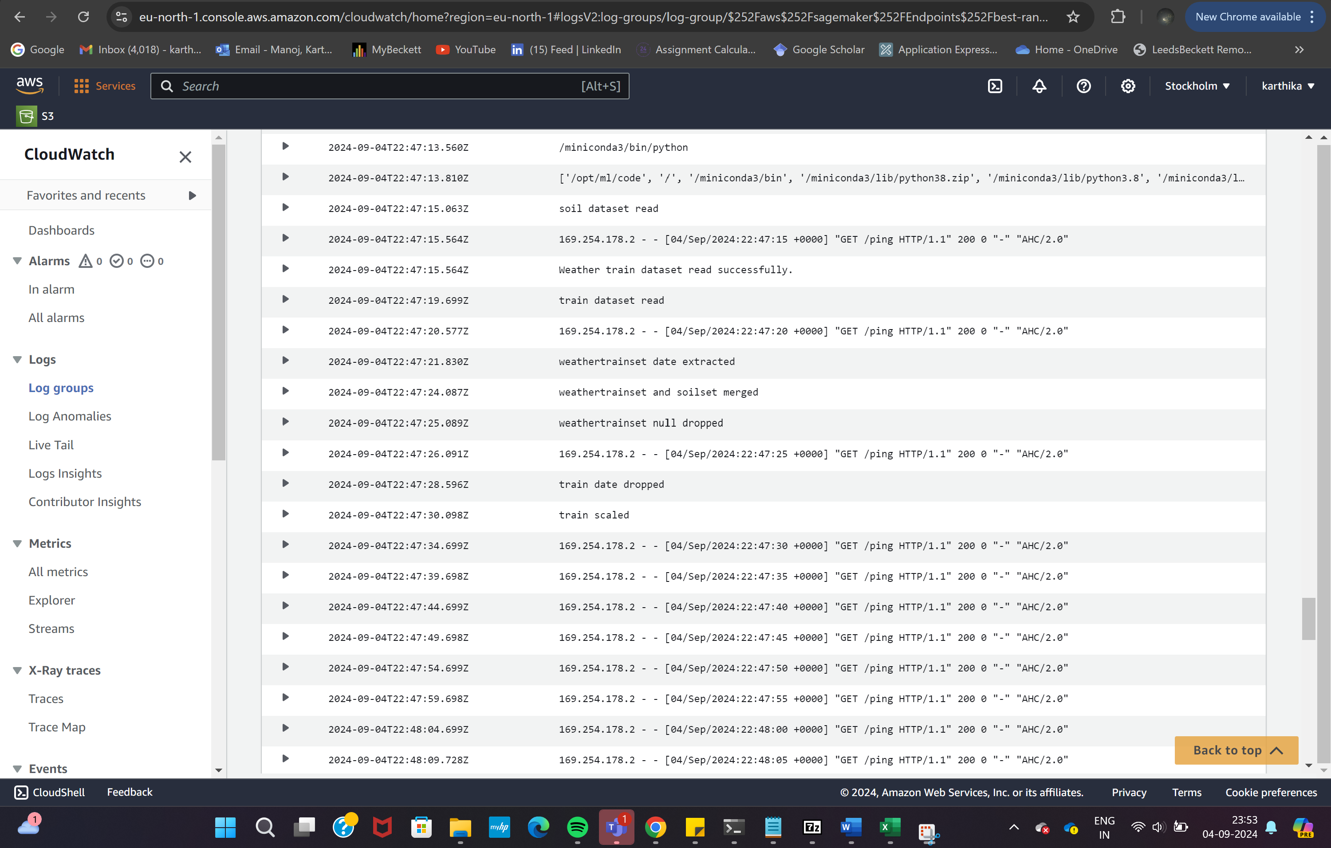

Figure 63 Logs of datasets being read and pre-processed

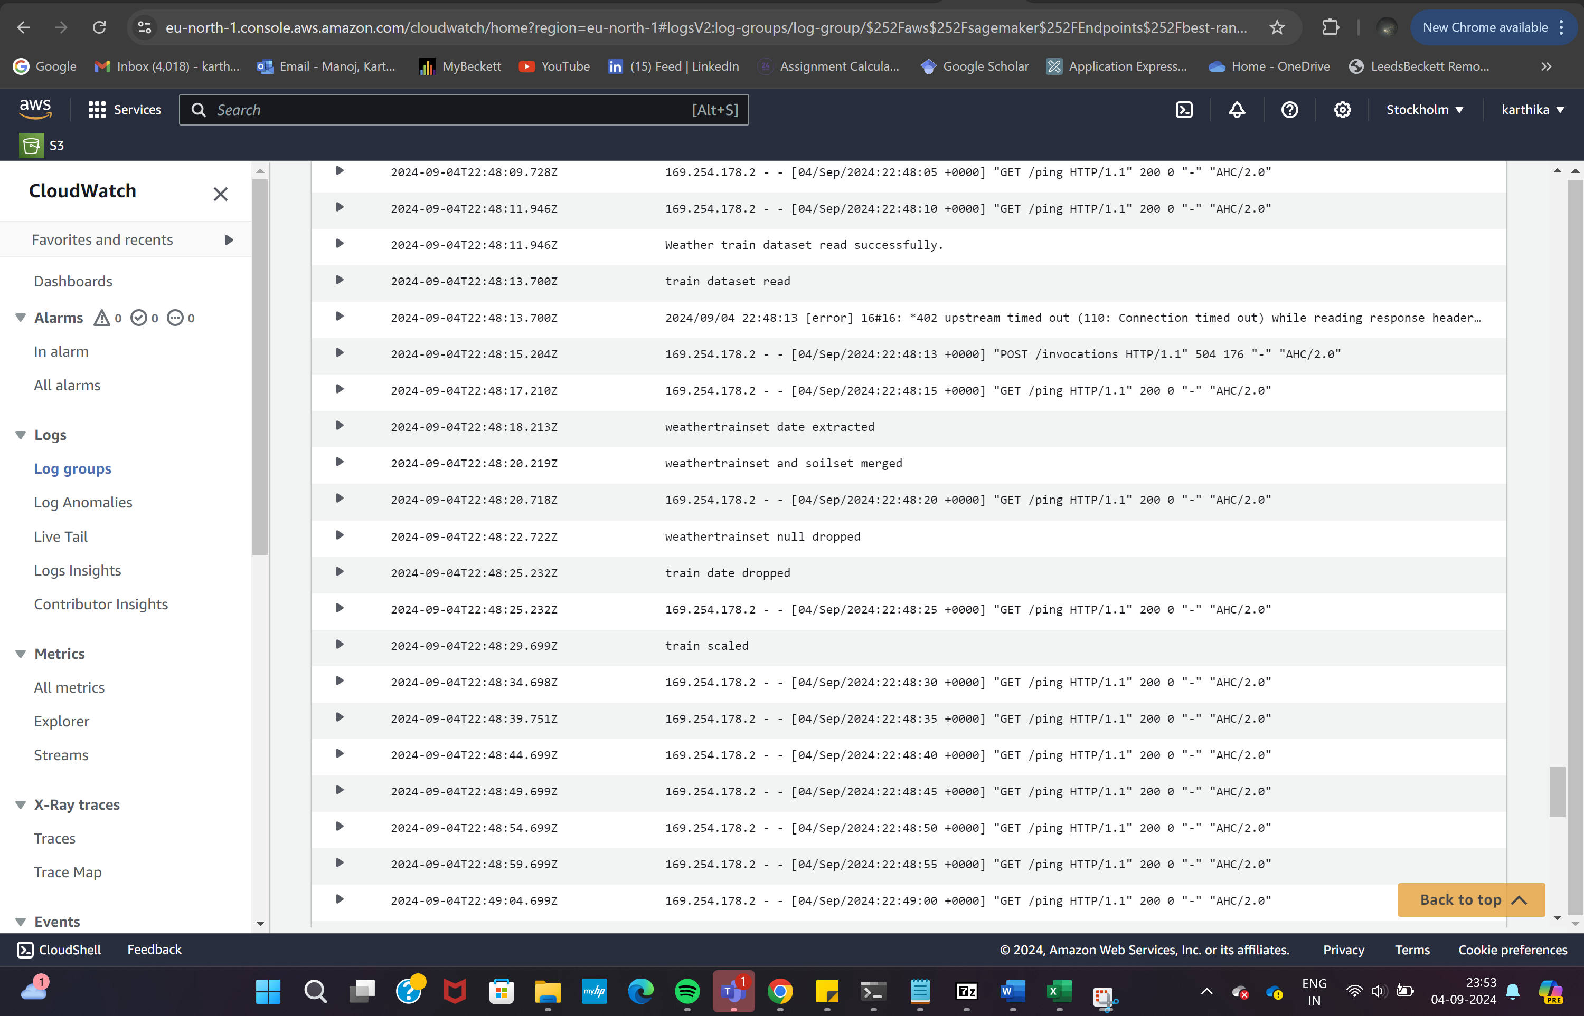

Figure 64 Logs of data preprocessing

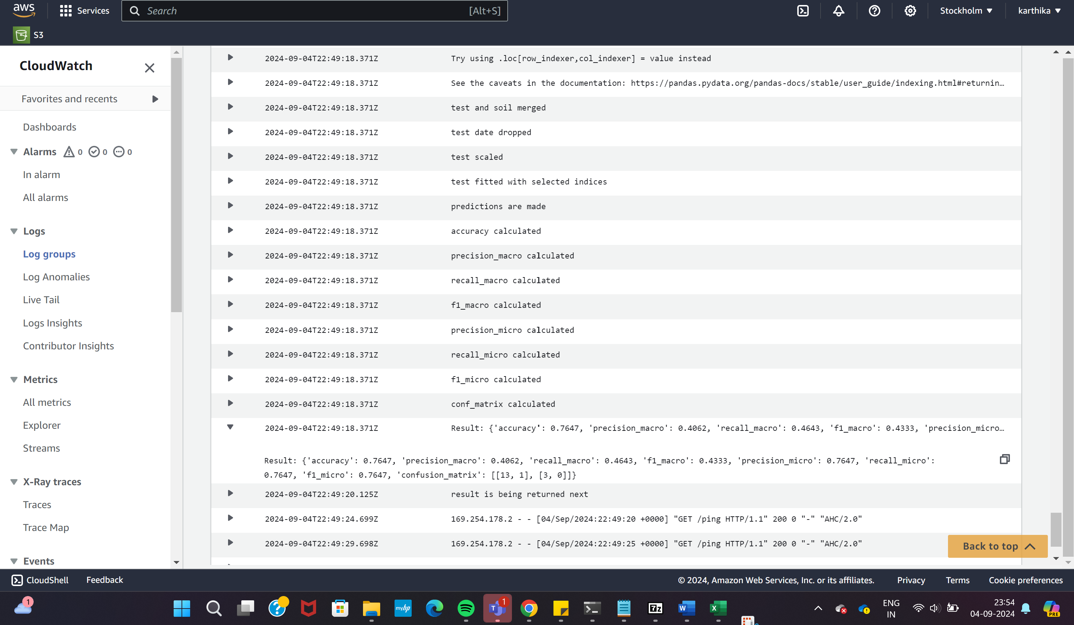

Figure 65 Metrics calculated in logs

# Chapter 6 : Project Management

Effective project management is crucial for the success of any research project. Throughout the project, regular communication and feedback sessions were held to ensure alignment with research objectives and to address any challenges encountered. Online meetings were conducted bi-weekly with the supervisor to discuss progress, address any issues, and receive feedback. Additionally, in-person meetings were held monthly from May to August to provide a more in-depth review of progress and receive hands-on guidance from the supervisor.

The project followed an agile iterative method, allowing for flexibility and adjustments based on ongoing feedback. A Gantt chart was prepared as part of the research proposal to efficiently plan the research activities and for timely submission of the same.



Figure 66 Gantt Chart for Research activities

The research was based on an agile iterative methodology, as continuous feedback from regular meetings provided opportunities for ongoing feedback from the supervisor. This helped for timely adjustments and refinements to the research approach. It also followed an iterative development where research was developed in iterative cycles, with each cycle involving the refinement of models, techniques, and methodologies based on previous findings and feedback. The iterative process enabled the research to adapt to new insights, challenges, and advancements, ensuring that the project remained on track and met its objectives effectively. This approach ensured that the research was continuously improved and aligned with the overall goals, leading to more robust and reliable outcomes.

# Chapter 7 : Conclusion and Future Work

This research aimed to develop and evaluate machine learning models for drought prediction using a combination of meteorological and soil data leading to the following conclusions:

* Best Performing Model: The Random Forest model with Recursive Feature Elimination (RFE) and GridSearchCV emerged as the most effective model for drought prediction, achieving the highest accuracy and overall performance metrics.
* Runtime Efficiency: The analysis of model runtimes highlighted a significant reduction in training times when models were executed on cloud-based environments compared to local systems. Notably, the ANN model experienced a substantial decrease in runtime, from approximately 11 hours on a local system to 67 minutes on AWS.
* Deployment and Practical Application: The successful deployment of the Random Forest model on AWS SageMaker demonstrated the feasibility of integrating machine learning models into real-world applications. The web application developed allows users to upload test data and receive predictions, although further enhancements are needed for complete functionality.

While the research successfully met its primary goals, there are several areas where further exploration and enhancement could be beneficial

* Web Application Development: Future work should focus on refining the web application to fully display results on the HTML page, improving user experience, and ensuring reliable and efficient functionality.
* Real-Time Predictions: Implementing real-time prediction capabilities and integrating the model with automated data acquisition systems could offer timely and actionable insights for drought management.
* Scalability and Optimization: Investigating optimization techniques to further reduce training and inference times and exploring scalable solutions to handle larger datasets and more complex models could improve the overall efficiency and applicability of the research findings.

# References

1. Achite, M., Elshaboury, N., Jehanzaib, M., Vishwakarma, D.K., Pham, Q.B., Anh, D.T., Abdelkader, E.M. and Elbeltagi, A., 2023. Performance of machine learning techniques for meteorological drought forecasting in the Wadi Mina Basin, Algeria. Water, 15(4), p.765.
2. Agana, N.A. and Homaifar, A., 2017, March. A deep learning based approach for long-term drought prediction. In *SoutheastCon 2017* (pp. 1-8). IEEE.
3. Alawsi, M.A., Zubaidi, S.L., Al-Ansari, N., Al-Bugharbee, H. and Ridha, H.M., 2022. Tuning ANN hyperparameters by CPSOCGSA, MPA, and SMA for short-term SPI drought forecasting. *Atmosphere*, *13*(9), p.1436.
4. Bacanli, U.G., Firat, M. and Dikbas, F., 2009. Adaptive neuro-fuzzy inference system for drought forecasting. Stochastic Environmental Research and Risk Assessment, 23, pp.1143-1154.
5. Belayneh, A. and Adamowski, J., 2012. Standard precipitation index drought forecasting using neural networks, wavelet neural networks, and support vector regression. Applied computational intelligence and soft computing, 2012(1), p.794061.
6. Belayneh, A. and Adamowski, J., 2013. Drought forecasting using new machine learning methods. Journal of Water and Land Development, 18(9), pp.3-12.
7. Belayneh, A., Adamowski, J. and Khalil, B.J.S.W.R.M., 2016a. Short-term SPI drought forecasting in the Awash River Basin in Ethiopia using wavelet transforms and machine learning methods. *Sustainable Water Resources Management*, 2, pp.87-101.
8. Belayneh, A., Adamowski, J., Khalil, B. and Quilty, J., 2016b. Coupling machine learning methods with wavelet transforms and the bootstrap and boosting ensemble approaches for drought prediction. Atmospheric Research, 172, pp.37-47
9. Bonaccorso, B., Bordi, I., Cancelliere, A., Rossi, G. and Sutera, A., 2003. Spatial variability of drought: an analysis of the SPI in Sicily. Water resources management, 17, pp.273-296.
10. Cacciamani, C., Morgillo, A., Marchesi, S. and Pavan, V., 2007. Monitoring and forecasting drought on a regional scale: Emilia-Romagna region. Methods and tools for drought analysis and management, pp.29-48.
11. Drought Classification Levels (2020) *U.S Drought Monitor*. [Online image]. Available from: < https://droughtmonitor.unl.edu/ > [Accessed 01 September 2024].
12. Edwards, D.C. and McKee, T.B., 1997. Characteristics of 20th century drought in the United States at multiple time scales.
13. Fung, K.F., Huang, Y.F., Koo, C.H. and Mirzaei, M., 2020. Improved SVR machine learning models for agricultural drought prediction at downstream of Langat River Basin, Malaysia. *Journal of Water and Climate Change*, *11*(4), pp.1383-1398.
14. Gill, M.K., Asefa, T., Kemblowski, M.W. and McKee, M., 2006. Soil moisture prediction using support vector machines 1. JAWRA Journal of the American Water Resources Association, 42(4), pp.1033-1046.
15. Gyaneshwar, A., Mishra, A., Chadha, U., Raj Vincent, P.D., Rajinikanth, V., Pattukandan Ganapathy, G. and Srinivasan, K., 2023. A contemporary review on deep learning models for drought prediction. Sustainability, 15(7), p.6160.
16. Hao, Z., AghaKouchak, A., Nakhjiri, N. and Farahmand, A., 2014. Global integrated drought monitoring and prediction system. *Scientific data*, *1*(1), pp.1-10.
17. Johnson, W.K. and Kohne, R.W., 1993. Susceptibility of reservoirs to drought using Palmer index. *Journal of Water Resources Planning and Management*, *119*(3), pp.367-387.
18. Karl, T.R., 1986. The sensitivity of the Palmer Drought Severity Index and Palmer's Z-index to their calibration coefficients including potential evapotranspiration. *Journal of Climate and Applied Meteorology*, pp.77-86.
19. Khan, N., Sachindra, D.A., Shahid, S., Ahmed, K., Shiru, M.S. and Nawaz, N., 2020. Prediction of droughts over Pakistan using machine learning algorithms. *Advances in Water Resources*, *139*, p.103562.
20. Kim, T.W. and Valdés, J.B., 2003. Nonlinear model for drought forecasting based on a conjunction of wavelet transforms and neural networks. Journal of Hydrologic Engineering, 8(6), pp.319-328.
21. Li, J., Wang, Z., Wu, X., Xu, C.Y., Guo, S., Chen, X. and Zhang, Z., 2021. Robust meteorological drought prediction using antecedent SST fluctuations and machine learning. *Water Resources Research*, *57*(8), p.e2020WR029413.
22. Liu, Z.N., Li, Q.F., Nguyen, L.B. and Xu, G.H., 2018. Comparing machine-learning models for drought forecasting in vietnam’s cai river basin. *Polish Journal of Environmental Studies*, *27*(6), pp.2633-2646.
23. Lohani, V.K. and Loganathan, G.V., 1997. An early warning system for drought management using the palmer drought index 1. JAWRA Journal of the American Water Resources Association, 33(6), pp.1375-1386.
24. Mather, J.R., 1981. USING COMPUTED STREAM FLOW IN WATERSHED ANALYSIS 1. JAWRA Journal of the American Water Resources Association, 17(3), pp.474-482.
25. Maybank, J., Bonsai, B., Jones, K., Lawford, R., O'brien, E.G., Ripley, E.A. and Wheaton, E., 1995. Drought as a natural disaster. Atmosphere-Ocean, 33(2), pp.195-222.
26. McKee, T.B., Doesken, N.J. and Kleist, J., 1993, January. The relationship of drought frequency and duration to time scales. In Proceedings of the 8th Conference on Applied Climatology (Vol. 17, No. 22, pp. 179-183).
27. Mishra, A.K. and Desai, V.R., 2005. Drought forecasting using stochastic models. Stochastic environmental research and risk assessment, 19, pp.326-339.
28. Mishra, A.K., Desai, V.R. and Singh, V.P., 2007. Drought forecasting using a hybrid stochastic and neural network model. Journal of Hydrologic Engineering, 12(6), pp.626-638.
29. Nachtergaele, F., van Velthuizen, H., Verelst, L., Wiberg, D., Henry, M., Chiozza, F., Yigini, Y., Aksoy, E., Batjes, N., Boateng, E. and Fisher, G., 2023. *Harmonized world soil database version 2.0*. FAO.
30. Nandgude, N., Singh, T.P., Nandgude, S. and Tiwari, M., 2023. Drought prediction: a comprehensive review of different drought prediction models and adopted technologies. Sustainability, 15(15), p.11684
31. Palmer, W.C., 1968. Keeping track of crop moisture conditions, nationwide: the new crop moisture index.
32. Park, S., Im, J., Jang, E. and Rhee, J., 2016. Drought assessment and monitoring through blending of multi-sensor indices using machine learning approaches for different climate regions. *Agricultural and forest meteorology*, *216*, pp.157-169.
33. Rao, K.N., George, C.J., Moray, P.E. and Mehta, N.K., 1973. Spectral analysis of drought index (Palmer) for India. *MAUSAM*, *24*(3), pp.257-270.
34. Sundararajan, K., Garg, L., Srinivasan, K., Bashir, A.K., Kaliappan, J., Ganapathy, G.P., Selvaraj, S.K. and Meena, T., 2021. A contemporary review on drought modeling using machine learning approaches. *Computer Modeling in Engineering & Sciences*, *128*(2), pp.447-487.
35. Tang, Z., De Almeida, C. and Fishwick, P.A., 1991. Time series forecasting using neural networks vs. Box-Jenkins methodology. *Simulation*, *57*(5), pp.303-310.
36. Thornthwaite, C.W. & Mather, J.R. (1955) The Water Balance. Publ.in Climatology, vol.8, no.l. C.W. Thornthwaite & Associates,Centerton, New Jersey
37. Tripathi, S., Srinivas, V.V. and Nanjundiah, R.S., 2006. Downscaling of precipitation for climate change scenarios: a support vector machine approach. Journal of hydrology, 330(3-4), pp.621-640.
38. Zhang, R., Chen, Z.Y., Xu, L.J. and Ou, C.Q., 2019. Meteorological drought forecasting based on a statistical model with machine learning techniques in Shaanxi province, China. *Science of the Total Environment*, *665*, pp.338-346.

# Appendices

## Ethics

**Ethics Approval**



**Ethics Form**

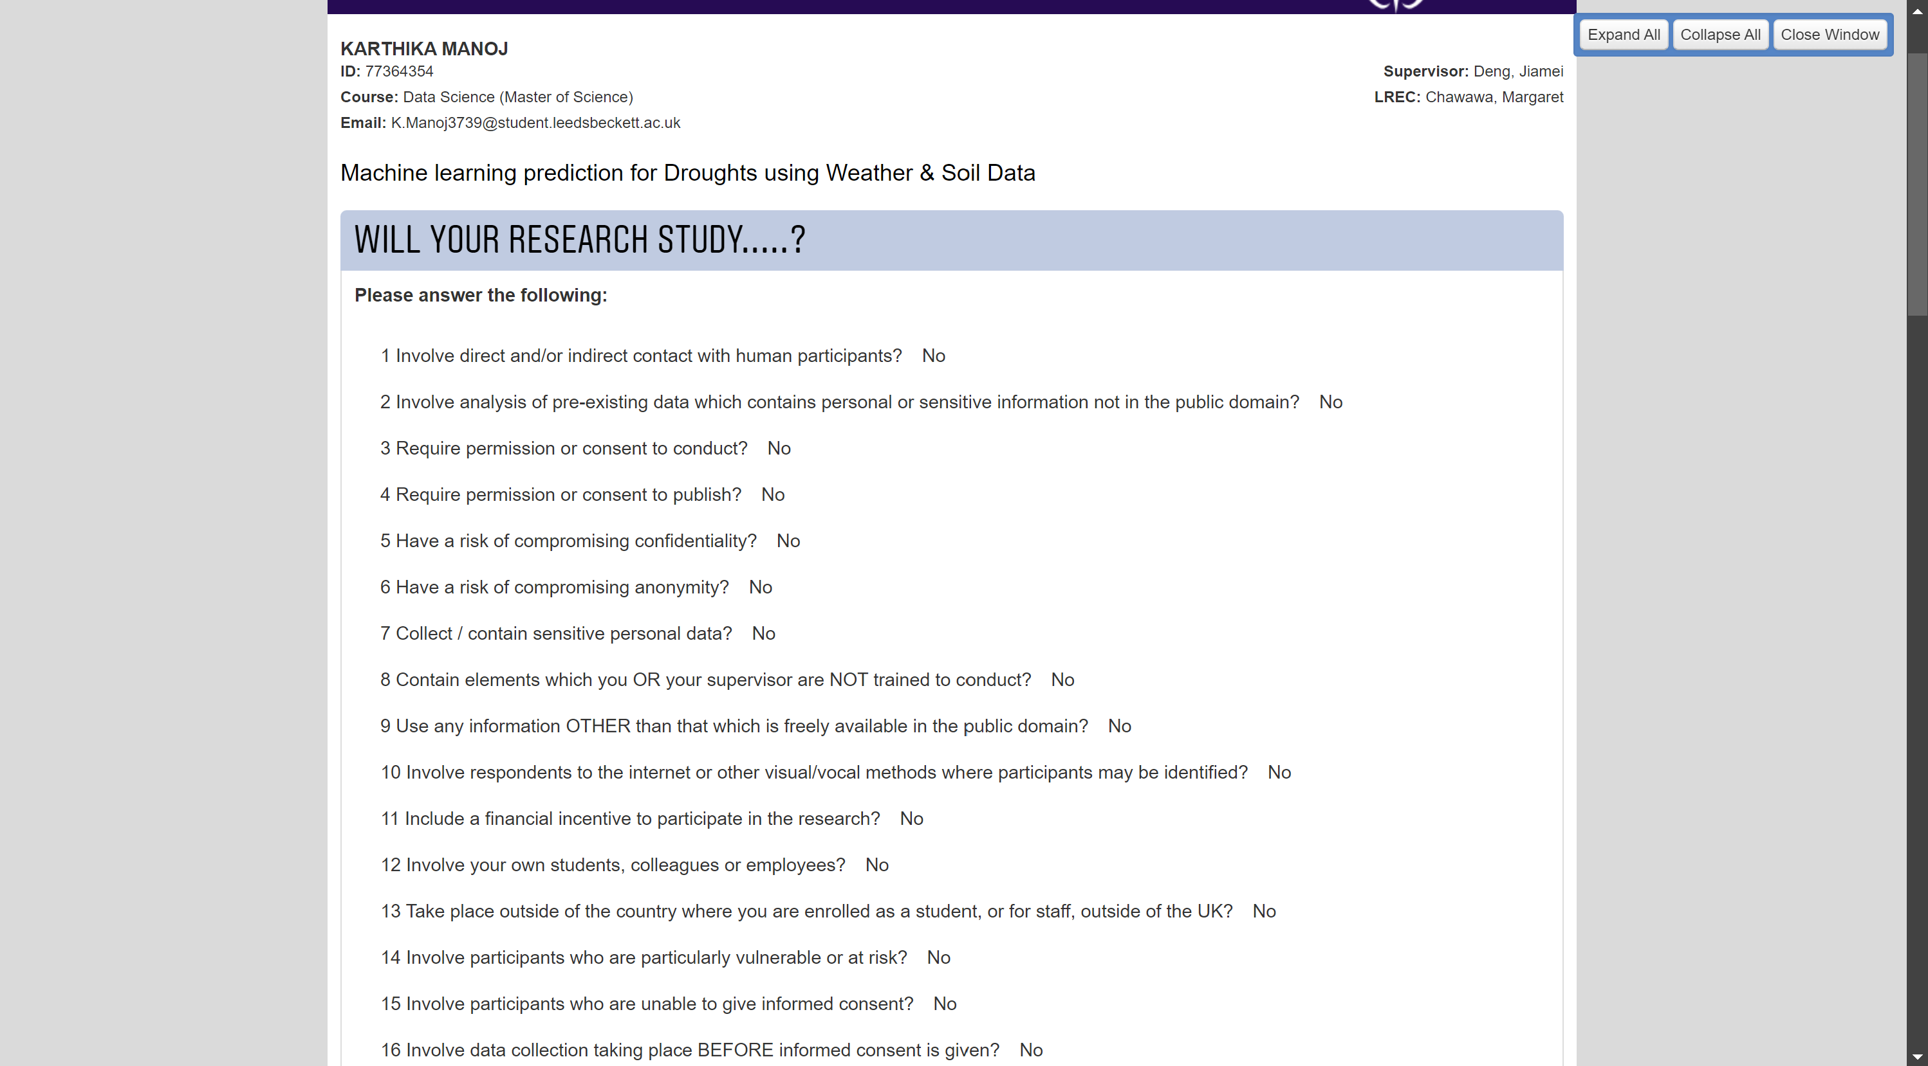



## Code Repository

1. Github link – <https://github.com/Karthikaaa/Drought-Prediction>
2. OneDrive – [Code](https://leedsbeckett-my.sharepoint.com/:f:/g/personal/k_manoj3739_student_leedsbeckett_ac_uk/EouFV_5spGlJgORFQQer1k0BC_rmf2b1hSOGZEsx7s_9Dg?e=HvAmFD)

## Presentation Video

YouTube Video and OneDrive Links

1. Personal account- <https://youtu.be/98BsHr3hEPY?si=6pSUnCtOqYnVQY_3>
2. University account- <https://youtu.be/oTNZB1I6AUE?feature=shared>
3. OneDrive - [Drought Prediction.mp4](https://leedsbeckett-my.sharepoint.com/:v:/g/personal/k_manoj3739_student_leedsbeckett_ac_uk/Ee--nsLGvstJg4idWbran_sBJOMYE8PggQgJGCA3hS0oEQ?nav=eyJyZWZlcnJhbEluZm8iOnsicmVmZXJyYWxBcHAiOiJPbmVEcml2ZUZvckJ1c2luZXNzIiwicmVmZXJyYWxBcHBQbGF0Zm9ybSI6IldlYiIsInJlZmVycmFsTW9kZSI6InZpZXciLCJyZWZlcnJhbFZpZXciOiJNeUZpbGVzTGlua0NvcHkifX0&e=tI9A75)

## Meetings

